worship@home resources for 6 December
Call to Worship & lighting ADVENT CANDLES
We come to prepare the way;
The way for Christ –
the hope of Christ, the peace of Christ –
to enter our world, to enter our hearts.
We cry out together in the wilderness:
the kingdom of heaven has come near.
We come to be part of the light–
the light that shines in the darkness.
ACKNOWLEDGEMENT OF COUNTRY
We acknowledge the Wurrundjeri people of the Kulin nation who have been the custodians of the lands on which we live and worship for thousands of years.
We pay respects to their Elders, past, present and emerging, and commit ourselves afresh to walk with all the First Peoples of this land in their search for justice.
HYMN TiS 647 Comfort, comfort all my people
Comfort, comfort all my people
with the comfort of my word.
Speak it tender to my people:
all your sins are taken away.
Though your tears be rivers running,
though your tears be an ocean full,
though you cry with the hurt of living:
comfort, comfort.
Every valley shall be lifted,
every mountain shall be low,
every rough place will be smoother:
comfort, comfort.
Refrain
Though your eyes see only darkness,
though your eyes can see no light,
though your eyes see pain and sorrow:
comfort, comfort.
Every night will have its morning,
every pain will have an end,
every burden will be lightened:
comfort, comfort.
Refrain
Though we fracture God's creation,
though we stand so far apart,
though we fail to love each other:
comfort, comfort.
Every wall will crack and crumble,
every stranger will be friend,
every one embrace another:
comfort, comfort.
Refrain
Words and music © 1975 Robin Mann.
YouTube version here https://www.youtube.com/watch?v=B8DXPAYWr-c
prayer
Living God,
who walks the roads of the world,
come to our place this morning
and call us to walk the road less travelled,
where steadfast love and faithfulness meet,
where righteousness and peace kiss each other.
Our spirits long to go to that place with you,
but the journey is long and the road is hard.
God who travels with us,
embolden our hearts and take our hands and lead us on.
Merciful God,
who spoke through the prophets of old,
forgive us when we put our heads down
and ignore the cries of injustice.
Forgive us when we presume to understand
the complexity of issues that divide and distract
the peoples of this land.
Forgive us, heal us and speak through us,
that we may be transformed through your refining fire,
and may prepare the way for the Christ child
to be welcomed among us in peace.
ASSURANCE OF FORGIVENESS
Hear the good news: through Christ we are forgiven and reconciled to God.
Thanks be to God.
BIBLE READINGS
Isaiah 40:1-5, 9-11 (NIV)
Comfort, comfort my people, says your God.
Speak tenderly to Jerusalem and proclaim to her
that her hard service has been completed,
that her sin has been paid for,
that she has received from the Lord’s hand
double for all her sins.
A voice of one calling:
‘In the wilderness prepare
the way for the Lord;
make straight in the desert
a highway for our God.
Every valley shall be raised up,
every mountain and hill made low;
the rough ground shall become level,
the rugged places a plain.
And the glory of the Lord will be revealed,
and all people will see it together.
For the mouth of the Lord has spoken.’ …
You who bring good news to Zion,
go up on a high mountain.
You who bring good news to Jerusalem,
lift up your voice with a shout,
lift it up, do not be afraid;
say to the towns of Judah,
‘Here is your God!’
See, the Sovereign Lord comes with power,
and he rules with a mighty arm.
See, his reward is with him,
and his recompense accompanies him.
He tends his flock like a shepherd:
he gathers the lambs in his arms
and carries them close to his heart;
he gently leads those that have young.
Mark 1:1-8
The beginning of the good news of Jesus Christ, the Son of God.
As it is written in the prophet Isaiah,
‘See, I am sending my messenger ahead of you,
who will prepare your way;
the voice of one crying out in the wilderness:
“Prepare the way of the Lord,
make his paths straight” ’,
John the baptiser appeared in the wilderness, proclaiming a baptism of repentance for the forgiveness of sins. And people from the whole Judean countryside and all the people of Jerusalem were going out to him, and were baptised by him in the river Jordan, confessing their sins. Now John was clothed with camel’s hair, with a leather belt around his waist, and he ate locusts and wild honey. He proclaimed, ‘The one who is more powerful than I is coming after me; I am not worthy to stoop down and untie the thong of his sandals. I have baptised you with water; but he will baptise you with the Holy Spirit.’
REFLECTION
A key theme in this week’s readings is beginning. The whole season of Advent is about beginnings – the beginning of the church year, the beginning of the hope and promise of the Messiah, the beginning of the good news of Jesus. As I mentioned last week, it is also a beginning of sorts for us as communities of God’s people as we begin to worship in face to face gatherings again for the first time since March. For us as well there are feelings of hope and promise, along with a few uncertainties and fears about how things will go.
In Isaiah, the people are living in exile in Babylon and feeling abandoned by God, who seems to be punishing them for past sins. But now a new word from God – a word of comfort, of forgiveness, of restoration. God is preparing the way for the people to return home to Jerusalem – smoothing the obstacles that stand in their path – and coming to save them with a mix of power and gentleness. Their new beginning – a new Exodus – will be like the former Exodus – a journey through the wilderness where they must learn to trust God once more.
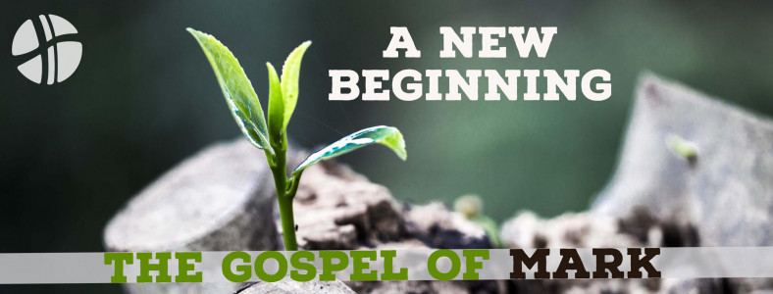
The opening line from Mark’s Gospel reads ‘The beginning of the good news of Jesus Christ’. It’s not immediately clear whether the beginning stands for the whole Gospel to follow or for the ministry of John who is preparing people for the coming of Jesus. Mark identifies John as both the messenger of the covenant from Malachi 3:1 and the voice crying in the wilderness from Isaiah 40:3. Once again, though, the good news is beginning in the wilderness, at the margins.
I wonder what new beginnings you have experienced this year? Perhaps learning new ways to keep in touch with others? New ways to shop? New ways to worship God at home? Has it felt like a wilderness experience that caused you to trust more in God’s provision?
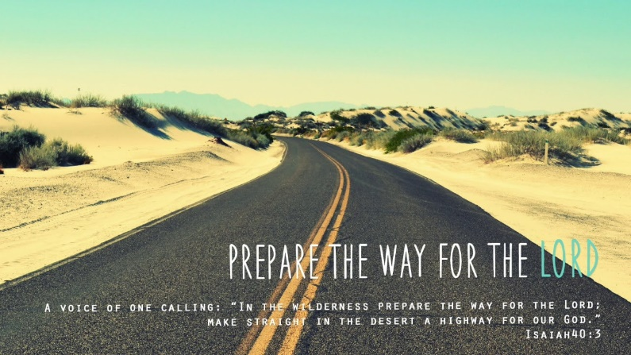
Another key theme in this week’s readings is that of preparing the way. The voice that cries out in Isaiah sees the very landscape being transformed. Later we will hear of God providing water in the desert. But the people must also prepare their hearts. They need to trust God once more and learn that God is powerful enough to bring about change but also loving enough to tend and care for them. A change in thinking is needed.
John calls this change of thinking repentance, literally to change one’s mind or turn around. So the way to prepare for the coming of Jesus is to repent. It’s the reason that the liturgical colour for Advent is purple, a colour shared with Lent, another season of repentance. In the longer version of this story in Luke’s Gospel, John calls on the people to live generously and humbly, sharing what they have and not demanding more than they need. It’s so different to the commercial voices at this time of year almost demanding that we spend, spend, spend!
This year we have got practised at preparing – whether it’s washing our hands carefully or not leaving home until we have our mask, or getting our spaces COVID safe. The cry in today’s readings is to prepare the way. Whose way are we really preparing for? And are we ready?
HYMN When out of poverty is born (tune Kingsfold TiS 585)
When out of poverty is born
a dream that will not die,
and landless, weary folk find strength
to stand with heads held high,
it’s then we learn from those who wait
to greet the promised day,
‘The Lord is coming; don’t lose heart.
Be blest: prepare the way!’
When people wander far from God,
forget to share their bread,
they find their wealth an empty thing,
their spirits are not fed.
For only just and tender love
the hungry soul will stay.
And so God’s prophets echo still
‘Be blest: prepare the way!’
When God took flesh and came to earth,
the world turned upside down,
and in the strength of woman’s faith
the Word of Life was born.
She knew that God would raise the low,
it pleased her to obey.
Rejoice with Mary in the call,
‘Be blest: prepare the way!’
Words © The Rev’d Kathryn Galloway (1952– ). Used with permission.
YouTube version here https://www.youtube.com/watch?v=MzwyjnACz0o
NOTICES
JOYS AND CONCERNS
Christmas Bowl – a story from BANGLADESH
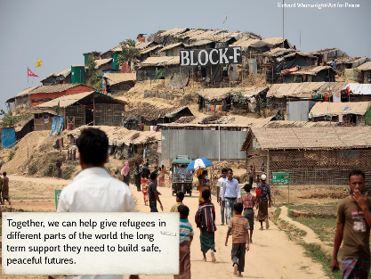
What does peace look like for the Rohingya people? After fleeing violence in Myanmar, they now face the threat of a deadly COVID-19 outbreak in Jamtoli refugee camp in Bangladesh. For Rohingya people living in the world’s largest refugee camp in Bangladesh, life was frightening enough before the coronavirus pandemic.
Food is in short supply and a third of households don’t have soap or regular access to water, so sickness is already rife. Dr Mehidi Hassan and his medical teams see up to 1,500 people every day at the health clinics scattered across the camp. Dr Hassan said: “Without support from the outside world, it will be devastating here. People will die of lack of food and treatment.” Now COVID-19 has reached Jamtoli refugee camp. There is widespread misinformation about the virus that is making it harder for doctors like Dr Hassan to stop a catastrophic outbreak.
This Christmas, vulnerable refugee communities urgently need your care. Please help them keep families safe through this pandemic, and shape the just, peaceful lives they deserve. Act for Peace’s local partner, Christian Aid, has teamed up with doctors, community workers and Rohingya religious leaders to distribute vital health messages. They are teaching people how handwashing and physical distancing can help stop the virus’ spread. Christian Aid is also dispelling dangerous COVID-19 myths that might stop infected people from seeking medical care. Together, we can help give refugees in different parts of the world the long term support they need to build safe, peaceful futures. Christ tells us that peace is always possible.
PRAYERS OF THE PEOPLE
Faithful God,
like the prophets of old, we wait for your glory to be revealed.
We pray for the people suffering violence and civil unrest,
for the places where injustice and cruelty reign.
Bring peace to your world, O God, and hear our prayer.
God of light,
like the magi on their long journey, we wait for your glory to be revealed.
We pray for your church both locally and throughout the world
for prophets who call us back to repentance
and for those who announce the good news through both their words and their actions.
Bring renewed life to your world, O God, and hear our prayer.

God of community,
like the shepherds in the fields, we wait for your glory to be revealed.
We pray for our neighbours, our schools and hospitals and our workplaces
still recovering from a year of turmoil and anxiety.
May your Christmas message of love and reconciliation bring hope.
Bring a renewed sense of community, O God, and hear our prayer.
God of compassion,
like Mary and Joseph awaiting the birth of their child, we wait for your glory to be revealed.
We pray for those known to us who need healing and wholeness,
for those who are sick and sorrowful, or who can no longer care for themselves,
for those people you’ve placed on our hearts this day who we name before you now …
Bring comfort and peace to your people, O God, and hear our prayer. Amen
COMMUNION SONG TiS 537 Let us talents and tongues employ
Let us talents and tongues employ,
reaching out with a shout of joy;
bread is broken, the wine is poured,
Christ is spoken and seen and heard.
Jesus lives again, earth can breathe again,
pass the Word around: loaves abound!
Jesus calls us in, sends us out
bearing fruit in a world of doubt,
gives us love to tell, bread to share:
God (Immanuel) everywhere.
Refrain
Frederick Herman Kahn 1929– Words by permission Stainer and Bell, London.
YouTube version here https://www.youtube.com/watch?v=FUh5l-FhLps
COMMUNION OF EMPTY HANDS
You may like to set up your space with an empty plate and an empty cup …
The peace of the Lord be always with you.
and also with you.
Just as Jesus prayed before breaking the bread, so we too give thanks …
The Lord is with us.
We lift our hearts to God.
We give thanks to God.
Together we proclaim the mystery of our faith …
Christ has died.
Christ is risen.
Christ will come again.
With an empty plate, we choose to see the world’s hunger.
We remember that millions of people, this day,
lack bread for communion, bread for breakfast, bread for life.
We acknowledge that we ourselves hunger, this day,
in ways that no earthly bread can satisfy.
Hospitable God, meet us in our unmet hungers –
and help us to put our abundance at the service of the poor.
With an empty cup, we choose to see the world’s thirst.
We remember that millions of people, this day,
lack wine for communion, fruit for juicing, water for life.
We acknowledge that we ourselves thirst, this day,
in ways that no earthly cup can quench.
Hospitable God, meet us in our unmet thirsts –
and help us to put our fullness at the service of the empty.
We pray now in the words Jesus taught his disciples, saying: Our Father in heaven…
It is Christ who is the bread of life, who satisfies the hungry heart.
It is Christ who is the cup of hope, who revives the thirsty.
In faith and hope, we hold out our empty hands...
In our empty hands, we celebrate the mystery of the incarnation
remembering that you chose to empty yourself for our sake.
As we approach the Christmas season we remember the words of the angelic choir as we say … Glory to God in the highest heaven
and on earth peace among all peoples.
BENEDICTION
May you go into the world this week
blessed by the steadfast love of God
filled with the compassion of Jesus Christ
and inspired by the creative energy of the Holy Spirit.
We go in peace to love and serve the Lord.
SENDING SONG TiS 782 Go now in peace
Go now in peace, go now in peace,
may the love of God surround you
everywhere, everywhere you may go.
Words and music © Natalie Sleeth 1930-92. Used with permission.
For YouTube version see https://www.youtube.com/watch?v=oRW1E0FzXek

