worship@home resources for 29 November
Call to Worship & lighting ADVENT CANDLES
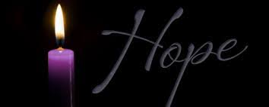
Lord Jesus Christ,
we await your coming in this Advent season.
We wait, filled with hope,
knowing your light will shine in the darkness.
We wait, anticipating your peace,
that one day will fill our world.
We wait, embracing your love,
that we might share it with our neighbours.
We wait with joy,
that wells up within us in expectation of your coming.
Lord we wait.
Come and fill us with your life.
ACKNOWLEDGEMENT OF COUNTRY
We acknowledge the Wurrundjeri people of the Kulin nation who have been the custodians of the lands on which we live and worship for thousands of years.
We pay respects to their Elders, past, present and emerging, and commit ourselves afresh to walk with all the First Peoples of this land in their search for justice.
HYMN TiS 272 Come thou long expected Jesus
Come, thou long expected Jesus,
born to set thy people free,
from our fears and sins release us,
let us find our rest in thee.
Israel's strength and consolation,
hope of all the earth thou art;
dear desire of every nation,
joy of every longing heart.
Born thy people to deliver,
born a child and yet a king,
born to reign in us forever,
now thy gracious kingdom bring.
By thine own eternal Spirit,
rule in all our hearts alone;
by thine own sufficient merit
raise us to thy glorious throne.
Charles Wesley 1707-88.
YouTube version here https://www.youtube.com/watch?v=0dmO8UPlWoo&t=39s
prayer
Gracious God,
as we gather this morning – both at home and here in church –
we thank you for being the stable anchor and rock
that has got us through this most challenging year.
We thank you for your protection and provision –
and for the many people in our community who helped us
to stay safe and to stay sane.
Loving Lord,
let Advent begin again in all of us this day,
for the first Christmas was not mostly for children,
but more for the old and the wise with eyes to see.
Help us to realise that Christmas is for everyone —
including people with bent backs and tired eyes
who seek hope and a new beginning.
Compassionate God,
even now as shops reopen and the frenzy of consumerism ramps up again,
we confess the pressure to conform.
Though we would like to be more Christ-minded in our daily lives,
we confess that we have not always loved our neighbour as ourselves.
Restore us, O God, and let your face shine upon us.
We wait in hope.
ASSURANCE OF FORGIVENESS
Hear the good news from Paul’s letter to the Corinthian church:
God is faithful and will never give up on us. Our sins are forgiven.
Thanks be to God.
BIBLE READINGS
Isaiah 64:1-9
O that you would tear open the heavens and come down,
so that the mountains would quake at your presence—
as when fire kindles brushwood
and the fire causes water to boil—
to make your name known to your adversaries,
so that the nations might tremble at your presence!
When you did awesome deeds that we did not expect,
you came down, the mountains quaked at your presence.
From ages past no one has heard,
no ear has perceived,
no eye has seen any God besides you,
who works for those who wait for him.
You meet those who gladly do right,
those who remember you in your ways.
But you were angry, and we sinned;
because you hid yourself we transgressed.
We have all become like one who is unclean,
and all our righteous deeds are like a filthy cloth.
We all fade like a leaf,
and our iniquities, like the wind, take us away.
There is no one who calls on your name,
or attempts to take hold of you;
for you have hidden your face from us,
and have delivered us into the hand of our iniquity.
Yet, O Lord, you are our Father;
we are the clay, and you are our potter;
we are all the work of your hand.
Do not be exceedingly angry, O Lord,
and do not remember iniquity for ever.
Now consider, we are all your people.
Mark 13:24-37 (The Message)
Following those hard times,
The sun will fade out,
the moon cloud over,
stars will fall out of the sky,
cosmic powers will tremble.
And then they’ll see the Son of Man enter in grand style, his arrival filling the sky—no one will miss it! He’ll dispatch the angels; they will pull in the chosen from the four winds, from pole to pole.
Take a lesson from the fig tree. From the moment you notice its buds form, the merest hint of green, you know summer’s just around the corner. And so it is with you. When you see all these things, you know he is at the door. Don’t take this lightly. I’m not just saying this for some future generation, but for this one, too—these things will happen. Sky and earth will wear out; my words won’t wear out.
But the exact day and hour? No one knows that, not even heaven’s angels, not even the Son. Only the Father. So keep a sharp lookout, for you don’t know the timetable. It’s like a man who takes a trip, leaving home and putting his servants in charge, each assigned a task, and commanding the gatekeeper to stand watch. So, stay at your post, watching. You have no idea when the homeowner is returning, whether evening, midnight, cockcrow, or morning. You don’t want him showing up unannounced, with you asleep on the job. I say it to you, and I’m saying it to all: Stay at your post. Keep watch.
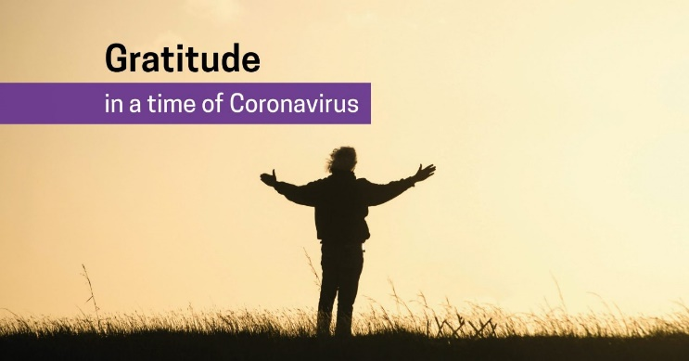
REFLECTION
This week feels like a new beginning – some of us back together for the first face-to-face worship in 8 months. So it feels like a time to give thanks and voice hope for the future.
But this week many of us will continue to gather virtually by Zoom and others again will be worshipping at home alone. So it also feels like a time to mourn for what we have lost this year and acknowledge what has been an awful year for many people in many places.
This week is also a time to wait on God and pray for God to act to restore what has been lost and to heal what has been broken and what is still hurting in the world.
Welcome to the season of Advent, the season of promise and the season of waiting. While it’s always tempting to run ahead to Christmas and skip Advent, that would greatly diminish our understanding and our faith. It would be like celebrating Easter without travelling through Lent or experiencing the bleakness of Good Friday.
In the passage from Isaiah, the people are wanting – desperately – for God to do something. They have endured the destruction of Jerusalem, exile in Babylon and now an empty return to their old home. In a similar way to us this year, they long for a return to ‘normal’. The people are impatient at God’s silence and hiddenness. As they wait, though, they become aware of their loss and their own contribution to what has happened.
I wonder what we see when we look around at the world this year? We probably see disruption to our lives, the fragility of life itself and our vulnerability to a microscopic virus. But do we also see inequity, injustice and widespread pain? And our part in systems that favour the rich over the poor, both in Australia and overseas? Something new is needed to transform us ... We may remember God’s action in the past when God did tear open the heavens and descend like a dove upon Jesus at his baptism, ushering in a message of hope. How might we need to change to more fully embrace this hope?
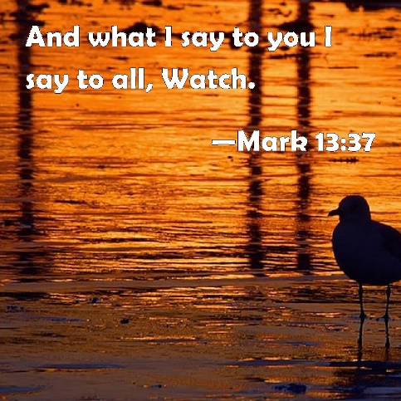
In our Gospel reading, we fast forward to the final week of Jesus’ life before he was arrested and killed. He is telling the disciples about the problems and troubles that await them. The new insight is that Jesus will return again, unexpectedly, on a day and at a time no one expects. So Jesus urges them to keep awake and watch and not get lazy or sleepy.

But how exactly are we to wait for this day? Given what has happened this year, some of us may wait with anxiety or fear about the future. While this is understandable, we need to hear again Jesus’ promise to be with us, always. We may be tempted to withdraw from the dangers and risks of the world. Again this is understandable, but we need to hear afresh Jesus’ call to live in the world and be a source of light that points others towards God’s love and goodness. Another alternative, inspired by this week’s readings, is to live with hope.
This will look different for each of us. But it seems that a good place to start is to listen to the advice of Paul, who had his fair share of difficulties, pain and anxiety to endure. Towards the end of his letter to the church in Rome, Paul lists out a series of behaviours and attitudes that will help us wait, with faith (from Romans 12:9-13):
- Hold fast to what is good
- Rejoice in hope
- Be patient in suffering
- Persevere in prayer
- Actively contribute to the needs of others
- Continue to offer hospitality to strangers
If we live holding onto these attitudes and actions we will stay awake and be ready to greet Jesus wherever and whenever he shows up.
HYMN TiS 265 O come, O come, Emmanuel
O come, O come, Emmanuel,
and ransom captive Israel,
that mourns in lonely exile here
until the Son of God appear.
Rejoice! Rejoice! Emmanuel
shall come to you, O Israel.
O come, O come, great Lord of might
who to the tribes on Sinai's height
in ancient times did give the law
in cloud and majesty and awe.
Refrain
O come, O key of David, come,
and open wide our heavenly home;
make safe the way that leads on high
and close the path to misery.
Refrain
O come, O branch of Jesse, free
your own from Satan's tyranny;
from depths of hell your people save
and give them victory o'er the grave.
Refrain
O come, O dayspring, come and cheer,
our spirits by your advent here;
disperse the gloomy clouds of night
and death's dark shadows put to flight.
Refrain
Based on Latin Antiphons from 9th century or earlier. Tr John Mason Neale 1818-66 alt.
YouTube version with slightly different verses here https://www.youtube.com/watch?v=7xtpJ4Q_Q-4
NOTICES
JOYS AND CONCERNS
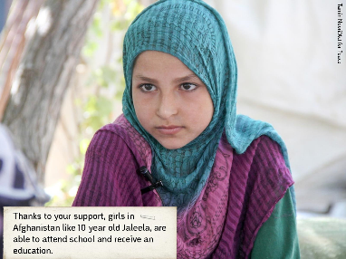
Christmas Bowl – a story from afghanistan
Hope keeps us going in bleak times. It’s faith that God will prevail in our lives. But COVID-19 is dashing the hopes of Afghani girls like Jaleela to go to school and escape the oppression they were born into. Ten-year-old Jaleela didn’t start school until she was eight because girls’ education wasn’t encouraged in her community. But Community World Service Asia, a local partner with Act for Peace, showed her Dad the benefits of having an educated daughter. Because of this advocacy, Jaleela has been getting the education that both her parents missed out on. She loves school and wants to help build a better future for her conflict-torn country. Jaleela said ‘There is so much fighting in this country so I want to become a doctor’.
Sadly the pandemic is making it even harder for girls like her to learn and realise their dreams. Schools closed in March, and most children don’t have internet, TV or radio access to learn remotely. The lockdown is particularly hurting girls who are already the most vulnerable in their society. As families come under greater financial strain, more girls are being forced to work, to care for their households, or into early marriages.
Through a gift to the Christmas Bowl, we can help show them a life of hope and opportunity is still within reach. Education brings hope. Please give this Christmas and renew the hope for girls in Afghanistan.

PRAYERS OF THE PEOPLE
Merciful God,
We see you in the most unlikely places – as a child in a stable and in an empty stone tomb.
May you hear our prayers today, which come from the unlikely corners of our lives.
We pray for places and people being torn apart by conflict – for Ethiopia and Yemen, for West Papua and Afghanistan. We pray for leaders to rule justly and wisely and with a servant heart, and we pray for refugees that you would watch over them and sustain them. We pray that girls like Jaleela can continue to receive an education.
Lord, bring the hope of your presence that the world may know that you have come.
We pray for places and people ravaged by sickness and disease, especially those countries where COVID is running wild and out of control and where hospitals are overwhelmed. We pray for doctors, nurses and carers and that sensible steps be taken to stop the spread of disease. We pray with hope for the vaccines to be made available soon to every country.
Lord, bring the hope of your presence that the world may know that you have come.
Closer to home, we pray for the people who are doing it tough. We pray especially for those known to us who are sick, grieving, lonely, unemployed or languishing in prisons. We pause to name them before you now …
We pray that you would bring strength and healing and hope for the future.
Lord, bring the hope of your presence that the world may know that you have come.
We pray for your people, O Lord, in the church. Give us courage and vision – and show us where you are already at work in our communities that we might work with you. Continue to impress on us areas of holy discontent where we might bring hope and abundant life.
Lord, bring the hope of your presence that the world may know that you have come.
Give us ears to hear, O God, and eyes to watch, that we may know your presence in our midst during this season of hope as we anticipate the coming of Jesus Christ.
We pray now in the words Jesus taught us, saying: Our Father in heaven…
BENEDICTION
As we leave today,
remember that God walks the journey beside us,
keeping us on track until Jesus returns.
God, who got us started on this spiritual adventure, will do this,
because God is faithful and will never give up on us.
We go in peace to love and serve the Lord.

SENDING SONG May the God of hope fill you
May the God of hope fill you
with all joy and peace,
as you trust in him today
may your faith increase.
So that you may overflow
with the hope he gives,
by the Holy Spirit’s power,
who forever lives.
May the grace of Jesus Christ
and the love of God
and the fellowship that comes
from the Spirit’s love,
be with us all everyone,
till we meet again,
and beyond this earthly life –
evermore, amen. Evermore, amen.
Words and music © Elaine Downie 1984. Used with permission.

