worship@home resources for 1 November
Call to Worship
Let us praise God today
and through every situation.
Through our words and action
our lives will honour God.
Come and lift up God’s name with me –
let us praise God’s name together!
ACKNOWLEDGEMENT OF COUNTRY
We acknowledge the Wurrundjeri people of the Kulin nation who have been the custodians of these lands and waters since time immemorial.
We pay respects to their Elders, past, present and emerging, and commit ourselves afresh to walk with the First Peoples of this land in their search for justice.
HYMN 10,000 reasons
Bless the Lord O my soul, O my soul,
worship his holy name.
Sing like never before, O my soul,
I’ll worship your holy name.
The sun comes up, it’s a new day dawning;
it’s time to sing your song again.
Whatever may pass and whatever lies before me –
let me be singing when the evening comes.
Refrain
You’re rich in love and you’re slow to anger,
your name is great and your heart is kind.
For all your goodness I will keep on singing –
ten thousand reasons for my heart to find.
Refrain
And on that day when my strength is failing,
the end draws near and my time has come,
still my soul will sing your praise unending –
ten thousand years and then forevermore.
Refrain
Matt Redman © 2011 Thankyou Music.
YouTube version here https://www.youtube.com/watch?v=DXDGE_lRI0E
prayer
Loving God,
We come to you today in all our weakness and strength,
with our fresh minds, our frail bodies and our faithful spirits.
We come with our firm yet questioning faith,
singing our praises and whispering our prayers.
Like the saints of old, we come with determination to make a difference
yet are mindful of our human limitations.
We come secure in your endless love for us,
for we know that we are part of your forever family.
Gracious God,
We know that we have not loved you with our whole heart,
nor have we loved our neighbour as ourselves.
Just as we seek your forgiveness, teach us how to forgive others
and lead us forward in new life through Jesus Christ our Lord. Amen.
ASSURANCE OF FORGIVENESS
Hear Christ’s word of grace to us today: ‘Your sins are forgiven’
Thanks be to God
BIBLE READINGS
Psalm 34:1-14 (NIV)
I will extol the Lord at all times;
his praise will always be on my lips.
I will glory in the Lord;
let the afflicted hear and rejoice.
Glorify the Lord with me:
let us exalt his name together.
I sought the Lord, and he answered me;
he delivered me from all my fears.
Those who look to him are radiant;
their faces are never covered with shame.
This poor man called, and the Lord heard him;
he saved him out of all his troubles.
The angel of the Lord encamps around those who fear him,
and he delivers them.
Taste and see that the Lord is good;
blessed is the one who takes refuge in him.
Fear the Lord, you his holy people,
for those who fear him lack nothing.
The lions may grow weak and hungry,
but those who seek the Lord lack no good thing.
Come, my children, listen to me;
I will teach you the fear of the Lord.
Whoever of you loves life
and desires to see many good days,
keep your tongue from evil
and your lips from telling lies.
Turn from evil and do good;
seek peace and pursue it.
Matthew 5:1-12
When Jesus saw the crowds, he went up the mountain; and after he sat down, his disciples came to him. Then he began to speak, and taught them, saying:
‘Blessed are the poor in spirit, for theirs is the kingdom of heaven.
Blessed are those who mourn, for they will be comforted.
Blessed are the meek, for they will inherit the earth.
Blessed are those who hunger and thirst for righteousness, for they will be filled.
Blessed are the merciful, for they will receive mercy.
Blessed are the pure in heart, for they will see God.
Blessed are the peacemakers, for they will be called children of God.
Blessed are those who are persecuted for righteousness’ sake, for theirs is the kingdom of heaven.
Blessed are you when people revile you and persecute you and utter all kinds of evil against you falsely on my account. Rejoice and be glad, for your reward is great in heaven, for in the same way they persecuted the prophets who were before you.’
Revelation 7:9-17
After this I looked, and there was a great multitude that no one could count, from every nation, from all tribes and peoples and languages, standing before the throne and before the Lamb, robed in white, with palm branches in their hands. They cried out in a loud voice, saying, ‘Salvation belongs to our God who is seated on the throne, and to the Lamb!’
And all the angels stood around the throne and around the elders and the four living creatures, and they fell on their faces before the throne and worshipped God, singing,
‘Amen! Blessing and glory and wisdom and thanksgiving and honour
and power and might be to our God for ever and ever! Amen.’
Then one of the elders addressed me, saying, ‘Who are these, robed in white, and where have they come from?’ I said to him, ‘Sir, you are the one that knows.’ Then he said to me, ‘These are they who have come out of the great ordeal; they have washed their robes and made them white in the blood of the Lamb.
For this reason they are before the throne of God, and worship him day and night within his temple, and the one who is seated on the throne will shelter them. They will hunger no more, and thirst no more; the sun will not strike them, nor any scorching heat; for the Lamb at the centre of the throne will be their shepherd, and he will guide them to springs of the water of life, and God will wipe away every tear from their eyes.’
REFLECTION
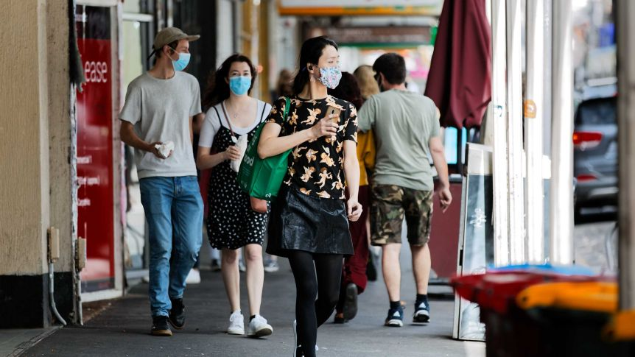
There has been an outpouring of joy and thanksgiving across Melbourne this week as we have controlled the second wave of coronavirus infections sufficiently that it is now safe to reopen many aspects of our life that have been closed for months. This is our reward for months of restrictions. Numbers at indoor gatherings will remain cautiously low for a while yet, which limits the possibilities for face-to-face worship, but we are already planning for what we might be able to do at Christmas.
Today in the church calendar is All Saints Day, a tradition that dates back to at least the sixth century. In the Bible, a saint is anyone whose life is dedicated to God and who is sanctified in Christ, which included all the members of the churches Paul wrote to (e.g. Rom 1:7, 1 Cor 1:2). On All Saints Day, some streams of the church – notably the Orthodox and Catholic faiths – focus almost exclusively on remembering and celebrating those Christian saints who have died. In the Protestant tradition, however, we remember the saints both living and dead, whether famous or obscure, who have brought us to faith, nurtured us in faith and who continue to inspire and stretch our faith today. Just as with the Covid19 situation, it is a day to be thankful but also a day of joy and worship.
The psalm is full of praise for God who delivered David from a dangerous situation. The psalm calls on the wider faith community to reflect on God’s blessings. As we emerge from lockdown, it would be a good spiritual exercise to reflect on what you are most thankful to God for during these past few months. If you keep a journal, write this down. Alternatively, you might like to pause and pray. The psalm also suggests that we express our thanks in how we live – speaking truthfully, doing good to others and seeking peace. I wonder what further life lessons you have learned from the saints in your life?
The Gospel reading is the familiar opening verses to the Sermon on the Mount, widely known as the Beatitudes (from Latin beatus meaning blessed or happy). These promised blessings remain very counter cultural. Back in Jesus’ day – and still today – the people usually considered blessed are the wealthy, the healthy and those who are praised. Jesus turns this on its head. Those who are blessed – through the ministry of Jesus – and in their response of faith – are the poor, the pure in heart, those who seek peace and righteousness and those who are persecuted for their unwavering faith in Jesus. Clearly, following Jesus is not a ‘cool’ thing to do and will not bring us wealth or fame. But following the way of Jesus puts us firmly on God’s side and aligns our life with God’s character of compassion, justice and true peace. Again, as you reflect on the saints who have influenced your life, what can you learn from their priorities and approach to life?
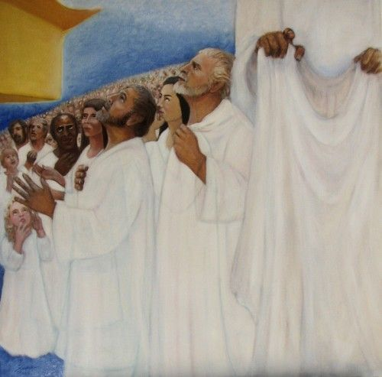
The third reading from Revelation paints a vivid word picture of a countless multitude of people from every nation and language, all dressed in white, waving palm branches and praising God. What message is this picture trying to portray? First, that God welcomes all people. God has no favourites – all are dressed alike and treated the same. Second, worship is of key importance in heaven and, by implication, here on earth also. Third, the presence of God and Jesus, the Lamb, will remain at the centre of our lives even after death, where earthly suffering is replaced by peace and security. This comforting image is consistent with Jesus’ teaching elsewhere. In Matthew’s Gospel, for instance, Jesus invites people who are feeling weary and burdened to come to him and find rest, which is what this vision portrays. Throughout Matthew’s Gospel there is the idea of God welcoming and richly blessing all God’s faithful people – all the saints – in the life to come. Today we remember that promise.
Lighting our ALL Saints Day CANDLES
HYMN For all the saints (to tune O Waly, Waly TiS 654)
For all the saints who’ve shown your love
in how they live and where they moved,
for mindful women, caring men,
accept our gratitude again.
For all the saints who loved your name,
whose faith increased their Saviour’s fame,
who sang your songs and shared your word,
accept our gratitude, good Lord.
For all the saints who named your will,
and showed the kingdom coming still
through selfless protest, prayer and praise,
accept the gratitude we raise.
Bless all whose will or name or love
reflects the grace of heaven above.
Though unacclaimed by earthly powers,
your life through theirs has hallowed ours.
John L Bell and Graham Maule. © 1989 Wild Goose Resources Group. Used by permission.
YouTube version of TiS 455 (the better known song by this name) see https://www.youtube.com/watch?v=1OaBgaMcOvM

PRAYERS OF THE PEOPLE
Living God,
we are reminded today that your blessings do not necessarily follow the logic of the world.
The world believes that the rich are blessed,
but Jesus reminds us that it is the poor who are blessed.
We pray for a more just world in which all have enough and none are left behind.
Though we sometimes fear death and avoid its inevitable arrival,
Jesus tells us that those who mourn are blessed.
Help us to bring hope and wholeness to those who are sick
and comfort to those of us who have lost loved ones.
While people covet power, Jesus blesses the meek.
Help us to stand with the oppressed and marginalised,
and show us your presence in the faces and lives of those the world forgets.
The world hungers after material possessions and physical pleasures
but Jesus tells us that seeking righteousness is what will truly satisfy.
Fill our hearts with love and mercy and a desire to seek justice for others.
Make our hearts pure, and give us a vision of your kingdom.
In a society with so many divisions and labels that we have created,
remind us that all people are created in your image.
Help us to be peacemakers and agents of reconciliation.
Gracious God,
you have blessed us richly with life, love and joy,
yet we are aware of people and situations where there is pain, anxiety and fear.
We pause to name them before you now …
and ask that you bring your healing and your peace.
Hear our prayers, O God, even as we pray in the words Jesus taught, saying:
Our Father in heaven…
BENEDICTION
Journeying God,
give us hearts and minds and spirits
ready to trust and follow wherever your Spirit leads.
Friends, go in peace to love and serve the Lord.
We will seek peace and pursue it, in the name of Christ.
SENDING SONG TiS 782 Go now in peace
Go now in peace, go now in peace,
may the love of God surround you
everywhere, everywhere you may go.
Words and music © Natalie Sleeth 1930-92. Used with permission.
For YouTube version see https://www.youtube.com/watch?v=oRW1E0FzXek

