worship@home resources for 25 October
Call to Worship
We are called to love the Lord our God
We are called to love God with all our heart, soul, mind and strength
We are called to love our neighbour
We are called to love our neighbour as we love ourselves
We are called to love the foreigner
We are called to love the foreigner as we love ourselves
Let us worship our God
ACKNOWLEDGEMENT OF COUNTRY
We acknowledge that the Wurrundjeri people of the Kulin nation have been the custodians of the land on which we meet since the time of the dreaming.
We pay respects to their Elders, past, present and emerging, and commit ourselves afresh to walk with the First Peoples of this land in their search for justice.
HYMN TiS 675 Lord the light of your love is shining
Lord, the light of your love is shining,
in the midst of the darkness, shining;
Jesus, Light of the world, shine upon us,
set us free by the truth you now bring us –
shine on me, shine on me.
Shine, Jesus, shine,
fill this land with the Father's glory;
blaze, Spirit, blaze, set our hearts on fire.
Flow, river, flow,
flood the nations with grace and mercy;
send forth your word, Lord, and let there be light.
Lord, I come to your awesome presence,
from the shadows into your radiance;
by the blood I may enter your brightness;
search me, try me, consume all my darkness –
shine on me, shine on me.
Refrain
As we gaze on your kingly brightness
so our faces display your likeness,
ever changing from glory to glory;
mirrored here may our lives tell your story –
shine on us, shine on us.
Refrain
Graham Kendrick 1950- Words and music © Thank you Music.
YouTube version featuring Graham Kendrick https://www.youtube.com/watch?v=QGmT4Gsh8CU
prayer
Living God,
We gather here this morning to remember and celebrate your beautiful creation,
your love for all people
and your compassion for us when we fall or ache.
We praise you that Jesus came to show us how to live –
how to let love, mercy and justice infiltrate our whole lives.
Holy Spirit, show us afresh today that …
goodness is stronger than evil,
love is stronger than hate,
kindness is stronger than greed,
truth is stronger than lies.
Transform our hearts and minds as we seek to be your people in this place.
Gracious God,
When we have not touched but trampled you in creation,
Lord, have mercy.
When we have not met but missed you in one another,
Christ, have mercy.
When we have not received but rejected you in the poor,
Lord, have mercy.
Forgive us and remake us in your image. Amen.
ASSURANCE OF FORGIVENESS
Hear the words of Jesus to all who are truly sorry and who seek to renew their lives:
Your sins are forgiven. Come, follow me.
We gladly accept your grace and healing. Thanks be to God.
BIBLE READINGS
Leviticus 19:1-2, 15-18, 33-34
The Lord spoke to Moses, saying: ‘Speak to all the congregation of the people of Israel and say to them: You shall be holy, for I the Lord your God am holy. …
You shall not render an unjust judgement; you shall not be partial to the poor or defer to the great; with justice you shall judge your neighbour … I am the Lord.
You shall not hate in your heart anyone of your kin; you shall reprove your neighbour, or you will incur guilt yourself. You shall not take vengeance or bear a grudge against any of your people, but you shall love your neighbour as yourself. I am the Lord.
When a foreigner resides with you in your land, you shall not oppress the foreigner. The foreigner who resides with you shall be to you as the citizen among you; you shall love the foreigner as yourself, for you were foreigners in the land of Egypt. I am the Lord your God.
Psalm 90:1-6, 13-17 (The Message)
God, you’ve been our home forever;
long before the mountains were born,
long before you brought earth itself to birth,
from “once upon a time” to “kingdom come”— you are God.
So don’t return us to mud, saying,
“Back to where you came from!”
Patience! You’ve got all the time in the world—
whether a thousand years or a day, it’s all the same to you.
Are we no more to you than a wispy dream,
no more than a blade of grass
that springs up gloriously with the rising sun
and is cut down without a second thought?
Oh! Teach us to live well!
Teach us to live wisely and well!
Come back, God—how long do we have to wait?—
and treat your servants with kindness.
Surprise us with love at daybreak;
then we’ll skip and dance all the day long.
Make up for the bad times with some good times;
we’ve seen enough evil to last a lifetime.
Let your servants see what you’re best at—
the ways you rule and bless your children.
And let the loveliness of our Lord, our God, rest on us,
confirming the work that we do.
Oh, yes. Affirm the work that we do!
Matthew 22:34-40
When the Pharisees heard that he had silenced the Sadducees, they gathered together, and one of them, a lawyer, asked him a question to test him. ‘Teacher, which commandment in the Law is the greatest?’ He said to him, ‘ “You shall love the Lord your God with all your heart, and with all your soul, and with all your mind.” This is the greatest and first commandment. And a second is like it: “You shall love your neighbour as yourself.” On these two commandments hang all the Law and the Prophets.’

REFLECTION
It won’t surprise you that one of the strongest characteristics of our modern Western culture is its focus on the individual, on me. Rather than being concerned for the well-being of the wider community, most of our advertising and politics is aimed at meeting the needs and aspirations of the individual. It’s why many people disregard climate change as a serious issue. It’s not affecting me directly, so I don’t need to change my behaviour or priorities. Likewise refugees and asylum seekers are out of sight and therefore largely out of mind … isolated and forgotten during the Covid19 pandemic but still locked up in prison like conditions … but why think or worry about them?
The Scriptures tell us a very different story. The starting point is always God – who is Creator, Redeemer and Sustainer. If we are to understand how to live well, we must begin by reflecting on God’s character of love, grace, compassion and faithfulness. So when Jesus is asked a serious question about the Jewish Law … what is the first or most important commandment? … his answer starts with God. He quotes the Shema from Deut 6:4-5 – the prayer recited by devout Jews every morning and every evening – both then and now:
Hear O Israel, the Lord our God, the Lord is one;
you shall love the Lord your God with all your heart,
and with all your soul and with all your strength.
We do this through our worship, our prayer, our reading of the Scriptures and in how we live. Everything else flows from this.
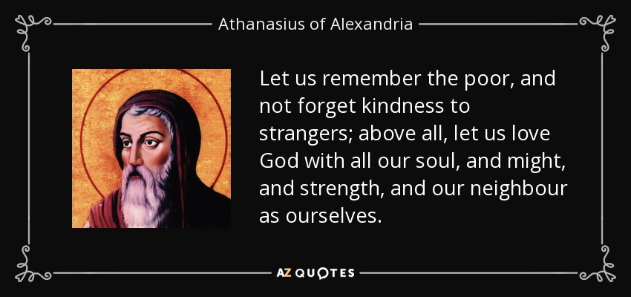
While God – and God alone – is to be worshipped, the Scriptures also show a high concern for how we are to live in community. There is a strong and consistent emphasis on reflecting God’s character in how we treat others. Hence we are called to love the poor, love our neighbour and love the stranger living amongst us – because this reflects God’s love for all people and God’s desire for justice. So Jesus goes on to say that there is a second vital commandment – to love your neighbour as yourself.
So how do I want to be treated by others? With respect? understanding? compassion? care? Then live like this towards others. As Jesus taught in the Sermon on the Mount – do to others as you would have them do to you (Matthew 7:12). This way of living flows from God’s love for us – demonstrated through Jesus – who welcomed us even when we were strangers and far off (Galatians 2:13).
How do we express our love for others? The Scriptures (and psychologists) tell us that it starts with the right heart attitude – the impulse to do good, to connect, to help, to encourage the other. This heart attitude then overflows into our words and our actions. In Luke’s version of this teaching on the greatest commandments, Jesus illustrates love for neighbour in the story we know as the good Samaritan, where love is costly and is prepared to cross boundaries to help those in need and to help people find their place in community. It’s why our ministries like Helping Hand, playgroup and the community lunches at Croydon North matter … they reflect God’s love in how we love our neighbours.
We also see love displayed as Jesus heals and accepts and restores people from all walks of life and then in the laying down of his life for the sake of others. We are able to love in this way because we are loved by God (1 John 4:19) and have been given God’s Spirit.
As we draw towards the end of the church year and the lectionary cycle of readings, it’s helpful to try and summarise the message of Jesus. We might do this in three points:
- The good news: know that you are loved and accepted by God, whoever you are
- The challenge: love God and love your neighbour as yourself, whoever they are
- The invitation: follow the example of Jesus, especially in how he treats others
I wonder which of these three is easier for you and which is harder?
HYMN TiS 607 Make me a channel of your peace
Make me a channel of your peace.
Where there is hatred, let me bring your love;
where there is injury, your pardon Lord;
and where there's doubt, true faith in you.
O Master, grant that I may never seek
so much to be consoled as to console,
to be understood as to understand,
to be loved, as to love with all my soul.
Make me a channel of your peace.
Where there's despair in life, let me bring hope;
where there is darkness, let me bring your light;
and where there's sadness, ever joy.
Refrain
Make me a channel of your peace.
It is pardoning that we are pardoned,
in giving of ourselves that we receive,
and in dying that we're born to eternal life.
Based on an anonymous prayer c. 1900. This version by J. Sebastian Templehoff.
YouTube version here https://www.youtube.com/watch?v=eHVz45n5a9M&t=41s
PRAYERS OF THE PEOPLE
These prayer points invite you to add your own prayers for each petition …
Compassionate God,
empower us by your Spirit to share your love with others even as we pray…
for the earth that we may learn to care for it …
for those who rule in the nations of the world …
as well as for the powerless and the oppressed in all nations …
for those imprisoned for defending truth or justice …
for the church and those who lead in it …
for the poor, the homeless, the hungry …
for those who mourn and are alone …
for our neighbours as well as the strangers in our midst …
for those known to us who are sick or grieving or worried …
And now we pray the prayer which Jesus Christ himself taught his followers saying:
Our Father in heaven …
BENEDICTION
Go in peace to love and to serve others
in the name of God, the Trinity of love
We will seek peace and pursue it
SENDING SONG God to enfold you
God to enfold you,
Christ to uphold you,
Spirit to keep you in heaven’s sight;
so may God grace you,
heal and embrace you,
lead you through darkness into the light.
Words and music John L. Bell and Graham Maule © WGRG. Used with permission.
For YouTube version see https://www.youtube.com/watch?v=zy8qDlxBp5I

