worship@home resources for 18 October
Call to Worship
In all time
In all things
God you are present
As we prepare for worship this day
may we be aware of your presence with us
and experience anew your gracious love for each one of us
ACKNOWLEDGEMENT OF COUNTRY
For many thousands of years Wurrundjeri people have lived in this place. They have cared and protected, honoured and respected the land on which we meet today. We acknowledge their custodianship of the past and pay respects to their Elders, past, present and emerging.
We pray that we all may walk with them in their search for justice and reconciliation.
HYMN TiS 217 Love divine, all loves excelling
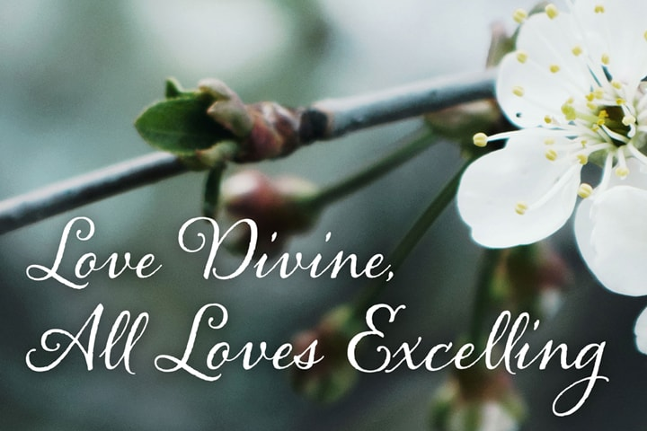
Love divine, all loves excelling
joy of heaven, to earth come down,
fix in us thy humble dwelling,
all thy faithful mercies crown:
Jesus, thou art all compassion,
pure unbounded love thou art;
visit us with thy salvation,
enter every trembling heart.
Come, almighty to deliver,
let us all thy life receive;
suddenly return and never,
never more thy temples leave:
thee we would be always blessing,
serve thee as thy hosts above,
pray and praise thee without ceasing,
glory in thy perfect love.
Finish then thy new creation,
pure and spotless let us be,
let us see thy great salvation,
perfectly restored in thee:
changed from glory into glory,
till in heaven we take our place,
till we cast our crowns before thee,
lost in wonder, love and praise.
Charles Wesley 1707-88 alt.
YouTube version from Westminster Abbey here https://www.youtube.com/watch?v=0gvCODgV1fc
prayer
Creator God,
through the timelessness of creation
through the wonder of the night sky
through the fresh blades of grass after spring rain
through the mighty gums and flowering wattles
through tiny rock pools and flowing rivers
We see your glory and honour your name.
Gracious and loving Lord,
We confess that so often we are not the people you would have us be.
We can be so involved with our personal pursuits that we tend to neglect the greater good.
We are too vocal on some issues, and remain silent on others when we should speak out.
Please forgive our weaknesses, and help us be the people you wish us to be.
In Christ's name we pray. Amen.
ASSURANCE OF FORGIVENESS
If we confess our sins, God is faithful and just, and will forgive our sins and cleanse us from all unrighteousness. Hear again the words of grace offered by Jesus Christ: “Your sins are forgiven.”
Thanks be to God.
BIBLE READINGS
Genesis 1:26-28, 31
Then God said, ‘Let us make humankind in our image, according to our likeness; and let them have dominion over the fish of the sea, and over the birds of the air, and over the cattle, and over all the wild animals of the earth, and over every creeping thing that creeps upon the earth.’
So God created humankind in his image,
in the image of God he created them;
male and female he created them.
God blessed them, and God said to them, ‘Be fruitful and multiply …’
And it was so. God saw everything that he had made, and indeed, it was very good.
Psalm 96:1-10 (NIV)
Sing to the Lord a new song;
sing to the Lord, all the earth.
Sing to the Lord, praise his name;
proclaim his salvation day after day.
Declare his glory among the nations,
his marvellous deeds among all peoples.
For great is the Lord and most worthy of praise;
he is to be feared above all gods.
For all the gods of the nations are idols,
but the Lord made the heavens.
Splendour and majesty are before him;
strength and glory are in his sanctuary.
Ascribe to the Lord, all you families of nations,
ascribe to the Lord glory and strength.
Ascribe to the Lord the glory due to his name;
bring an offering and come into his courts.
Worship the Lord in the splendour of his holiness;
tremble before him, all the earth.
Say among the nations, ‘The Lord reigns.’
Matthew 22:15-22
Then the Pharisees went and plotted to entrap him in what he said. So they sent their disciples to him, along with the Herodians, saying, ‘Teacher, we know that you are sincere, and teach the way of God in accordance with truth, and show deference to no one; for you do not regard people with partiality. Tell us, then, what you think. Is it lawful to pay taxes to the Emperor, or not?’ But Jesus, aware of their malice, said, ‘Why are you putting me to the test, you hypocrites? Show me the coin used for the tax.’ And they brought him a denarius. Then he said to them, ‘Whose head is this, and whose title?’ They answered, ‘The Emperor’s.’ Then he said to them, ‘Give therefore to the Emperor the things that are the Emperor’s, and to God the things that are God’s.’ When they heard this, they were amazed; and they left him and went away.
REFLECTION
Our Gospel reading today seems highly relevant after the Federal Government handed down its Budget last week. A key part of the Budget was promising personal tax cuts, usually a welcome move. The Budget also promised what amounts to business tax cuts for new equipment purchased, along with other incentives for business to hire new – and especially – younger people, also a welcome move (if it doesn’t mean that older workers lose their jobs). As is usual following the Budget, there was analysis of ‘winners’ and ‘losers’. According to the media commentators, the biggest winners from the Budget were those on higher taxable incomes and also business. Losers apparently included women, university students and staff, students and workers from overseas, the unemployed, refugees and people working in hospitality, the arts, retail or tourism – some of the areas hardest hit by Covid19 restrictions. We will come back to these lists a little later.
The Gospel reading continues Jesus’ teaching in Jerusalem in the week leading up to his arrest and passion. His opponents are becoming bolder and are trying to trap him into saying or doing something that will be cause to hand him over to the Roman authorities or else turn the people against him. The question posed in today’s reading is a devious Catch-22 type question: is it lawful to pay taxes to Caesar or not? If Jesus answers ‘no’, then he can be handed over to the Romans as someone inciting revolt against Rome. But if Jesus answers ‘yes’, then he will lose face with most of the people who detested this aspect of Roman rule.
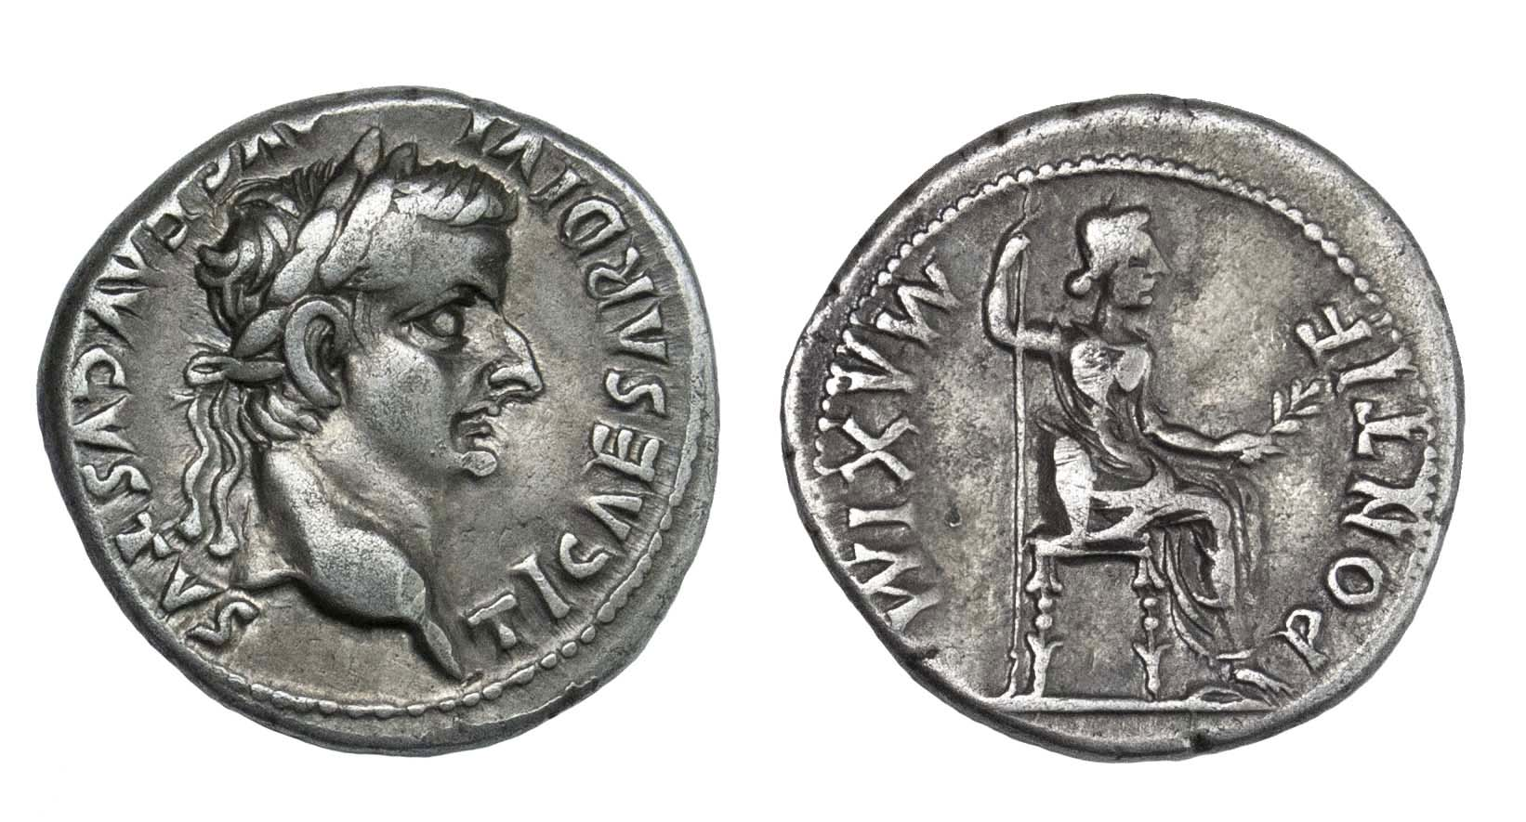
Jesus’ response is both wise and challenging. He asks his opponents to bring a coin that was used to pay the tax and asks whose image is on the coin. Clearly it is Caesar’s image and inscription (Tiberius Caesar, divine son of Augustus) and so Jesus suggests that both the coin and the payment of the tax belong to the realm of Caesar and should be treated accordingly, thus giving grudging approval to payment of this oppressive tax. But he then challenges his hearers to give to God what rightly belongs in the realm of God. For any Jewish hearer, this implies giving everything to God – including how we spend our money and payment of legitimate taxes – for God was considered the Creator and Sustainer of every aspect of life.
While the coin carries the image of Caesar, people carry the image of God according to the reading from Genesis. Hence if we are to honour God in how we live, we will not only worship God but also honour people who are made in the image of God. This recalls Jesus’ summary of the Jewish Law that the two most important commandments are to love God and love our neighbour as ourselves, which will be the focus of next week’s Gospel reading. These commandments, Jesus suggests, are rather more important – and even more challenging and demanding – than questions about paying taxes to Caesar.
Which brings us back to our government’s Budget. While the cuts to personal and business taxes are no doubt welcome, I wonder about neglecting those people struggling the most. In a few weeks’ time, we will consider Jesus’ parable about the sheep and the goats, where we are encouraged to offer help to the poorest and the least. As I look at the lists compiled of winners and losers from the Budget, it’s hard not to think that our government’s priorities do not line up with Jesus' priorities. It is further evidence of the truth and challenge of Jesus’ response in today’s reading – to pay to Caesar what belongs to Caesar but to give to God what belongs to God – including our worship, our love for neighbour and our commitment to care for the last and the least.

HYMN TiS 686 Because we bear your name
Lord Jesus, we belong to you,
you live in us, we live in you;
we live and work for you —
because we bear your name.
Help us receive each other, Lord,
for you receive the least of us
and come to us in them —
because we bear your name.
Bless those who give us any gift,
because they know that we are yours;
reward them with your grace —
because we bear your name.
Let us acknowledge those as friends
who use your name to right a wrong
but have not joined us yet —
because we bear your name.
Let nothing that we do or say
offend the weak so that they fall
and lose their faith in you —
because we bear your name.
Keep us from missing out on life;
give hands that help, and single sight,
and feet that walk your way —
because we bear your name.
You are the salt that cleanses us,
so clean us out, and make us fit
for common life with you —
because we bear your name.
Words © John Wilfred Kleinig 1942– Music © Robin Mann 1949–
YouTube version here https://www.youtube.com/watch?v=FGCoJy5fwFQ
PRAYERS OF THE PEOPLE
Creator God,
We pray for the peoples of the world:
for the millions of people suffering from coronavirus,
for those crushed by oppression,
for those going hungry because of famine.
We pray also for those working for a more just, caring and safer world.
Gracious God, in your mercy, hear our prayer.
Redeemer God,
We pray for your people throughout the world:
for those in our midst who provide food for the hungry and care for the homeless,
for those who help children at risk and who look after the aged.
We pray for all those who spend their lives in doing your will.
Gracious God, in your mercy, hear our prayer.
Compassionate God,
We pray for those in need of your tender comfort and healing:
for those sick in mind or body or spirit,
for those struggling with anxiety or unemployment,
for those known to us whom you have placed on our hearts today …
Gracious God, in your mercy, hear our prayer.
Wise God,
We give you thanks for sending Jesus,
for his message that both comforts and challenges us,
and who taught his followers to pray, saying: Our Father in heaven …
BENEDICTION
Go on your journey refreshed and encouraged,
strengthened and inspired.
May you feel the presence of Christ walking with you
and may you reflect his love in all that you say and do.
We go in peace to love and serve the Lord. Amen.
SENDING SONG TiS 779 May the feet of God walk with you
May the feet of God walk with you,
and God’s hand hold you tight.
May the eye of God rest on you,
and God’s ear hear your cry.
May the smile of God be for you,
and God’s breath give you life.
May the Child of God grow in you,
and God’s love bring you home.
Words © Aubrey Podlich 1946– Music © Robin Mann
YouTube version from Adelaide see https://www.youtube.com/watch?v=OJ6RaKX4_I4&t=12s

