worship@home resources for 4 October
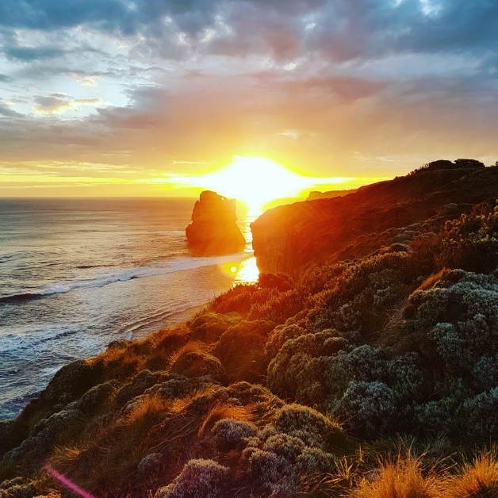
Call to Worship
O God, you summon the day to dawn;
you teach the morning to waken the earth.
Great is your name, great is your love.
For you the valleys will sing for joy,
the trees of the field will clap their hands.
Great is your name, great is your love.
Your love and justice shall last forever,
fresh as the morning, sure as the sunrise.
Great is your name, great is your love.
ACKNOWLEDGEMENT OF COUNTRY
For thousands of years, indigenous people have walked this land, on their own country.
Their relationship with the land is at the centre of their lives.
We acknowledge the Wurundjeri people of the Kulin nation
and their stewardship of this land throughout the ages.
We pay our respects to their elders and leaders, past, present and emerging,
and pray for the future of their communities.
May we all walk gently together and respectfully on this land,
seeking justice and reconciliation.
HYMN TiS 156 Morning has broken
Morning has broken like the first morning;
blackbird has spoken like the first bird.
Praise for the singing, praise for the morning,
praise for them springing fresh from the word
Sweet the rain's new fall, sunlit from heaven,
like the first dew fall on the first grass.
Praise for the sweetness of the wet garden,
sprung in completeness where his feet pass.
Mine is the sunlight; mine is the morning
born of the one light Eden saw play.
Praise with elation, praise every morning,
God's recreation of the new day.
Eleanor Farjeon 1881-1965.
For YouTube version see https://www.youtube.com/watch?v=h5D3LEjGF8A

prayer
Faithful God,
you have led your people through the generations,
sheltering us in your shadow.
You are generous to all who call upon you,
bringing life to all who follow you.
We praise and adore you.
Living God,
be with us today.
Draw close through your Holy Spirit
that we might dwell in Christ.
Gracious God,
we confess that we have sinned against you in thought, word and action.
You have given us love,
but we have often returned apathy;
you have given us neighbours,
yet we have often become self-centred;
you have given us a world to enjoy,
but we have spoiled our home.
Forgive us for the wrong things we have done,
and for the good things we have failed to do. Amen.
ASSURANCE OF FORGIVENESS
God is love.
Through Christ our sins are forgiven.
Take hold of this forgiveness
and live in the power of the Holy Spirit.
BIBLE READINGS
Psalm 19:1-7, 14
The heavens declare the glory of God;
the skies proclaim the work of his hands.
Day after day they pour forth speech;
night after night they reveal knowledge.
They have no speech, they use no words;
no sound is heard from them.
Yet their voice goes out into all the earth,
their words to the ends of the world.
In the heavens God has pitched a tent for the sun.
It is like a bridegroom coming out of his chamber,
like a champion rejoicing to run his course.
It rises at one end of the heavens
and makes its circuit to the other;
nothing is deprived of its warmth.
The law of the Lord is perfect,
refreshing the soul.
The statutes of the Lord are trustworthy,
making wise the simple.
May these words of my mouth and this meditation of my heart
be pleasing in your sight,
Lord, my Rock and my Redeemer.
Philippians 3:4b-14
If anyone else has reason to be confident in the flesh, I have more: circumcised on the eighth day, a member of the people of Israel, of the tribe of Benjamin, a Hebrew born of Hebrews; as to the law, a Pharisee; as to zeal, a persecutor of the church; as to righteousness under the law, blameless.
Yet whatever gains I had, these I have come to regard as loss because of Christ. More than that, I regard everything as loss because of the surpassing value of knowing Christ Jesus my Lord. For his sake I have suffered the loss of all things, and I regard them as rubbish, in order that I may gain Christ and be found in him, not having a righteousness of my own that comes from the law, but one that comes through faith in Christ, the righteousness from God based on faith. I want to know Christ and the power of his resurrection and the sharing of his sufferings by becoming like him in his death, if somehow I may attain the resurrection from the dead.
Not that I have already obtained this or have already reached the goal; but I press on to make it my own, because Christ Jesus has made me his own. Beloved, I do not consider that I have made it my own; but this one thing I do: forgetting what lies behind and straining forward to what lies ahead, I press on towards the goal for the prize of the heavenly call of God in Christ Jesus.
Matthew 21:33-46
‘Listen to another parable. There was a landowner who planted a vineyard, put a fence around it, dug a wine press in it, and built a watch-tower. Then he leased it to tenants and went to another country. When the harvest time had come, he sent his slaves to the tenants to collect his produce. But the tenants seized his slaves and beat one, killed another, and stoned another. Again he sent other slaves, more than the first; and they treated them in the same way. Finally he sent his son to them, saying, “They will respect my son.” But when the tenants saw the son, they said to themselves, “This is the heir; come, let us kill him and get his inheritance.” So they seized him, threw him out of the vineyard, and killed him. Now when the owner of the vineyard comes, what will he do to those tenants?’ They said to him, ‘He will put those wretches to a miserable death, and lease the vineyard to other tenants who will give him the produce at the harvest time.’
Jesus said to them, ‘Have you never read in the Scriptures:
“The stone that the builders rejected has become the cornerstone;
this was the Lord’s doing, and it is amazing in our eyes”?
Therefore I tell you, the kingdom of God will be taken away from you and given to a people that produces the fruits of the kingdom. The one who falls on this stone will be broken to pieces; and it will crush anyone on whom it falls.’
When the chief priests and the Pharisees heard his parables, they realised that he was speaking about them. They wanted to arrest him, but they feared the crowds, because they regarded him as a prophet.
REFLECTION
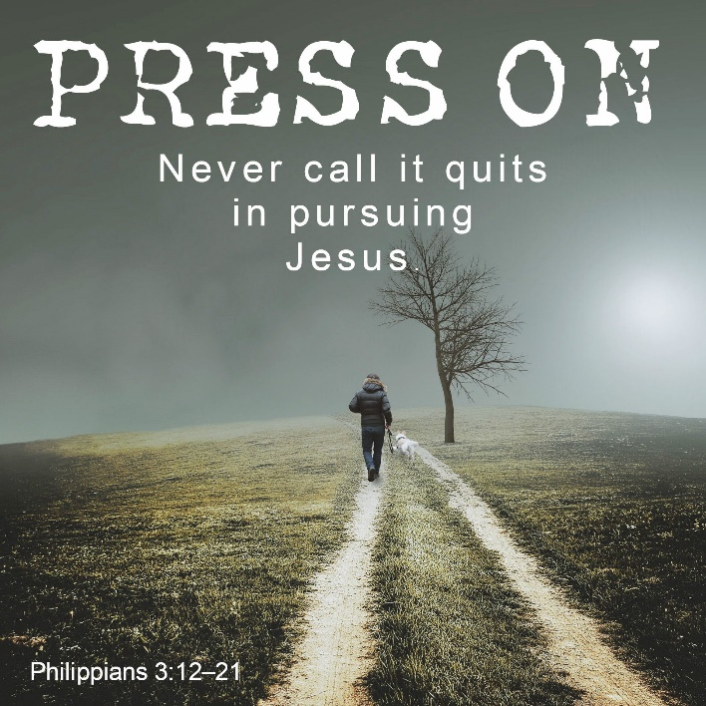
The psalm continues the thread from the season of creation, reminding us that the heavens – the skies and sun and stars – just as much as the land point to God as Creator. They do not speak in words, yet their presence and glory speak everywhere in every nation of God’s goodness and power. Likewise, God’s law or torah refreshes our soul and guides us into right living. The response of the psalmist is to beseech God that his life – his speaking and his reflecting – would be pleasing in God’s sight. Note that God is present in many ways in the world. In this psalm, God is Creator, is a place of sanctuary (a Rock) and is the one who redeems God’s people (Redeemer).
The reading from Philippians contains a rare insight into the faith journey of the apostle Paul. Here he recounts the blessings of being born and growing up as a Jew. He was born into privilege, we might say, having a place among God’s people and zealously striving to follow God’s ways. Yet following torah does not lead Paul into a personal relationship with God. For him, his previous world and his previous life have been turned upside down by Jesus Christ, whom he now knows intimately. So faith for Paul is about relationship first and foremost – relationship with God through Christ. This relationship – like any other human relationship – needs attention and effort on Paul’s part. Faith is a journey – for Paul and for all of us. Paul has not reached the goal, but presses onward with all his energy and focus. Paul’s example is inspiring but also challenging. Do we seek Christ above all, and seek to know Christ intimately?
In the Gospel reading, Jesus has reached Jerusalem and is engaged in fierce debate with his various opponents. Today’s reading comes in the aftermath of Jesus clearing the temple of the money-changers and his direct challenge to the chief priests. They are not honouring God in the way they operate the temple and control people’s worship. This direct challenge will ultimately lead to their plot to arrest and eliminate Jesus.
The parable Jesus tells is a thinly veiled warning to these Jewish leaders that God is looking for fruit – for people who honour God’s ways and who will live as a light to the nations. They may succeed in killing Jesus (the son in the parable), but God will give the vineyard over to other tenants (presumably in Matthew’s eyes the emerging church community of Jew and Gentile). These new tenants, however, are tasked with the same responsibility as the earlier tenants, namely to produce fruit that reflects God’s character and God’s mission in the world.
What might we take from these readings? The psalm calls for praise and humility. The letter from Paul reminds us of the importance of relationship, especially with Jesus who lies at the heart of our faith. The Gospel reminds us of the sort of life that God is looking for among God’s people – living in such a way that others will see the character of God in how we live and interact with others.
HYMN TiS 547 Be thou my vision
Be thou my vision, O Lord of my heart,
naught be all else to me, save that thou art
thou my best thought, by day or by night,
waking or sleeping, thy presence my light.
Be thou my wisdom, be thou my true word;
I ever with thee and thou with me, Lord;
thou my great Father, thy child let me be;
thou in me dwelling, and I one with thee.
Riches I scorn and the world’s empty praise,
thou my inheritance, now and always;
thou and thou only the first in my heart;
high King of heaven, my treasure thou art.
High King of heaven, after victory won,
may I reach heaven's joys, O bright Heaven's Sun!
Heart of my own heart, whatever befall,
still be my vision, O ruler of all.
Gaelic 8th cent. tr. Mary E. Byrne 1880-1931. Versified by Eleanor H. Hull 1860-1935 alt.
YouTube version here https://www.youtube.com/watch?v=6CMclLT_Hjg
PRAYERS OF THE PEOPLE
Where the hungry go unfed, while the privileged gorge themselves;
where the poor go begging while the rich amass greater fortunes;
where tyrants have bitten the dust but their successors prove no better,
God of justice, show yourself.
Where the prisoner is not prepared for freedom
and the refugee is not accorded dignity;
where those who are disadvantaged are excluded
and those who are disabled are left on the margins;
where gender, race or religion are grounds for suspicion,
or confer unmerited privilege,
God of justice, show yourself.
To those who speak for the voiceless and defend the persecuted,
to those who protest for a fairer world and practise simpler living,
to those who share their faith in Jesus in places where faith is suspected,
God of justice, show yourself.
And to us, that we might serve and love you
with body, soul and mind,
God of justice, show yourself.
God, hear our prayer
and make us willing agents of your gracious purposes,
in Jesus’ name, who taught his followers to pray, saying:
Our Father in heaven …
BENEDICTION
From where we are to where you need us,
Jesus, lead us on.
From the familiarity of what we know
to the wonder of what you will reveal,
Jesus, lead us on.
To transform the fabric of this world
until it resembles the shape of your kingdom,
Jesus, lead us on.
Because good things have been prepared
for those who love God,
Jesus, lead us on.
SENDING SONG TiS 782 Go now in peace
Go now in peace, go now in peace,
may the love of God surround you everywhere,
everywhere you may go.
Words and music © Natalie Sleeth 1930-92. Used with permission.
For YouTube version see https://www.youtube.com/watch?v=oRW1E0FzXek

