worship@home resources for 27 September

Call to Worship
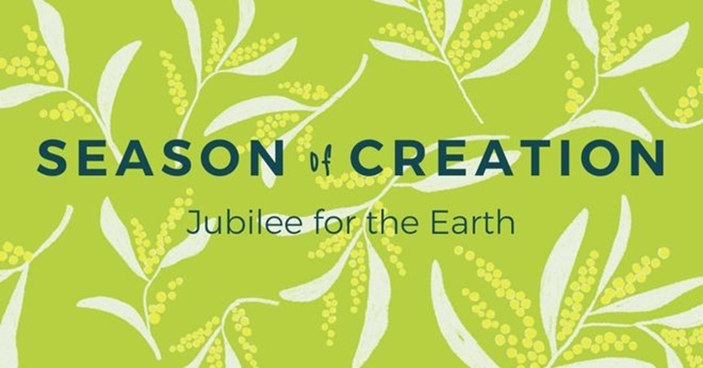
Holy! Holy! Holy!
The whole earth is filled with God’s glory!
Be still and feel the presence of God,
the presence pulsing through the earth.
Be still and hear the Spirit of God,
the Spirit bringing life throughout the earth.
Be still and behold the glory of God,
the glory that is filling the earth.
HYMN TiS 188 Where wide sky rolls down
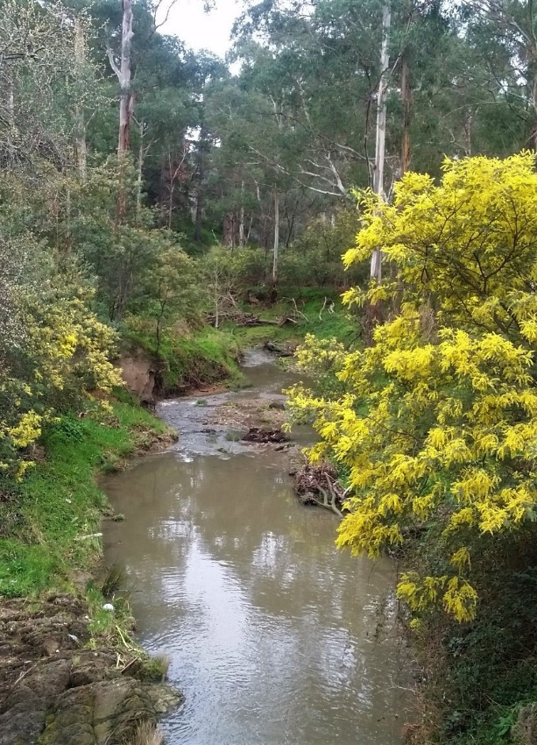
Where wide sky rolls down and touches red sand,
where sun turns to gold the grass of the land,
let spinifex, mulga and waterhole tell
their joy in the One who made everything well.
Where rain-forest calm meets reef, tide and storm,
where green things grow lush and oceans are warm,
let every sea-creature and tropical bird
exult in the light of the life-giving Word.
Where red gum and creek cross hillside and plain,
where cool tree-ferns rise to welcome the rain,
let bushland, farm, mountain-top, all of their days
delight in the Spirit who formed them for praise.
Now, people of faith, come gather around
with songs to be shared, for blessings abound!
Australians, whatever your culture or race,
come, lift up your hearts to the Giver of grace.
Words © Elizabeth J. Smith 1956-.
For YouTube version see https://www.youtube.com/watch?v=eFX7VBH_2ZQ&t=3s
prayer (by Deidre Palmer, UCA President)
Creator God,
you move across our world, bringing light, new life and hope.
We give you thanks for the beauty of your creation,
the intricate and interconnected web of life.
We give you thanks for the sacred earth, the air and water,
for the oceans that teem with life,
for the rain that refreshes and sustains life,
for the water that we drink that maintains life.
Christ Jesus, you come to bring renewal and reconciliation to the whole of creation.
We pray for all those places, creatures and plants, that are suffering,
as humans exploit your earth and its resources.
Forgive us for the destruction we have caused.
Guide us into the way of respect and care for the earth and all living things.
We pray that you will renew our resolve to participate with you
in the healing and renewal of our earth.
May your Holy Spirit strengthen us with courage,
to be bearers of your creative and life-giving presence in all the earth.
Amen.
RESPONSE
Just as the people of Jesus’ day came to the Jordan River to repent
so Jesus hears our call and forgives our sin.
Teach us to love the earth and to care for its creatures.
COMMISSIOING OF ELDERS AT CROYDON
There are diverse gifts:
but it is the same Spirit who gives them.
There are different ways of serving God:
but it is the same Lord who is served.
God works through people in different ways:
but it is the same God whose purpose is achieved through them all.
Each one of us is given a gift by the Spirit:
and there is no gift without its corresponding service.
There is one ministry of Christ:
and in this ministry we all share.
Together we are the body of Christ:
and individually members of it.
Will you, the members of this congregation,
accept these brothers and sisters as Elders and Leaders?
We will.
Will you encourage them in love and support them in their ministry,
serving with them the one Lord Jesus Christ?
We will.

BIBLE READINGS
Genesis 9:12-17 (NIV)
God said, ‘This is the sign of the covenant I am making between me and you and every living creature with you, a covenant for all generations to come: I have set my rainbow in the clouds, and it will be the sign of the covenant between me and the earth. Whenever I bring clouds over the earth and the rainbow appears in the clouds, I will remember my covenant between me and you and all living creatures of every kind. Never again will the waters become a flood to destroy all life. Whenever the rainbow appears in the clouds, I will see it and remember the everlasting covenant between God and all living creatures of every kind on the earth.’ So God said to Noah, ‘This is the sign of the covenant I have established between me and all life on the earth.’
Psalm 104:5-13
You set the earth on its foundations,
so that it shall never be shaken.
You cover it with the deep as with a garment;
the waters stood above the mountains.
At your rebuke they flee;
at the sound of your thunder they take to flight.
They rose up to the mountains, ran down to the valleys
to the place that you appointed for them.
You set a boundary that they may not pass,
so that they might not again cover the earth.
You make springs gush forth in the valleys;
they flow between the hills,
giving drink to every wild animal;
the wild asses quench their thirst.
By the streams the birds of the air have their habitation;
they sing among the branches.
From your lofty abode you water the mountains;
the earth is satisfied with the fruit of your work.
John 4:7-15
When a Samaritan woman came to draw water, Jesus said to her, “Will you give me a drink?” (His disciples had gone into the town to buy food.) The Samaritan woman said to him, “You are a Jew and I am a Samaritan woman. How can you ask me for a drink?” (For Jews do not associate with Samaritans.) Jesus answered her, “If you knew the gift of God and who it is that asks you for a drink, you would have asked him and he would have given you living water.” “Sir,” the woman said, “you have nothing to draw with and the well is deep. Where can you get this living water? Are you greater than our father Jacob, who gave us the well and drank from it himself, as did also his sons and his livestock?” Jesus answered, “Everyone who drinks this water will be thirsty again, but whoever drinks the water I give them will never thirst. Indeed, the water I give them will become in them a spring of water welling up to eternal life.” The woman said to him, “Sir, give me this water so that I won’t get thirsty and have to keep coming here to draw water.”

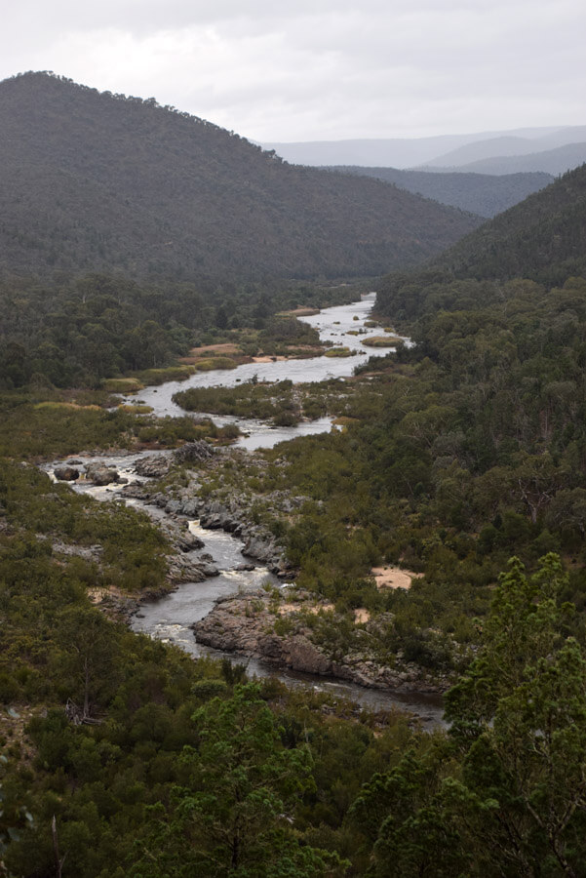
REFLECTION
Life on our planet relies on water. In the second of the creation accounts in Genesis 2, God makes streams and springs that water the earth and a life-giving river flows out of the garden of Eden. These streams and rivers support the plants and trees that grown in the garden and which in turn support the diversity of creatures that God has made. Despite the symbolism of the account it is clear that the streams and rivers support life. They are like the arteries of the earth carrying water across the land, providing life wherever they flow.
Too much rainfall, however, can result in rivers bursting their banks and causing flooding and destruction that kills life. Following the description of the great flood in Genesis 6-9, God makes a covenant with humanity never to flood the whole earth again. The sign of this covenant is the rainbow, a sign of promise and sign of peace. More recently the rainbow has been used as a symbol of diversity – with South Africa declaring itself the rainbow nation and the LGBTIQ community using the rainbow flag to celebrate its diversity.
When it doesn’t rain, the land suffers drought and life is again threatened. Living in an arid climate, God’s people Israel knew all about drought. In Amos, the prophet rebukes the people for their neglect of the poor and for failing to repent when God sends drought on the land. Amos instead calls on the people to let justice roll down like rivers and righteousness like a never-failing stream. Again the river is used as a symbol of life, this time a life that reflects the just character of God, who sends rain upon the rich and the poor without discrimination.
In John’s Gospel, Jesus speaks to the woman at the well about living water that gushes forth in a believer’s heart leading to eternal life. This water is the indwelling Holy Spirit. Anyone who drinks this water will never be thirsty, for they will know the presence of God flowing inside their very being like a river, bringing spiritual life (see also John 7:37-39).
In a dry continent like Australia, rivers play a significant role in bringing life to communities. For indigenous people, the rivers provided food in the form of fish and eels and nesting spaces for many birds. For later European settlers, rivers provided water for stock and later for irrigation. Yet like so much else in the natural environment we have polluted our rivers and changed their normal flow patterns. Water provides life but water also provides profits for farmers.
The competition for water is illustrated in the dire situation of the Murray-Darling river system. There are competing demands for water between irrigators, towns and the river itself and the creatures who live in it and who depend upon it. Water licenses granted to farmers by governments lead to greed, power, corruption, fights … and of course politics!
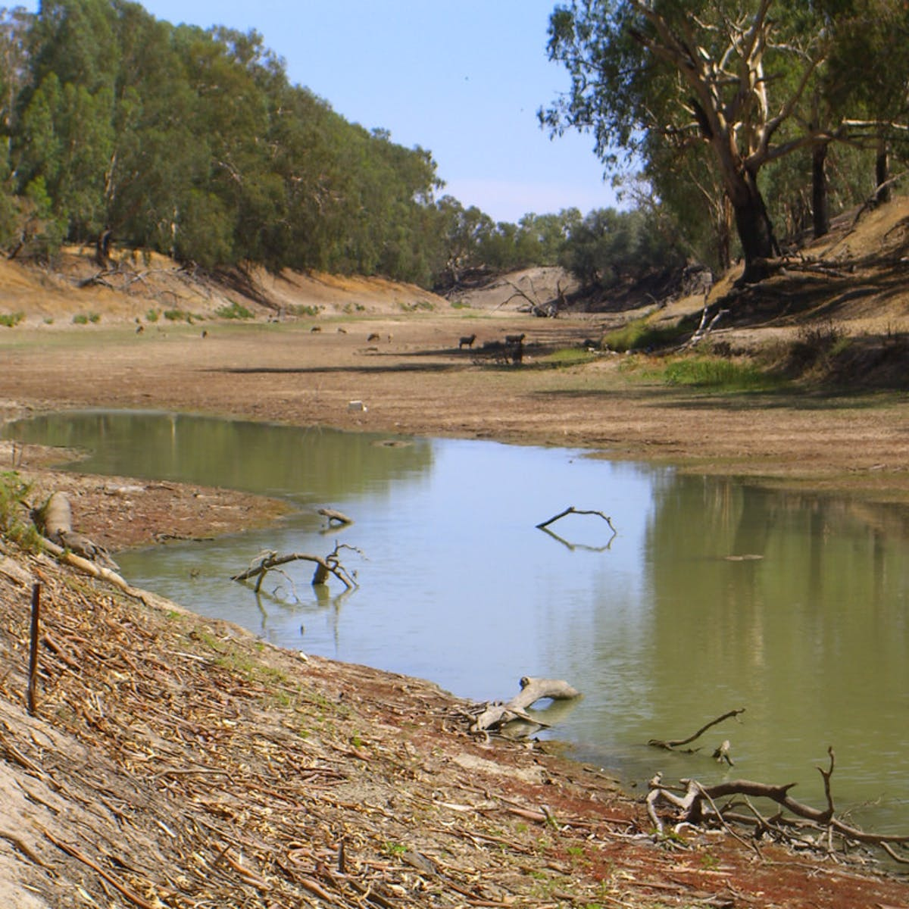
Farmers build levee banks and dams to keep as much of the water for themselves as possible to grow crops inappropriate to the arid inland area of Australia such as cotton, while the river itself and communities downstream miss out. In 2019 the Darling River stopped flowing altogether resulting in the death of millions of fish. Everyone wants more water and yet with climate change and prolonged droughts there is less to go around. The rivers that God designed to bring life instead bring death. What have we done? We urgently need to repent of our greed and to seek environmental justice for our rivers.

HYMN TiS 668 Touch the earth lightly
Touch the earth lightly,
use the earth gently,
nourish the life of the world in our care:
gift of great wonder,
ours to surrender,
trust for the children tomorrow will bear.
We who endanger,
who create hunger,
agents of death for all creatures that live,
we who would foster
clouds of disaster,
God of our planet, forestall and forgive!
Let there be greening,
birth from the burning,
water that blesses and air that is sweet,
health in God's garden,
hope in God's children,
regeneration that peace will complete.
God of all living,
God of all loving,
God of the seedling, the snow and the sun,
teach us, deflect us,
Christ reconnect us,
using us gently and making us one.
Words Shirley Erena Murray. Music Colin Gibson © 1992 Hope Publishing Co. Used with permission.
For Youtube version see https://www.youtube.com/watch?v=-js8Ko2qU1I
PRAYERS OF THE PEOPLE
God, you are our source of life,
you offer us your love and healing
so that we may help to repair our broken world.
Renew our relationships with you and all your creation.
Disturb us from our complacency so that we can become agents of healing.
Teach us to care for creation.
Jesus Christ, teach us to empathise with the earth.
Make our spirits sensitive to the cries of creation,
cries for justice from the hills and the trees.
Make our faith sensitive to the groans of the Spirit,
groans from the deserts, the forests and the rivers.
Make our souls sensitive to the songs of our fellow creatures,
songs of celebration from the sea, the land and the air.
Teach us to care for creation.
Holy Spirit, our comforter and healer,
hear the prayers that we bring today for our community.
We pray for those in pain and those suffering alone,
for those who care for them and for essential workers.
and for our political leaders making difficult decisions.
We pause now to name before you those you have placed on our hearts today …
Help us to live into your promise of new life
as we pray the prayer that Jesus taught us, saying ‘Our Father in heaven … ‘
BENEDICTION
God cares for us as God also cares for all of creation.
Just as water flows endlessly from the river of life,
go out and spread God’s love to the whole of creation.
We go in peace to serve Christ and care for the earth.
SENDING SONG Scatter us Lord Jesus Christ
Scatter us Lord Jesus Christ, you know where we’re going.
Use our gifts so that we may share life overflowing.
Heal us, bless us now, our Lord, in your name we’re going.
Be our comfort and our strength, share life overflowing.
Holy Spirit, go with us, in your joy we’re growing.
Be our light, our love, our hope, be life overflowing.
Words and music © 2012 Beatrice Panne. Used with permission.

