worship@home resources for 20 September
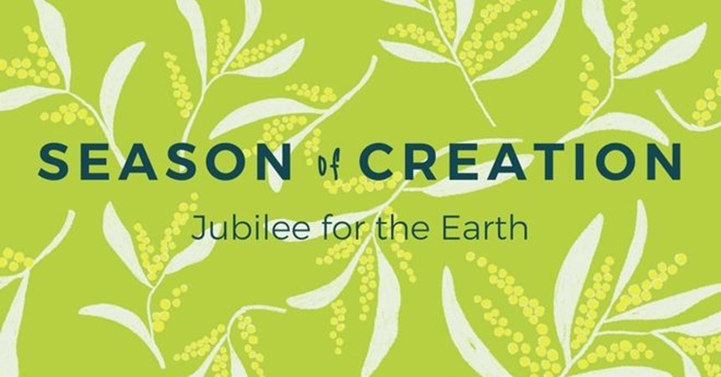
Call to Worship
Holy! Holy! Holy!
The whole earth is filled with God’s glory
Be still and feel the presence of God
Be still and hear the Spirit of God
Be still and behold the glory of God
HYMN O God, you search me and you know me
O God, you search me, and you know me.
All my thoughts lie open to your gaze.
When I walk or lie down you are before me:
ever the maker and keeper of my days.
You know my resting and my rising.
You discern my purpose from afar,
and with love everlasting you besiege me:
in every moment of life or death, you are.
Before a word is on my tongue, Lord,
you have known its meaning through and through.
You are with me beyond my understanding:
God of my present, my past and future, too.
Although your Spirit is upon me,
still I search for shelter from your light.
There is nowhere on earth I can escape you:
even the darkness is radiant in your sight.
For you created me and shaped me,
gave me life within my mother's womb.
For the wonder of who I am, I praise you:
safe in your hands, all creation is made new.
Words and music © Bernadette Farrell (1957–). All rights reserved. Used with permission.
For YouTube version with images from NZ see https://www.youtube.com/watch?v=mEGc3_D19Vo
prayer
Creator God,
We praise you for the wild and untamed places on earth,
the worlds of great wonder and mystery,
and for the dreaming of the indigenous peoples of this land.
Lift our spirits to rejoice with the ghost gums and animals of the wilderness.

God, our Maker,
whose glory fills our planet,
help us to discern your vibrant presence among us
and among the rocks, the deserts and the wide spaces of the outback.
Help us empathise with your creatures who are suffering.
Compassionate God,
We are sorry for polluting the desert with radioactive waste.
We are sorry for desecrating sacred sites in the outback.
We are sorry for destroying the habitat of wild creatures.
RESPONSE
Christ hears our prayer and forgives us our sins.
Teach us to love and care for the whole earth.
BIBLE READINGS
Exodus 15:22-24, 16:1-3, 17:1-3 (The Message)
Moses led Israel from the Red Sea on to the wilderness of Shur. They travelled for three days through the wilderness without finding any water. They got to Marah, but they couldn’t drink the water at Marah; it was bitter. That’s why they called the place Marah (bitter). And the people complained to Moses, “So what are we supposed to drink?” …
On the fifteenth day of the second month after they had left Egypt, the whole company of Israel moved on from Elim to the wilderness of Sin which is between Elim and Sinai. The whole company of Israel complained against Moses and Aaron there in the wilderness. The Israelites said, “Why didn’t God let us die in comfort in Egypt where we had lamb stew and all the bread we could eat? You’ve brought us out into this wilderness to starve us to death, the whole company of Israel!” …
Directed by God, the whole company of Israel moved on by stages from the wilderness of Sin. They set camp at Rephidim. And there wasn’t a drop of water for the people to drink. The people took Moses to task: “Give us water to drink.” But Moses said, “Why pester me? Why are you testing God?” But the people were thirsty for water there. They complained to Moses, “Why did you take us from Egypt and drag us out here with our children and animals to die of thirst?”
Psalm 63:1-7 (A Psalm of David, when he was in the wilderness of Judah)
O God, you are my God, I seek you,
my soul thirsts for you;
my flesh faints for you,
as in a dry and weary land where there is no water.
So I have looked upon you in the sanctuary,
beholding your power and glory.
Because your steadfast love is better than life,
my lips will praise you.
So I will bless you as long as I live;
I will lift up my hands and call on your name.
My soul is satisfied as with a rich feast,
and my mouth praises you with joyful lips
when I think of you on my bed,
and meditate on you in the watches of the night;
for you have been my help,
and in the shadow of your wings I sing for joy.
Isaiah 43:18-21 (NIV)
‘Forget the former things;
do not dwell on the past.
See, I am doing a new thing!
Now it springs up; do you not perceive it?
I am making a way in the wilderness
and streams in the wasteland.
The wild animals honour me,
the jackals and the owls,
because I provide water in the wilderness
and streams in the wasteland,
to give drink to my people, my chosen,
the people I formed for myself
that they may proclaim my praise.’
REFLECTION
In our day and culture, we regard the wilderness as a place of beauty to protect and to explore, a place to go for a holiday – perhaps even for a glamping experience (glamour camping) – before returning to our comfortable existence in the city. As for the outback, we may harbour a romantic perception inspired by the writings of John Flynn. In reality the outback is a harsh environment populated by cattle graziers, miners and indigenous people – along with large feral populations of camels, foxes, cats, rabbits and cane toads.
In the Bible, the wilderness or midbah had other connotations. It was a place uninhabited by people where there was no food or water. Hence it was a dangerous place for humans to venture into, a place to cross over to get somewhere else, a place of extreme vulnerability.
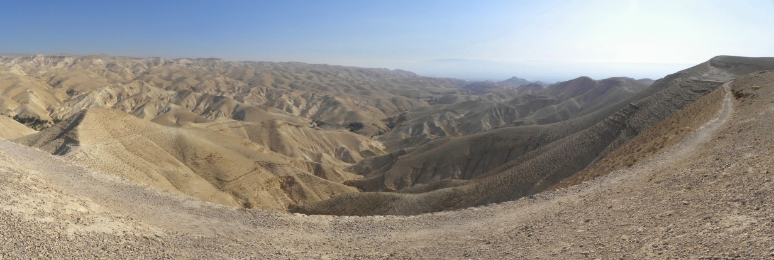
One reason a person might go into the wilderness was in order to escape persecution. We might think of Moses fleeing from Pharaoh after he had killed an Egyptian (Exodus 2:12-15) or David fleeing from King Saul, which provides the context for the psalm we read above. Others were driven into the wilderness against their will. We might think of Abraham’s servant Hagar and her son Ishmael, who are banished into the wilderness with the expectation that they will die of thirst. We might also think of Elijah who encounters God in the wilderness, or Jesus, driven into the wilderness by God’s Spirit for a time of testing. In each case God provides.
The most formative experience of wilderness occurs during the Exodus when the Israelites escape from Pharaoh’s army through the Reed Sea and are then thrust into the wilderness. They are soon confronted with the danger of the place – no food and no water – and they complain bitterly to Moses, as in the passages above. They are saved through divine provision of manna and quails and water. Later, at Mt Sinai, Moses receives the Law and the people learn about true worship of Yahweh. And so the wilderness for the Israelites is a place of encounter with God, a place of testing and also a place of transformation as their worldview is changed from that of slaves to that of being God’s chosen people.
When the Israelites are later taken into exile in Babylon, the wilderness again features. It is a geographical, psychological and theological barrier that stops them from wanting to return to Jerusalem. The people complain that Yahweh has abandoned them. Yet in several prophecies in Isaiah, such as the one above, Yahweh promises to transform the wilderness by providing streams in the desert and water for the people to drink. Hence the exiles are invited to re-imagine the wilderness and embark on a new Exodus journey back to Jerusalem.
In Australia, European settlers saw the wilderness in a similar way to many of the biblical references – as a dangerous and empty place, a place of fear and death, and, eventually, as a place to be tamed. By contrast, indigenous people who live in these outback places view it as their home, as a place of life if one has the necessary knowledge and skill to find water and food. For them it is also a deeply spiritual place with close connection to the Creator Spirit of God, and a place to care for.
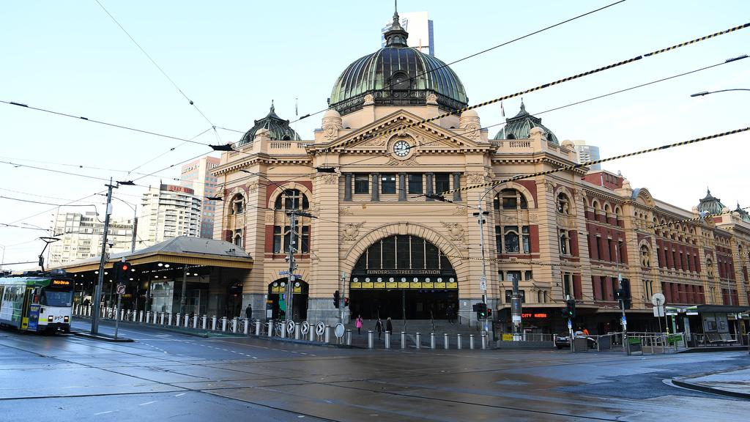
In our day, we might view the current pandemic as a wilderness experience. The city streets are nearly empty and eerily quiet. Venturing outside involves risk and so we remain mostly indoors where it is safe. But if we learn from the Bible and from our aboriginal brothers and sisters, the wilderness is also a place to encounter God and a place of transformation. Hence my prayer is that we will emerge from this experience with a new appreciation of what is really vital for living and what is essential to being the people of God. May we learn to listen for God’s word to us and God’s offer of life, even in the midst of the wilderness.
HYMN TiS 52 Let us sing to the God of salvation
Let us sing to the God of salvation,
let us sing to the Lord our rock!
Let us come to his house with thanksgiving,
let us come before the Lord and sing!
Praise our Maker, praise our Saviour,
praise the Lord our everlasting King.
Every throne must bow before him,
God is Lord of everything!
In his hand are the earth's deep places
and the strength of the hills is his;
all the sea is the Lord's, for he made it,
by his hand the solid rock was formed.
Refrain
Let us worship the Lord our Maker,
let us kneel to the Lord our God;
for we all are the sheep of his pasture,
he will guide us by his powerful hand.
Refrain
Let today be the time when you hear him!
May our hearts not be hard or cold,
lest we stray from the Lord in rebellion,
as his people did in time of old.
Refrain
Words Richard Bewes. Music Norman Warren © 1973 Hope Publishing Co. Used by permission.
For Youtube version see https://www.youtube.com/watch?v=A8pFxKuRN3A
PRAYERS OF THE PEOPLE
God of the wilderness,
we pray for those who work to protect and defend wilderness
and wild places around the world.
We pray for young people responding to the crisis of climate change.
Give them courage and perseverance and give our leaders ears to hear.
Lord, in your mercy, hear our prayer.
God of justice,
we pray for the restoration of full and flourishing life across the world,
especially in places that have seen destruction from human and natural disasters.
We pray for areas recovering from summer bushfires, areas recovering from drought
and for the beautiful Great Barrier Reef.
May you breathe new life into these ravaged places.
Lord, in your mercy, hear our prayer.
God of mystery,
we praise you for the many inter-connections and inter-dependence of all creation.
Help us to embrace our place with exuberance and joy.
May we remember that we are but one part of the glorious web of your creation.
Give us passion to care for creation and commitment to reduce our excessive consumption.
Lord, in your mercy, hear our prayer.
God of mercy,
we come before you today aware of the needs of those known to us,
those suffering from illness and pain, those feeling anxious
and those struggling to balance all of the demands of life at present.
We pause to remember and name before you those you’ve placed on our hearts …
May these people know your love, healing and peace today.
Lord, in your mercy, hear our prayer.
Finally, we pray in the name of Christ who taught us to pray, saying ‘Our Father in heaven … ‘
BENEDICTION
Christ calls us to be disciples,
to follow him with love and compassion
and to serve the earth by caring for creation.
So go in peace
and may God’s Spirit fill you with the knowledge of God’s presence throughout the earth.
We go in peace to serve Christ and care for the earth.
SENDING SONG For you, deep stillness
For you, deep stillness of the silent inland
For you, deep blue of the desert skies
For you, flame red of the rocks and stones
For you, sweet water from hidden springs
From the edges seek the heartlands
and when you're burnt by the journey
may the cool winds of the hovering
Spirit soothe and replenish you.
In the name of Christ
In the name of Christ
Words © Julie Perrin. Music © Robin Mann 1997. Used with permission.
For YouTube version from Balhannah UC in South Australia see https://www.youtube.com/watch?v=gpRWWnZa6Ro

