The groaning of the land
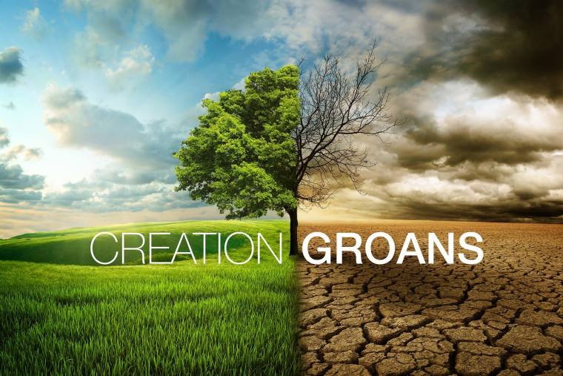

This week’s focus in the season of creation is the land. Many of us may be fondly attached to our small suburban block where we live and may have a favourite location to visit on holidays, but our relationship with the land is very different to that of indigenous people. For them the connection to land is visceral and spiritual.
In our reading from Genesis 3 this week, we learn that the land was implicated in the fallout from the earlier incident involving Adam and Eve and the serpent. It will grow weeds and thorns and not readily yield crops. It is not clear why the land is implicated except that the rift between God and humanity involves the whole of creation, including the land. In Paul’s commentary on this Genesis passage in Romans 8:18-25 he notes that creation is groaning and frustrated and longs for freedom. These deep emotions are not something that we white people readily associate with the land, but indigenous people do feel the connection.
Why is the land groaning? Because we have mistreated it through over cropping and over grazing it, through prolonged droughts worsened by climate change and through overuse of chemical fertilisers and pesticides. It is time to repent and change our thinking and our ways. Our greed and appetite for ever more things is slowing killing the planet. Yet the Romans reading suggests there is hope for creation, tied in with the broader Christian hope of redemption. We humans are clearly part of the problem but we are also a key part of the solution.
[tags Genesis 3:14-19, Romans 8:18-25]

