worship@home resources for 30 August
Call to Worship (based on Psalm 105)
Give thanks to the LORD; call on the name of the LORD.
Tell the world what God has done.
Sing to the LORD, sing praises;
tell of God’s wonderful works.
Rejoice in God’s holy name;
let us seek the LORD, and the presence of the LORD.
HYMN TiS 143 Immortal, invisible, God only wise
Immortal, invisible, God only wise,
in light inaccessible hid from our eyes,
most blessèd, most glorious, the Ancient of Days,
almighty, victorious, your great name we praise.
Unresting, unhasting, and silent as light,
nor wanting, nor wasting, but ruling in might;
your justice like mountains high soaring above,
your clouds which are fountains of goodness and love.
You give life to all, Lord, to both great and small,
in all life now living, the true life of all;
we blossom and flourish as leaves on a tree,
then wither but ever unchanged you will be.
All praise we would render: reveal to our sight
what hides you is only the splendour of light;
and so let your glory, Almighty, impart,
through Christ in the story, your Christ to the heart.
Walter Charmers Smith 1824-1908 alt.
For one of many YouTube versions see https://www.youtube.com/watch?v=spE-BE23qxA&t=3s
prayer
Loving God,
as we come before you this morning, give us open hearts and open hands.
Make us eager to hear your voice and seek your guidance.
Open our minds to your ever-present Spirit that is always moving within and around us.
Open our spirits to your nudging and open our lives to your love.
You call us to turn away from our own selfish interests, to take up our cross, and to follow you.
You invite us to find our lives, that we live them in service of your mission.
Compassionate God,
We want to be followers of Jesus, but we do not always want to follow Jesus.
We don’t even want to listen when the conversation turns toward darkness and death.
We prefer to indulge ourselves.
We are eager to put down our crosses.
We cling tightly to our lives. We grasp at worldly rewards.
Holy and loving God,
forgive our thoughts and actions that would stop us from walking the path of Christ,
in whose name we pray. Amen.
ASSURANCE OF FORGIVENESS
Jesus came to show us a new way to relate to God.
So I declare to you: our sins are forgiven.
Thanks be to God.
BIBLE READINGS
Exodus 3:1-15
Moses was keeping the flock of his father-in-law Jethro, the priest of Midian; he led his flock beyond the wilderness, and came to Horeb, the mountain of God. There the angel of the Lord appeared to him in a flame of fire out of a bush; he looked, and the bush was blazing, yet it was not consumed. Then Moses said, ‘I must turn aside and look at this great sight, and see why the bush is not burned up.’ When the Lord saw that he had turned aside to see, God called to him out of the bush, ‘Moses, Moses!’ And he said, ‘Here I am.’ Then he said, ‘Come no closer! Remove the sandals from your feet, for the place on which you are standing is holy ground.’ He said further, ‘I am the God of your father, the God of Abraham, the God of Isaac, and the God of Jacob.’ And Moses hid his face, for he was afraid to look at God.
Then the Lord said, ‘I have observed the misery of my people who are in Egypt; I have heard their cry on account of their taskmasters. Indeed, I know their sufferings, and I have come down to deliver them from the Egyptians …
I will send you to Pharaoh to bring my people, the Israelites, out of Egypt.’ But Moses said to God, ‘Who am I that I should go to Pharaoh, and bring the Israelites out of Egypt?’ He said, ‘I will be with you; and this shall be the sign for you that it is I who sent you: when you have brought the people out of Egypt, you shall worship God on this mountain.’
Moses said to God, ‘If I come to the Israelites and say to them, “The God of your ancestors has sent me to you”, and they ask me, “What is his name?” what shall I say to them?’ God said to Moses, ‘I AM WHO I AM.’ He said further, ‘Thus you shall say to the Israelites, “I AM has sent me to you.” ’ This is my name for ever.

Romans 12:9-21
Let love be genuine;
hate what is evil, hold fast to what is good;
love one another with mutual affection;
outdo one another in showing honour.
Do not lag in zeal, be ardent in spirit, serve the Lord.
Rejoice in hope, be patient in suffering, persevere in prayer.
Contribute to the needs of the saints; extend hospitality to strangers.
Bless those who persecute you; bless and do not curse them.
Rejoice with those who rejoice, weep with those who weep.
Live in harmony with one another;
do not be haughty, but associate with the lowly; do not claim to be wiser than you are.
Do not repay anyone evil for evil, but take thought for what is noble in the sight of all.
If it is possible, so far as it depends on you, live peaceably with all.
Beloved, never avenge yourselves, but leave room for the wrath of God,
for it is written, ‘Vengeance is mine, I will repay, says the Lord.’
No, ‘if your enemies are hungry, feed them; if they are thirsty, give them something to drink; for by doing this you will heap burning coals on their heads.’
Do not be overcome by evil, but overcome evil with good.
Matthew 16:21-26 (The Message)
Then Jesus made it clear to his disciples that it was now necessary for him to go to Jerusalem, submit to an ordeal of suffering at the hands of the religious leaders, be killed, and then on the third day be raised up alive. Peter took him in hand, protesting, “Impossible, Master! That can never be!” But Jesus didn’t swerve. “Peter, get out of my way. Satan, get lost. You have no idea how God works.”
Then Jesus went to work on his disciples. “Anyone who intends to come with me has to let me lead. You’re not in the driver’s seat; I am. Don’t run from suffering; embrace it. Follow me and I’ll show you how. Self-help is no help at all. Self-sacrifice is the way, my way, to finding yourself, your true self. What kind of deal is it to get everything you want but lose yourself? What could you ever trade your soul for?
REFLECTION
Back in 2006, former US Vice President Al Gore released a movie called An Inconvenient Truth that focused on the challenges posed by climate change and what could be done to address them. The title of the movie was based on two observations. First, the truth or reality of climate change and its causes, which basically come down to the laws of physics. Second, the inconvenience of this truth for it requires all of us – the peoples of the world – to change our habits and change the way we live. Al Gore didn’t shy away from asking the hard questions.
This week’s readings offer two examples of God calling on a person to embrace an inconvenient truth. First there is Moses who fled from Egypt after killing an Egyptian for mistreating one of the Jewish slaves. Now he quietly goes about his business as a shepherd. One day he sees a bush that is burning yet not consumed. He stops for a closer look and God speaks to him. God has seen the misery of the Jewish people in Egypt and heard their cries for help. So now God recruits Moses to the cause to go to Pharaoh to demand their release. Moses baulks at the suggestion and starts making various excuses as to why he can’t go and why he isn’t the right person for the role. God’s call is mighty inconvenient … and also mighty dangerous for Moses personally.
In the Gospel reading, Peter has just identified Jesus as the Messiah and Son of the living God. No sooner has Jesus finished praising Peter for this insight, than Jesus is predicting what sort of Messiah he will be – a Messiah who suffers and dies. Peter rejects this suggestion and disputes with Jesus about the ‘right’ course of action for the Messiah. Jesus dismisses Peter’s concerns and goes on to explain that anyone wanting to follow him must also be prepared to embrace this way of suffering. Again this is mighty inconvenient … and unthinkable for Peter. Just recall how Peter reacts later in the story when Jesus is arrested.
We are accustomed to asking God to bless us, to heal those who are sick and to help restore peace. But sometimes God calls us to take a different path, to pursue actions or causes that take us well out of our comfort zones – and that may even place us in harm’s way. During the Covid19 pandemic, this is a choice that every health care worker makes every day.
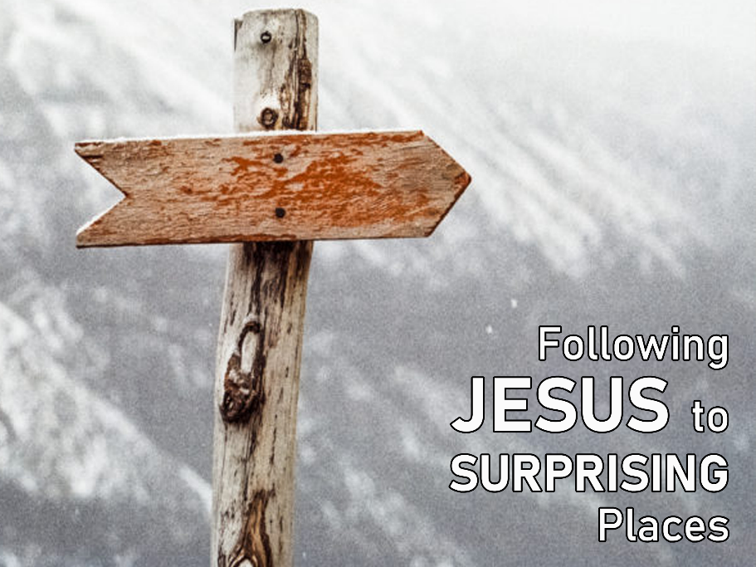
The inconvenient truth of following Jesus is that he never promises that our lives will be easy or free from suffering. But as we navigate our way through the journey of life, the invitation is to follow Jesus and to find true life.
What does this life look like? The reading from Romans gives us several clues. It is a life lived in community with a focus on love and doing good for others, even our enemies. Sometimes this will lead to rejoicing and sometimes there will be weeping. But the promise is that God will be with us in every situation, even the most difficult and painful ones. And that is a most encouraging truth.
HYMN The Summons
Will you come and follow me if I but call your name?
Will you go where you don't know and never be the same?
Will you let my love be shown, will you let my name be known,
will you let my life be grown in you and you in me?
Will you leave yourself behind if I but call your name?
Will you care for cruel and kind and never be the same?
Will you risk the hostile stare should your life attract or scare?
Will you let me answer prayer in you and you in me?
Will you let the blinded see if I but call your name?
Will you set the prisoners free and never be the same?
Will you kiss the leper clean and do such as this unseen,
and admit to what I mean in you and you in me?
Will you love the "you" you hide if I but call your name?
Will you quell the fear inside and never be the same?
Will you use the faith you've found to reshape the world around,
through my sight and touch and sound in you and you in me?
Lord, your summons echoes true when you but call my name.
Let me turn and follow you and never be the same.
In your company I'll go where your love and footsteps show.
Thus I'll move and live and grow in you and you in me.
Words John L. Bell & Graham Maule. © WGRG Iona Community, Glasgow. Used with permission.
Youtube version here https://www.youtube.com/watch?v=zk6IUalJ3sk
PRAYERS OF THE PEOPLE
Holy God, mysterious I AM,
in every age you have heard the cries of your people and have come to deliver them.
Hear us now as we bring our prayers for your world and your church.
Just God
who walks beside us in times of trouble,
we pray for people suffering hardship or violence,
whether for economic, religious or family reasons.
Save us from hostility and fear that we might live generously
and with justice so all may live in peace.
Faithful God, hear our prayer.
Life-giving God
who watches over your people,
we pray for your church, both here and wherever you are worshipped,
for those who serve and who bring your love to others.
Save us from apathy or smallness of vision
that we might live out and proclaim your gospel through both our words and our actions.
Faithful God, hear our prayer.
Community-building God
whose will is to build strong communities,
we pray for the people who make up our community,
for those who care for others, who clean, who stack the supermarket shelves,
who teach, who deliver parcels, who grow our food
and for all those whose work and lives go unnoticed.
Save us from prejudice and self-interest that we may be a hospitable community.
Faithful God, hear our prayer.
Loving God
who rejoices with those who rejoice,
who weeps with those who weep,
and who is present amid the confusion and uncertainty of these days.
We pray for those whom we name with our lips
and those we name in the silence of our hearts …
Faithful God, hear our prayer.
We pray now in the words Jesus taught us, saying ‘Our Father in heaven … ‘
BENEDICTION
Go into this week,
blessed by the goodness of God,
inspired by the love of Jesus Christ,
and strengthened by the presence of the Holy Spirit.
We go in peace to love and serve the Lord. Amen
SENDING SONG God to enfold you
God to enfold you,
Christ to uphold you,
Spirit to keep you in heaven’s sight;
so may God grace you,
heal and embrace you,
lead you through darkness into the light.
Words and music John L. Bell and Graham Maule © WGRG. Used with permission.
For YouTube version see https://www.youtube.com/watch?v=zy8qDlxBp5I

