worship@home resources for 23 August
Call to Worship (based on Psalm 124)
If it were not for the presence of God with us
we would struggle to overcome the things that threaten us
Blessed be God who saves us in times of distress
Our help is in the name of the Lord
who made heaven and earth
Praise God who hears and answers our calls for help
Let us worship God
HYMN TiS 210 O for a thousand tongues
O for a thousand tongues to sing
my great Redeemer’s praise,
the glories of my God and King,
the triumphs of his grace!
Jesus! the name that charms our fears,
that bids our sorrows cease;
such music in the sinner’s ears
is life, and health, and peace.
Hear him, you deaf; his praise, you dumb,
your loosened tongues employ;
you blind, behold your Saviour come;
and leap, you lame, for joy!
My gracious Master and my God,
assist me to proclaim,
to spread through all the earth abroad
the honours of your name.
Charles Wesley 1707-88 alt.
For one of many YouTube versions see https://www.youtube.com/watch?v=2e475ww32Jg
prayer
Faithful God,
we come into your presence with thanksgiving,
grateful for the love and faithfulness you have shown toward us.
When we are tired, you give us the strength to go on.
When we find ourselves in trouble, you are there, standing beside us.
And so we come before you with our thanks and praise,
and offer you the worship of our hearts and lives.
Open our eyes to see you here amongst us;
open our ears to recognise your voice speaking to us.

Gracious God,
You call us to no longer live by the patterns and priorities of this world
but to be transformed into your likeness.
Forgive us when we continue to follow
the world’s way of selfishness and greed.
You call us to love our neighbour as ourselves
and to extend compassion and mercy to others.
Forgive us for the times we have failed to do this
and strengthen us to share Christ’s love with our neighbours.
This we ask in Jesus’ name. Amen
ASSURANCE OF FORGIVENESS
Everyone who trusts in Jesus is forgiven and given new life.
So I declare to you: our sins are forgiven.
Thanks be to God.
BIBLE READINGS
Psalm 138
I will give thanks to you, O Lord, with my whole heart;
before the gods I will sing your praise.
I will bow down towards your holy temple
and praise your name for your love and faithfulness;
for you have glorified your name
and your word above everything.
When I called, you answered me;
you increased my strength within me.
All the kings of the earth will praise you, O Lord,
when they have heard the words of your mouth.
They will sing of the ways of the Lord,
for great is the glory of the Lord.
For though the Lord is high,
he cares for the lowly;
Though I walk in the midst of trouble, you keep me safe;
and your right hand shall save me.
The Lord will make good his purpose for me;
your steadfast love, O Lord, endures for ever.
Romans 12:1-8
Therefore, I urge you, brothers and sisters, in view of God’s mercy, to offer your bodies as a living sacrifice, holy and pleasing to God—this is your true and proper worship. Do not conform to the pattern of this world, but be transformed by the renewing of your mind. Then you will be able to test and approve what God’s will is—his good, pleasing and perfect will.
For by the grace given me I say to every one of you: do not think of yourself more highly than you ought, but rather think of yourself with sober judgment, in accordance with the faith God has distributed to each of you. For just as each of us has one body with many members, and these members do not all have the same function, so in Christ we, though many, form one body, and each member belongs to all the others. We have different gifts, according to the grace given to each of us. If your gift is prophesying, then prophesy in accordance with your faith; if it is serving, then serve; if it is teaching, then teach; if it is to encourage, then give encouragement; if it is giving, then give generously; if it is to lead, do it diligently; if it is to show mercy, do it cheerfully.
Matthew 16:13-20
Now when Jesus came into the district of Caesarea Philippi, he asked his disciples, ‘Who do people say that the Son of Man is?’ And they said, ‘Some say John the Baptist, but others Elijah, and still others Jeremiah or one of the prophets.’
Then he said to them, ‘But who do you say that I am?’ Simon Peter answered, ‘You are the Messiah, the Son of the living God.’ And Jesus answered him, ‘Blessed are you, Simon son of Jonah! For flesh and blood has not revealed this to you, but my Father in heaven. And I tell you, you are Peter, and on this rock I will build my church, and the gates of Hades will not prevail against it. I will give you the keys of the kingdom of heaven, and whatever you bind on earth will be bound in heaven, and whatever you loose on earth will be loosed in heaven.’
Then he sternly ordered the disciples not to tell anyone that he was the Messiah.
REFLECTION
I wonder what mind games you played in your childhood to pass the time? One popular game that we played as children was ‘Who am I?’, where one person thinks of a well-known figure and others have to guess who it is. Another variation on this game is ‘famous faces’ that is sometimes played at trivia nights. It seems that Jesus plays his own version of these games with the disciples in today’s Gospel reading. The answers that the disciples come up with reveal important understandings of Jesus’ identity.
Before looking at these responses, though, it’s worth pondering who Jesus is in our contemporary culture. If you asked someone on the street who they thought Jesus was, they might respond … a swearword, a great moral teacher, a good but ordinary man (that the church has made into God), a myth (that the church has created), a mighty prophet (which is the Muslim view) or a false Messiah (which is the Jewish view). There are also several other views in our culture regarding who Jesus is
When Jesus quizzes the disciples about who the common people thought he was, the consensus view is that the crowds view Jesus as a great prophet, like Elijah or Jeremiah or even like John the Baptist. When Jesus makes the question more personal and asks the disciples who they think he is, Peter answers that Jesus is the Messiah, the Son of the living God. Peter is the first human in the Gospel to draw this conclusion, although the reader of Matthew’s Gospel has known this from the opening verse.
Jesus praises Peter for his perception, because Jesus does not act and speak as the Messiah was expected to (e.g. defeat Israel’s enemies, restore proper worship, usher in a period of sustained peace). Further, as the Messiah, Jesus will suffer and die … but that is next week’s story. Peter’s so-called confession of Jesus as the Messiah will be the rock or foundation upon which the later church is built. It is why followers of Jesus are called Christians because Christos is the Greek translation of the Hebrew Messiah. So every time we use the words Jesus Christ we are really saying that Jesus is the Messiah.
But who is Jesus for us? In addition to the titles and roles described above we might add that Jesus is our companion on the way, our Saviour, our inspirational guide or the one who speaks truth to power. The answer we might give to Jesus’ question of course involves more than simply correct belief or intellectual assent.
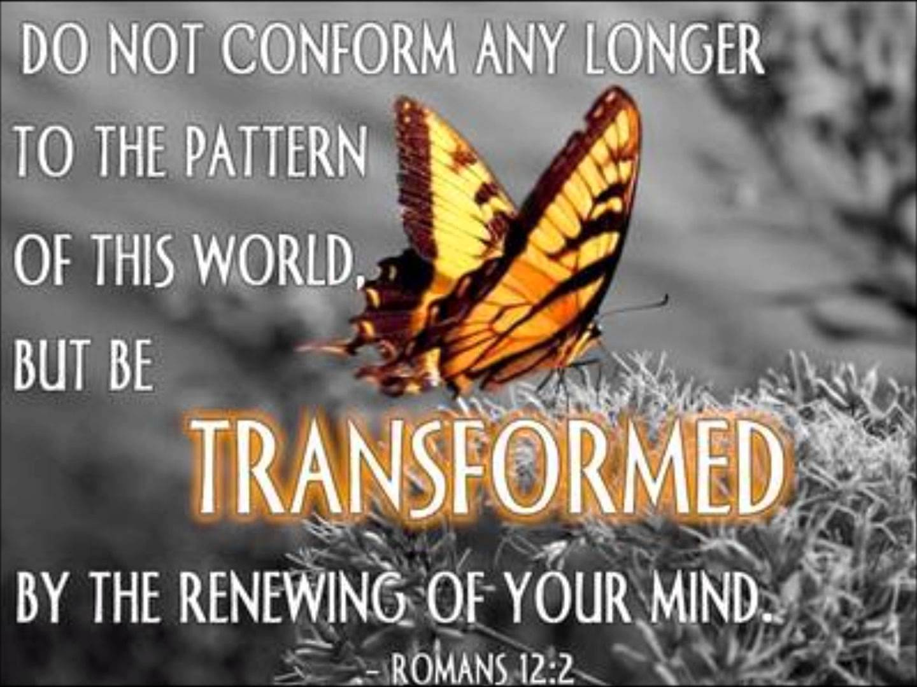
The reading from Romans suggests that an appropriate response is worship and a new way of thinking – changing from a worldly values system to a godly values system, where Jesus’ priorities become our priorities. And it will also involve putting our faith into action by serving others with whatever gifts God has given us. So there are major implications in how we answer Jesus’ question – because it affects not just what we believe but also what we do and how we live.
HYMN TiS 571 Forth in your name, O Lord, I go
Forth in your name, O Lord, I go
my daily labour to pursue;
you, Lord, alone resolved to know,
in all I think or speak or do.
Each task your wisdom has assigned
still let me cheerfully fulfil,
in all my works your presence find
and prove your good and perfect will.
You may I set at my right hand
whose eyes my inmost substance see,
and labour on at your command,
and offer all my works to you.
Give me to bear your easy yoke,
and every moment watch and pray,
and still to things eternal look,
and hasten to your glorious day.
for you delightfully employ
all that your bounteous grace has given,
and run my course with even joy,
and closely walk with you to heaven.
Charles Wesley 1707-88 alt.
Youtube version here https://www.youtube.com/watch?v=2ppFnYypfLM
PRAYERS OF THE PEOPLE
Lord Jesus,
you are a Lord who walks beside your people.
So we pray for people who seek your justice …
… for refugees and asylum seekers and those advocating for them
… for the indigenous peoples of this country
You are a Lord who raises up those who are bent low.
So we pray for those ground down by the hardships of life …
… for those who are sick and those caring for them
… for the homeless
You are a Lord who feeds the hungry.
So we pray for all who long for daily bread …
… for casual workers and overseas students
… for the unemployed struggling to put food on the table
You are a Lord who celebrates the small and the insignificant.
So we pray for those who are often ignored ...
… for the elderly isolated at home
… for the children who are missing their school friends
… for those people known to us whom you have placed on our hearts today …
You are a Lord who says ‘Follow me’.
So we pray for courage and faith for ourselves
that we may take up your message and find it leads to life.
We pray now in the words Jesus taught us, saying ‘Our Father in heaven … ‘

BENEDICTION
We are the body of Christ.
May we carry within us the heart of Christ, tender for mercy.
May we look with the eyes of Christ, to see a world in need.
May we walk in the footsteps of Christ, to bring good news.
Go in peace and may God go with you.
We go in peace to love and serve the Lord!
SENDING SONG Scatter us Lord Jesus Christ
Scatter us Lord Jesus Christ,
you know where we’re going.
Use our gifts so that we may
share life overflowing.
Heal us, bless us now, our Lord,
in your name we’re going.
Be our comfort and our strength,
share life overflowing.
Holy Spirit, go with us,
in your joy we’re growing.
Be our light, our love, our hope,
be life overflowing.
Words and music © 2012 Beatrice Panne. Used with permission.

