worship@home resources for 16 August
Call to Worship (based on Psalm 67)
Let the peoples praise you, O God;
let all the peoples praise you.
Let the nations be glad and sing for joy,
for you judge the peoples with equity
and guide the nations upon earth.
Let the peoples praise you, O God;
let all the peoples praise you!
HYMN TiS 106 Now thank we all our God
Now thank we all our God, with heart and hands and voices,
who wondrous things has done, in whom this world rejoices;
who from our mothers’ arms has blessed us on our way
with countless gifts of love, and still is ours today.
O may this bounteous God through all our life be near us,
with ever joyful hearts and blessed peace to cheer us.
Lord, keep us in your grace, and guide us when perplexed,
and free us from all harm in this world and the next.
All praise and thanks to God who reigns in highest heaven,
to Father and to Son and Spirit now be given:
the one eternal God, whom heaven and earth adore,
who ever was, is now, and shall be ever more.
Martin Rinkart 1586-1649. tr. Catherine Winkworth 1827-78 alt.
For YouTube version see https://www.youtube.com/watch?v=s99dNPKYtHk
prayer
God of the nations,
With open arms you welcome all who call on your name.
No one stands outside the circle of your mercy and love.
And so we come to offer you our worship today.
Through the presence of your Holy Spirit open our eyes to see you here;
open our minds to receive your truth,
and our mouths to speak and sing your praise.
God of love,
through Jesus you broke down the barriers
that separate people from one another
we confess our struggle to be inclusive –
to welcome the stranger and befriend the poor.
God of all humanity,
you call us to seek after justice and to work for reconciliation and peace.
We confess that our good intentions often do not result in action.
God of compassion,
teach us what it means to truly love one another
and how to love our neighbour as ourselves.
We pray in the name of Christ. Amen.
ASSURANCE OF FORGIVENESS
In God’s grace, we are all included, welcomed and loved.
Hear the good news: through Christ we are forgiven and renewed.
Thanks be to God!
BIBLE READINGS
Psalm 133
How very good and pleasant it is
when kindred live together in unity!
It is like the precious oil on the head,
running down upon the beard,
on the beard of Aaron,
running down over the collar of his robes.
It is like the dew of Hermon,
which falls on the mountains of Zion.
For there the Lord ordained his blessing,
life for evermore.
Matthew 15:21-28
Jesus left that place and went away to the district of Tyre and Sidon. Just then a Canaanite woman from that region came out and started shouting, ‘Have mercy on me, Lord, Son of David; my daughter is tormented by a demon.’ But he did not answer her at all. And his disciples came and urged him, saying, ‘Send her away, for she keeps shouting after us.’ He answered, ‘I was sent only to the lost sheep of the house of Israel.’ But she came and knelt before him, saying, ‘Lord, help me.’ He answered, ‘It is not fair to take the children’s food and throw it to the dogs.’ She said, ‘Yes, Lord, yet even the dogs eat the crumbs that fall from their masters’ table.’ Then Jesus answered her, ‘Woman, great is your faith! Let it be done for you as you wish.’ And her daughter was healed instantly.
REFLECTION
I wonder which portrayal of Jesus in the Gospels that you are most drawn to. Is it Jesus the compassionate healer, reaching out and touching those on the margins? Is it Jesus the radical prophet, opening people’s eyes to the nature of God and calling people to embrace God’s kingdom? Or perhaps it’s the deeply spiritual Jesus who spends long hours in prayer with God and who doesn’t seem to get riled by anyone or anything?
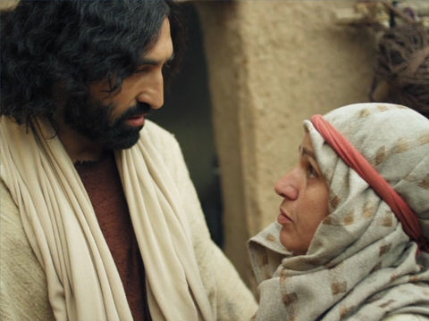
So which Jesus features in this Gospel story today? It seems to be grumpy Jesus or at least indifferent Jesus who doesn’t seem to care too much about the woman’s plight. But perhaps what we have here is a portrayal of a very human Jesus who just wants a little peace and quiet – away from the crowds – so he can properly mourn the passing of John the Baptist – or enjoy some uninterrupted teaching time with the disciples.
While this may surprise some people, Jesus only gradually came to understand his mission and his calling. Today’s story is an example where Jesus, I think, had a profound moment of insight. When Jesus is called upon to heal the daughter of a foreign woman, his reluctance to become involved appears based on his understanding that he is the Jewish Messiah, called to restore the lost sheep of Israel. The woman challenges this notion and perhaps recalls for Jesus the strand of prophetic teaching that God will one day bless all the nations.
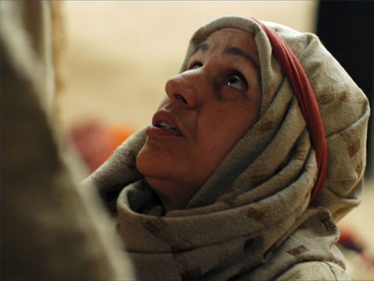
The unnamed woman in the story is actually one of the great heroes of faith in the Bible. She implicitly trusts that this Jewish prophet – and the God he worships – can heal her daughter. She knows her need and so is quite bold in approaching Jesus. She is also persistent and will not easily give up. She puts her faith into action by seeking Jesus out and offers him a new insight into the nature of God. She pushes and crosses boundaries.
So what might we take from this passage?
One reminder is the need to remain teachable. If we ever think that we have fully worked out God’s character or our calling, then we need to think again. There is much that we still need to learn, sometimes from unlikely sources such as this woman.
Another reminder is the call to remain inclusive. The New Testament highlights the struggle that the early Christians had to welcome everybody into the family of God. Paul was one of the first to recognise that there is no longer Jew or Gentile, slave or free, male or female, because all are one in Jesus Christ (Galatians 3:28). The Black Lives Matter movement demonstrates that we still need to make significant changes if this statement is to truly lived out.
Perhaps a third reminder is that humour plays an important role in our faith. It is the woman’s wit and humour that finally wins Jesus over. At times our faith is rightly seen as serious, but it’s also helpful if we can occasionally laugh at ourselves.
HYMN TiS 629 When I needed a neighbour
When I needed a neighbour, were you there, were you there?
When I needed a neighbour, were you there?
And the creed and the colour and the name won't matter
were you there?
I was hungry and thirsty, were you there, were you there?
I was hungry and thirsty, were you there?
Refrain
I was cold, I was naked, were you there, were you there?
I was cold, I was naked, were you there?
Refrain
When I needed a shelter, were you there, were you there?
When I needed a shelter were you there?
Refrain
When I needed a healer, were you there, were you there?
When I needed a healer, were you there?
Refrain
Wherever you travel, I'll be there, I'll be there,
wherever you travel, I'll be there.
Refrain
Sydney Carter 1915-2004.
Youtube version here https://www.youtube.com/watch?v=ym8yOdCFGPc
PRAYERS OF THE PEOPLE
O Christ our Lord,
as the Canaanite woman brought her daughter’s need to you,
confident of your healing in her life,
we bring to you the needs of others now in prayer:

We pray for those for whom pain is a constant companion,
for those living daily with chronic illness or ill-health.
We pray for those who struggle with the confusion and distress of mental illness
and for those suffering anxiety and loneliness during these days of lockdown.
We pray for those who have lost jobs due to coronavirus
that they will not lose hope.
We pray for doctors, nurses, carers, cleaners, paramedics, contact tracers and scientists,
helping to care for the sick and trying to combat this virus –
may you give them strength and stamina.
We pray for our political leaders and those making decisions that affect us all –
may you sustain them and grant them your wisdom.
And we pray for those people known to us whom you have placed on our hearts.
We lift them before you now …
For all those we have named today
Lord Jesus, bring healing and bring peace. Amen.
We pray now in the words Jesus taught us, saying ‘Our Father in heaven … ‘
BENEDICTION
May the God we serve pour grace and blessing into our lives.
May the face of God shine light upon us.
May we live out God’s love and justice in such a way
that people around us will come to know God,
and will experience God’s grace and blessing for themselves.
We go in peace to love and serve the Lord!
SENDING SONG TiS 782 Go now in peace
Go now in peace, go now in peace,
may the love of God surround you
everywhere, everywhere you may go.
Words and music © Natalie Sleeth 1930-92. Used with permission.
For YouTube version see https://www.youtube.com/watch?v=oRW1E0FzXek

