worship@home resources for 9 August
Call to Worship
God of wind and fire
Dance through our lives today
God of earthquakes and stillness
Share our tears of sadness and pain
God of creation and new beginnings
Show us again your vision of healing and wholeness
HYMN TiS 179 Praise with joy the world’s Creator
Praise with joy the world's Creator,
God of justice, love, and peace,
source and end of human knowledge,
force of greatness without cease.
Celebrate the Maker's glory,
power to rescue and release.
Praise the Son who feeds the hungry,
frees the captive, finds the lost,
heals the sick, up-sets religion,
fearless both of fate and cost.
Celebrate Christ's constant presence –
friend and stranger, guest and host.
Praise the Spirit sent among us,
liberating truth from pride,
forging bonds where race or gender,
age or nation dare divide.
Celebrate the Spirit's treasure –
foolishness none dare deride.
Praise the Maker, son and Spirit,
one God in community,
calling Christians to embody
oneness and diversity.
Thus the world shall yet believe, when
shown Christ’s vibrant unity.
Words John L. Bell and Graham Maule © Wild Goose Publications. Used with permission.
For YouTube version see https://www.youtube.com/watch?v=pwjkuvtNEfM
prayer
Almighty God who is greater than the most powerful forces in this world,
enable us to be still and to know that you are God.
Gentle Lord who answers out of the whirlwind of everyday life,
breathe in us your Holy Spirit to strengthen, comfort
and guide us in the midst of the storm.
O still, small voice, speak to us today
that we might become agents of your peace
in our homes, in our communities, in our world.
Merciful God, forgive the frantic fury of our anxious lives.
Speak to us in the midst of the struggles of daily living.
Come to us now, we pray, in a moment of silence,
as we wait, together, on you.
Time for silent reflection
Gracious God, your love brings life to dead souls,
light to dark minds, strength to trembling hearts.
Show us how to search for you in the midst of life.
We pray all this in the name of the One who calmed the raging sea.
ASSURANCE OF FORGIVENESS
Jesus calls to us to not be afraid, but rather to trust in his goodness and grace.
Hear the good news: through Christ we are loved, forgiven and offered new life.
Thanks be to God!
BIBLE READINGS
1 Kings 19:9-13
Then the word of the Lord came to Elijah, saying, ‘What are you doing here, Elijah?’ He answered, ‘I have been very zealous for the Lord, the God of hosts; for the Israelites have forsaken your covenant, thrown down your altars and killed your prophets with the sword. I alone am left, and they are seeking my life, to take it away.’
‘Go out and stand on the mountain before the Lord, for the Lord is about to pass by.’ Now there was a great wind, so strong that it was splitting mountains and breaking rocks in pieces before the Lord, but the Lord was not in the wind; and after the wind an earthquake, but the Lord was not in the earthquake; and after the earthquake a fire, but the Lord was not in the fire; and after the fire, sheer silence. Elijah … wrapped his face in his mantle and went out and stood at the entrance of the cave.
Psalm 85:8-13
I will listen to what God the Lord says:
he promises peace to his people, his faithful servants—
but let them not turn to folly.
Surely his salvation is near those who fear him,
that his glory may dwell in our land.
Love and faithfulness meet together;
righteousness and peace kiss each other.
Faithfulness springs forth from the earth,
and righteousness looks down from heaven.
The Lord will indeed give what is good,
and our land will yield its harvest.
Righteousness goes before him
and prepares the way for his steps.
Matthew 14:22-33
Immediately Jesus made the disciples get into the boat and go on ahead to the other side, while he dismissed the crowds. And after he had dismissed the crowds, he went up the mountain by himself to pray. When evening came, he was there alone, but by this time the boat, battered by the waves, was far from the land, for the wind was against them. And early in the morning he came walking towards them on the lake. But when the disciples saw him walking on the lake, they were terrified, saying, ‘It is a ghost!’ And they cried out in fear. But immediately Jesus spoke to them and said, ‘Take heart, it is I; do not be afraid.’
Peter answered him, ‘Lord, if it is you, command me to come to you on the water.’ He said, ‘Come.’ So Peter got out of the boat, started walking on the water, and came towards Jesus. But when he noticed the strong wind, he became frightened, and beginning to sink, he cried out, ‘Lord, save me!’ Jesus immediately reached out his hand and caught him, saying to him, ‘You of little faith, why did you doubt?’ When they got into the boat, the wind ceased. And those in the boat worshipped him, saying, ‘Truly you are the Son of God.’
REFLECTION
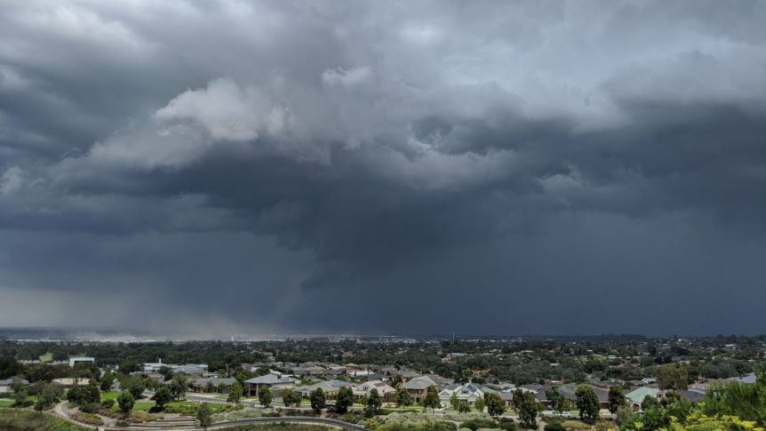
Storms can disrupt our lives. Some are physical storms like we’ve experienced this week with rain and wind, similar to the weather the disciples experienced as they crossed Lake Galilee at night. In such storms it’s hard to see clearly what’s going on, with our heads kept down, trying to reach our destination. In the midst of such storms we might just want to hunker down and curl up under the doona.
We’re currently in the middle of another quite different storm – the pandemic caused by Covid19, which is affecting people’s health, their sense of connection with others, their work routines and, for many, their financial security. Where is God during such a storm? What is God up to in the midst of the coronavirus pandemic?
We may have many questions, but they don’t have clear answers. Even the government’s regularly changing lists of restrictions are a bit like the classic Bob Dylan song … the answer, my friend, is blowin’ in the wind, the answer is blowin’ in the wind. Perhaps that’s also how Elijah felt, standing at the mouth of the cave, desperately wanting to hear a word from God but hearing only the sound of the wind.
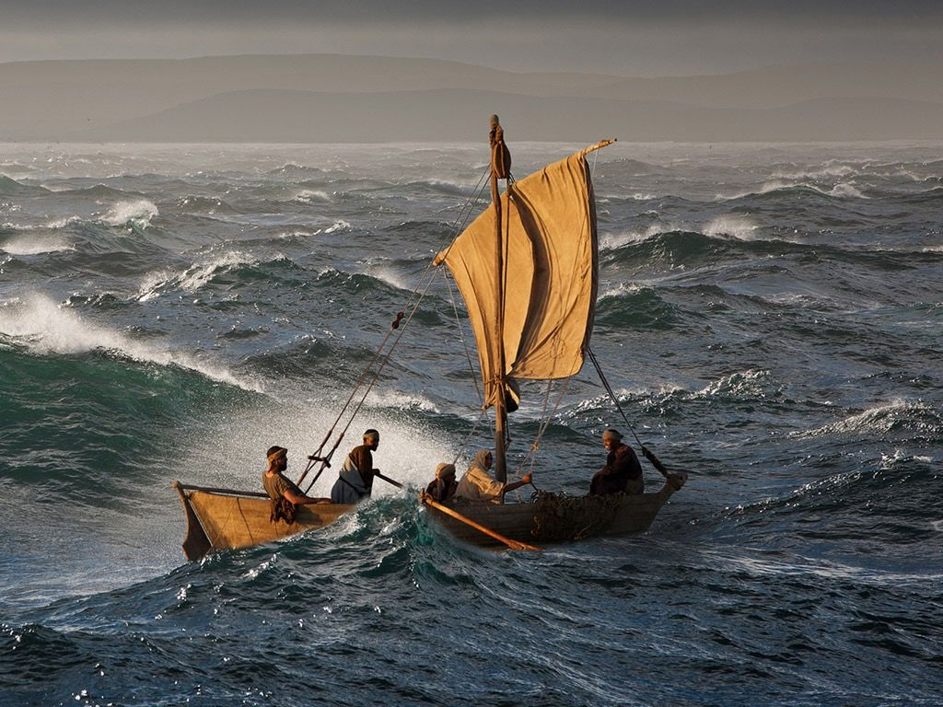
One interpretation of the Gospel story is that the disciples in the boat represent the experience of Matthew’s community in the late first century. Following Jesus is not easy – the way is hard to discern (it’s dark) and there is significant opposition (the wind, the waves). It’s just the church (the boat) cast adrift on the ocean of the world. There will be fears, doubts and struggle – everyone will get tired – and God may feel quite distant.
This sounds a bit like navigating through these days of coronavirus. We may draw comfort from the promise that Jesus is praying for us, but the struggle is real and the struggle is ours. The situation we face is summed up well in the Forty days reflection by Beth Barnett in the newsletter this week.
That’s only half the story though. In the Elijah story, God is not to be found in the storm or the fire or the earthquake, but rather speaks into the silence that follows. For the disciples it’s different. Jesus comes to them in the midst of the storm and approaches the boat and greets them. So there is not a single way that God or Jesus may speak to us or comfort us.
When Jesus does show up, though, the disciples are not overjoyed to see him but rather are absolutely terrified, thinking that Jesus is a ghost, some departed soul that drowned in the lake. Jesus actually showing up, coming to them unexpectedly in the midst of their struggles, really freaks them out.
Jesus speaks and says to have courage. Impetuous Peter then says and does something typical but rather foolish. If it’s really you, Jesus, tell me to come to you on the water. Jesus says ‘Come’ and so Peter bravely – foolishly – gets out of the boat and starts walking towards Jesus. While he is looking at Jesus, Peter is fine, but he is soon distracted by the wind and the waves and starts to sink. Jesus reaches out to catch Peter and gently rebukes him for his lack of faith. They both get into the boat, the wind dies down and there is a happy ending as the disciples look at Jesus with renewed awe and confess him to be the Son of God, perhaps a confession of Matthew’s later community. Note that it’s still dark and they haven’t yet reached shore. What’s changed is the knowledge and awareness that Jesus is with them.
So a question to ponder is this: are the disciples – and ourselves - better off with or without the presence of Jesus?
Does the presence of Jesus in some way encourage us to take risks or rescue us from our troubles?
The good news in this story is that if we’re able to trust that Jesus really is Emmanuel – God with us – then we can live with courage and with hope, we can take risks in trying new things and we can seek the good of others in our community – knowing that God is always there for us in Jesus.
HYMN TiS 409 O breath of life
O breath of life, come sweeping through us,
revive your church with life and power;
O breath of life, come cleanse, renew us,
and fit your church to meet this hour.
O wind of God, come bend us, break us,
till humbly we confess our need;
then in your tenderness remake us,
revive, restore; for this we plead.
O breath of love, come breathe within us,
renewing thought and will and heart;
come, love of Christ, afresh to win us,
revive your church in every part.
Revive us, Lord! Is zeal abating
while harvest fields are vast and white?
Revive us, Lord, the world is waiting,
equip your church to spread the light.
Elizabeth Ann Porter Head 1850-1936.
Youtube version here https://www.youtube.com/watch?v=5QHZB_v0ZaY
PRAYERS OF THE PEOPLE
Merciful God,
just as you came to your disciples long ago in the midst of a storm,
we pray that you would come again to your people
tossed about by the troubles and uncertainties of these days,
that we might be encouraged by your presence.
We pray for all those caught up in the coronavirus pandemic,
especially for frontline health workers, other essential workers,
for those struggling with loneliness or anxiety,
for those who have lost their jobs this week,
for those who don’t know where their next meal is coming from.
Merciful God, come and bring your peace.

God of the nations,
we look beyond our city and our nation
to those places where disease and fear and violence are ravaging lives.
We pray for countries still emerging from civil war,
for peoples afflicted by poverty and famine,
and for groups bringing support and hope,
We pray for leaders to rule wisely and with compassion.
God of the nations, come and bring your justice.
Gracious God,
we bring you our prayers for those known to us who are in need,
for those struggling with physical, mental or spiritual burdens,
for those who are afraid, anxious or without hope,
for those who are sick and those receiving ongoing medical treatment.
We pause now to name them before you now in the silence of our hearts …
Gracious God, come and bring your hope.
Finally we pray using the words Jesus taught us, saying ‘Our Father in heaven … ‘
BENEDICTION
When we struggle through hard times and difficulties,
we can put our trust in Jesus.
God will be with us and will bless us.
When we cry out to Jesus,
we can rely on his strength to be in us.
God will be with us and will bless us.
As we go into this week,
we can trust God to meet our needs.
God will be with us and will bless us.
SENDING SONG TiS 779 May the feet of God walk with you
May the feet of God walk with you,
and God’s hand hold you tight.
May the eye of God rest on you,
and God’s ear hear your cry.
May the smile of God be for you,
and God’s breath give you life.
May the Child of God grow in you,
and God’s love bring you home.
Words © Aubrey Podlich 1946– Music © Robin Mann
YouTube version https://www.youtube.com/watch?v=OJ6RaKX4_I4&t=12s

