worship@home resources for 19 July

Call to Worship (based on Ps 139)
O God, you know us inside and out, through and through
You search us out and lay your hand upon us
We praise you, O God, for the wonderful knowledge
that wherever we go, you are with us.
Let us worship the living God.
HYMN TiS 158 God has spoken
God has spoken by his prophets,
spoken his unchanging word,
each, from age to age proclaiming
God, the one, the righteous Lord.
In the world’s despair and turmoil
one firm anchor holds us fast,
God is king, his throne eternal,
God the first, and God the last.
God has spoken by Christ Jesus,
Christ, the everlasting Son,
brightness of the Father’s glory,
with the Father ever one;
spoken by the Word incarnate,
God from God, ere time began,
Light from Light, to Earth descending,
God, revealed as Son of Man.
God is speaking by his Spirit,
speaking to our hearts again,
in the age-long word expounding
God’s own message, now as then,
through the rise and fall of nations
one sure faith yet standing fast;
God still speaks, his word unchanging,
God the first, and God the last.
George Wallace Briggs 1875-1959 alt. Words © 1953 by The Hymn Society. All rights reserved. Used by permission.
For a fairly gentle YouTube version see https://www.youtube.com/watch?v=UCpWU_NStr4
prayer
Living God,
We come as your beloved people to worship you
honoured and humbled that you call us your children
and include us as part of your family.
Where we have worries this morning, grant us your peace.
Where we are sad or grieving, grant us your joy.
Where we are fearful, grant us your hope.
Draw close to us through your Spirit
and fill us afresh with your compassionate life.
Loving Creator God,
we confess that we do not always follow your ways,
but instead follow our own wisdom
and the worldly ways of comfort, success and power.
Silent reflection
Forgive us and call us back into your intention –
to love others and to love you
and to be good stewards of all you have given us.
We pray in Jesus’ name. Amen.
ASSURANCE OF FORGIVENESS
Where can we go to escape from God’s presence?
There is no place we can go where we are forgotten by God.
Hear the good news: through Christ we are known, accepted, loved and forgiven.
Thanks be to God for loving us as children
BIBLE READINGS
Psalm 139:1-12, 23-24
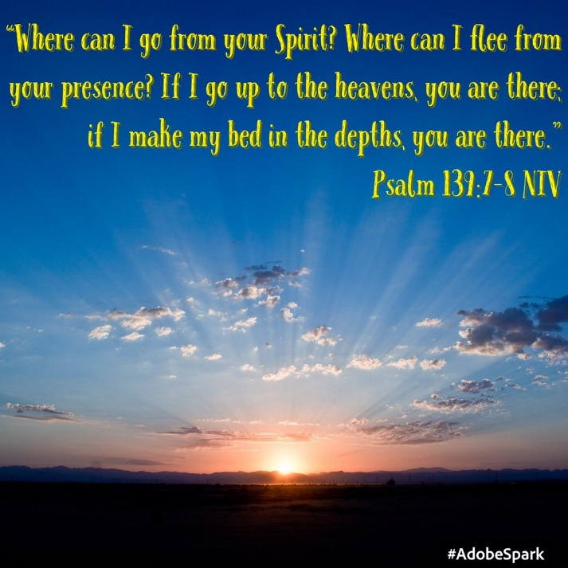
O Lord, you have searched me and known me.
You know when I sit down and when I rise up;
you discern my thoughts from far away.
You search out my path and my lying down,
and are acquainted with all my ways.
Even before a word is on my tongue,
O Lord, you know it completely.
You hem me in, behind and before,
and lay your hand upon me.
Such knowledge is too wonderful for me;
it is so high that I cannot attain it.
Where can I go from your spirit?
Or where can I flee from your presence?
If I ascend to heaven, you are there;
if I make my bed in Sheol, you are there.
If I take the wings of the morning
and settle at the farthest limits of the sea,
even there your hand shall lead me,
and your right hand shall hold me fast.
If I say, ‘Surely the darkness shall cover me,
and the light around me become night’,
even the darkness is not dark to you;
the night is as bright as the day,
for darkness is as light to you.
Search me, O God, and know my heart;
test me and know my thoughts.
See if there is any wicked way in me,
and lead me in the way everlasting.
Romans 8:14-25
For all who are led by the Spirit of God are children of God. For you did not receive a spirit of slavery to fall back into fear, but you have received a spirit of adoption. When we cry, ‘Abba! Father!’ it is that very Spirit bearing witness with our spirit that we are children of God, and if children, then heirs, heirs of God and joint heirs with Christ—if, in fact, we suffer with him so that we may also be glorified with him.
I consider that the sufferings of this present time are not worth comparing with the glory about to be revealed to us. For the creation waits with eager longing for the revealing of the children of God; for the creation was subjected to futility, not of its own will but by the will of the one who subjected it, in hope that the creation itself will be set free from its bondage to decay and will obtain the freedom of the glory of the children of God. We know that the whole creation has been groaning in labour pains until now; and not only the creation, but we ourselves, who have the first fruits of the Spirit, groan inwardly while we wait for adoption, the redemption of our bodies. For in hope we were saved. Now hope that is seen is not hope. For who hopes for what is seen? But if we hope for what we do not see, we wait for it with patience.
Matthew 13:24-30, 36-43
Jesus put before them another parable: ‘The kingdom of heaven may be compared to someone who sowed good seed in his field; but while everybody was asleep, an enemy came and sowed weeds among the wheat, and then went away. So when the plants came up and bore grain, then the weeds appeared as well. And the slaves of the householder came and said to him, “Master, did you not sow good seed in your field? Where, then, did these weeds come from?” He answered, “An enemy has done this.” The slaves said to him, “Then do you want us to go and gather them?” But he replied, “No; for in gathering the weeds you would uproot the wheat along with them. Let both of them grow together until the harvest; and at harvest time I will tell the reapers, collect the weeds first and bind them in bundles to be burned, but gather the wheat into my barn.” ’

REFLECTION
The parable about the weeds is every farmer’s or home gardener’s nightmare. You plant good seed into your carefully prepared soil and what comes up? A surprising mix of the plants you want plus a whole lot of unwanted weeds. Where did the weeds even come from? You certainly didn’t plant them – but there they are anyway! The question is … what to do now?
The wisdom from the parable is to be patient and to let the weeds be and let them grow up along with the plants you want. Then when it’s harvest time, it will be obvious which are the weeds and they can be pulled up and tossed out and you can then gather the plants you want.
Who does the parable apply to? Some commentators have seen it as applying to both the good and evil within the church community, where sometimes the weeds simply must be removed (e.g. evidence of child sexual abuse that was not acted upon). But perhaps it also applies to our own hearts, where there are both good desires and blind prejudices. It’s good that God is patient with us and allows the gentle work of the Holy Spirit to keep working at our flaws and failings.
Life can at times be painful – and may at times even appear futile or pointless – especially as we grow older. But the reading from Romans suggests that if we know Jesus and walk in the way of God’s Spirit – and thus know ourselves as God’s children – then our future hope is glorious. As Paul goes on to say later in this chapter – not even death will be able to separate us from God’s love. Instead, the relationship we have with God now will remain and deepen and all things – including our bodies and all of creation – will be made new. And in the midst of all this, the unchanging constant is God’s presence and love for us. So – like the farmer in the parable – we wait with hope and we wait with patience.

HYMN TiS 571 Forth in your name O Lord I go
Forth in your name, O Lord, I go,
my daily labour to pursue,
you, Lord, alone resolved to know,
in all I think, or speak, or do.
Each task your wisdom has assigned
still let me cheerfully fulfil,
in all my works your presence find,
and prove your good and perfect will.
You may I set at my right hand,
whose eyes my inmost substance view,
and labour on at your command,
and offer all my works to you.
Give me to bear your easy yoke,
and every moment watch and pray,
and still to things eternal look,
and hasten to your glorious day;
For you delightfully employ
all that your bounteous grace has given,
and run my course with even joy,
and closely walk with you to heaven.
Charles Wesley 1707-88 alt.
Youtube version here https://www.youtube.com/watch?v=2ppFnYypfLM
PRAYERS OF THE PEOPLE
Faithful God,
There is no place on earth that is beyond your presence.
Hear the prayers that we bring for the world and its people.
We pray for the whole creation …
Help us to see how the rest of creation brings you praise,
and help us to address the serious and permanent damage we are
making to this world through our greed and apathy.
Life giving God, hear our prayer.
We pray for the nations of the world,
for people who live with the daily reality of war, oppression and famine,
as well as the millions now trying to deal with Covid-19 infections.
We pray for the leaders of nations, including Australia, for wisdom and compassion.
Transform hearts that peace and justice may reign.
Life giving God, hear our prayer.
You have promised to make us your sons and daughters,
and so we pray for the church,
especially for those persecuted for their faith
and for Ministers, teachers, evangelists, pastoral carers, worship and other leaders.
Show us how we might bring light and love in these challenging times.
May our lives witness to your good news in words and actions.
Life giving God, hear our prayer.
You have promised to be with us even in the darkest parts of life.
We pray for those known to us who are anxious, in pain, or grieving,
those in hospital and aged care as well as those who care for them
and in the silence we name them before you now …
Life giving God, hear our prayer.
Lord, search our hearts and lead us in the way everlasting.
And we pray using the words Jesus taught us, saying ‘Our Father in heaven … ‘
BENEDICTION
Go into this week knowing God is with you,
blessing you and nurturing the life of Jesus within you
through the creative love of the Holy Spirit.
We go in peace to love and serve the Lord. Amen.
SENDING SONG TiS 779 May the feet of God walk with you
May the feet of God walk with you,
and God’s hand hold you tight.
May the eye of God rest on you,
and God’s ear hear your cry.
May the smile of God be for you,
and God’s breath give you life.
May the Child of God grow in you,
and God’s love bring you home.
Words © A.W. Podlich. Music © R. Mann.
For YouTube version see https://www.youtube.com/watch?v=OJ6RaKX4_I4&t=12s

