worship@home resources for 5 July

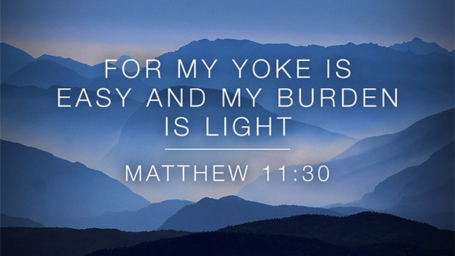
Call to Worship (based on Matt 11:28-30)
If you are tired from carrying heavy burdens,
come to me and I will give you rest.
Take the yoke I give you and learn from me.
I am gentle and humble, and you will find rest.
Christ calls us to come to worship –
to rest from the things that are troubling us;
to learn what Christ can teach of life;
to realise what we can offer to others
and so to return into the world to serve.
Let us worship God together.
HYMN TiS 152 Joyful, joyful, we adore you
Joyful, joyful, we adore you,
God of glory, God of love;
hearts unfold like flowers before you
opening to the sun above.
Melt the clouds of sin and sadness,
drive the dark of doubt away;
giver of immortal gladness,
fill us with the light of day.
All your works with joy surround you,
earth and heav’n reflect your rays,
stars and angels sing around you,
centre of unbroken praise.
Field and forest, vale and mountain,
flowery meadow, flashing sea,
singing bird and flowing fountain
call to praise you joyfully.
You are giving and forgiving,
ever blessing, ever blest,
wellspring of the joy of living,
ocean depth of happy rest.
You our Father, Christ our brother,
all are yours who live in love;
teach us how to love each other,
lift us to your joy above.
Henry Van Dyke 1852-1935 alt.
For YouTube version see https://www.youtube.com/watch?v=eMY3ivdNzwE
prayer (by Bill Loader)
O God,
our hearts are restless till they find their rest in you.
You are beyond our busy imaginings,
far above our thoughts and worries.
Yet you meet us on the road.
Your footprints cross ours.
You tread the path behind us and before us,
you lead the way,
you lift us up.
You look upon us through the face of the poor;
you bless us in the nurture of friendship;
you challenge us in the cries for justice
and the weeping for hope.
Yoked to Jesus your Son,
we strain against your direction;
summoned to follow your way,
we burden ourselves and others.
Forgive us the wrongs we have done
to others, to ourselves, to you.
Forgive us our bondage to old patterns
when they no longer serve you;
and our surrender to newness when newness is folly.
Forgive us our failure to listen to the old people of this land
and the new who are hurting,
and all those hidden beyond our preoccupations.
Lift us from our fear that we may see your vision,
know your wisdom and find our rest in you,
through Jesus Christ our Lord.
Amen
ASSURANCE OF FORGIVENESS
Jesus said: Come to me all you who are weary
and are carrying heavy burdens and I will give you rest.
Hear the good news: our sins are forgiven and we can live in peace.
Thanks be to God

BIBLE READINGS
Psalm 145:8-14
The Lord is gracious and merciful,
slow to anger and abounding in steadfast love.
The Lord is good to all,
and his compassion is over all that he has made.
All your works shall give thanks to you, O Lord,
and all your faithful shall bless you.
They shall speak of the glory of your kingdom,
and tell of your power,
to make known to all people your mighty deeds,
and the glorious splendour of your kingdom.
Your kingdom is an everlasting kingdom,
and your dominion endures throughout all generations.
The Lord is faithful in all his words,
and gracious in all his deeds.
The Lord upholds all who are falling,
and raises up all who are bowed down.
Matthew 11:16-30
‘But to what will I compare this generation? It is like children sitting in the market-places and calling to one another,
“We played the flute for you, and you did not dance;
we wailed, and you did not mourn.”
For John came neither eating nor drinking, and they say, “He has a demon”; the Son of Man came eating and drinking, and they say, “Look, a glutton and a drunkard, a friend of tax-collectors and sinners!” Yet wisdom is vindicated by her deeds.’
Then he began to reproach the cities in which most of his deeds of power had been done, because they did not repent. ‘Woe to you, Chorazin! Woe to you, Bethsaida! For if the deeds of power done in you had been done in Tyre and Sidon, they would have repented long ago in sackcloth and ashes. But I tell you, on the day of judgement it will be more tolerable for Tyre and Sidon than for you.
And you, Capernaum, will you be exalted to heaven?
No, you will be brought down to Hades. For if the deeds of power done in you had been done in Sodom, it would have remained until this day. But I tell you that on the day of judgement it will be more tolerable for the land of Sodom than for you.’
At that time Jesus said, ‘I thank you, Father, Lord of heaven and earth, because you have hidden these things from the wise and the intelligent and have revealed them to infants; yes, Father, for such was your gracious will. All things have been handed over to me by my Father; and no one knows the Son except the Father, and no one knows the Father except the Son and anyone to whom the Son chooses to reveal him.
‘Come to me, all you that are weary and are carrying heavy burdens, and I will give you rest. Take my yoke upon you, and learn from me; for I am gentle and humble in heart, and you will find rest for your souls. For my yoke is easy, and my burden is light.’
REFLECTION
I have included the whole of this passage, even though the Lectionary omits the verses about the unrepentant cities. When we hear the whole passage, are these words mostly about challenge (rejection of Jesus and his message) or about comfort (lifting of heavy burdens)?
In these days of coronavirus, many of us feel weary and burdened, worried now by the recent spike in new infections just as life seemed to be gradually returning to some sort of normal. So it is tempting to focus on just the last couple of verses and so miss the bigger picture.
Jesus is in dispute with opponents such as the Pharisees but also with the fickle crowds who lap up Jesus’ mighty acts of healing yet who fail to truly recognise Jesus as the Messiah and also fail to repent (turn their lives around).
In this contested space, where is wisdom to be found?
Further, where is wisdom to be found in our day? To whom or where would we turn?
To nature? To authority figures such as health experts?
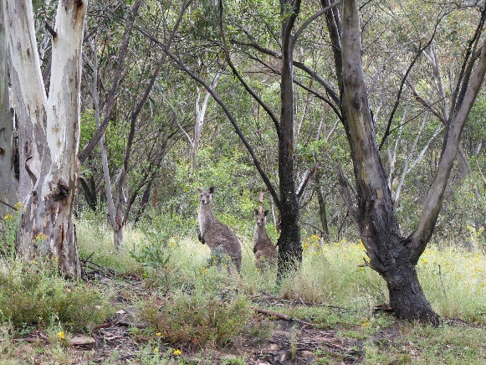

Neither Jesus nor John the Baptist was widely recognised as a wise person in their day. John was too demanding and severe and Jesus considered too lax. To his many critics, Jesus was naïve in his understanding of political power and influence, upset many religious people by his loose interpretation of God’s laws and liked hanging around with too many disreputable and contemptible types of people. And he had the gall to claim a close and intimate relationship with God whom he called Father! Even John the Baptist had doubts about Jesus, as Jesus was not bringing about the purifying of Israel that John expected. So for various reasons Jesus was not considered wise by the majority of his contemporaries.
Yet according to Jesus, his religious contemporaries were loading heavy burdens on people (e.g. purity laws, food laws) that completely missed the more important aspects of God’s ways (e.g. love, grace, mercy, justice). Instead Jesus is offering an alternative way of living, an alternative way of being ‘yoked’ – with him – that leads to rest for our souls.
Jesus’ statement that his yoke is ‘easy’ and ‘light’ compared to other ways of living is not immediately obvious. Jesus’ ethical teaching – as given in the Sermon on the Mount for instance – seems more demanding than other ways of living. And throughout Christian history, the church has often imposed its own set of rules that modern Western culture has now largely rejected. So in what ways is Jesus’ yoke ‘easy’ and ‘light’?
Rather than following a long list of rules, Jesus ultimately makes it simple and clear – love God wholeheartedly and love your neighbour as you love yourself. A wise person will hear these guidelines and live them out in practice. They provide a ready means of assessing all our actions – do they demonstrate God’s love in a practical way – as shown by Jesus?
If the answer is ‘yes’ then our spirits will be at peace and we will find rest.
HYMN TiS 585 I heard the voice of Jesus say
I heard the voice of Jesus say,
“Come unto me, and rest;
lay down, O weary one, lay down
your head upon my breast.”
I came to Jesus as I was,
weary, and worn, and sad;
I found in him a resting-place,
and he has made me glad.
I heard the voice of Jesus say,
“Behold, I freely give
the living water: thirsty one,
stoop down, and drink and live.”
I came to Jesus, and I drank
of that life-giving stream;
my thirst was quenched, my soul revived,
and now I live in him.
I heard the voice of Jesus say,
“I am this dark world’s light;
look unto me, your morn shall rise,
and all your day be bright.”
I looked to Jesus, and I found
in him my star, my sun;
and in that light of life I’ll walk
till travelling days are done.
Horatius Bonar 1808-89 alt.
YouTube version here https://www.youtube.com/watch?v=74kyfROS4q8

PRAYERS OF THE PEOPLE
Our Creator God,
you sustain all life.
Provide bread to all who need it today,
and hear the cries of the poor.
You alone have power to bring lasting peace and justice
and you are the provider of true safety and security.
Change the hearts of selfish or power hungry leaders
that they might seek peace and good for all their people.
We ask that, just as you have graciously provided for us and our needs,
may you provide for those who call to you today
in despair and great need.
We pause now to name those known to us who need a touch from you …
Grant them strength and hope in these coming days.
We pray in Jesus’ name, who taught his followers to pray, saying:
Our Father in heaven …
BENEDICTION
May the love of God surround you,
the compassion of Jesus inspire you
and the wisdom of the Holy Spirit guide you.
We go in peace to love and serve the Lord. Amen.
SENDING SONG God to enfold you
God to enfold you,
Christ to uphold you,
Spirit to keep you in heaven’s sight;
so may God grace you,
heal and embrace you,
lead you through darkness into the light.
Words and music John L. Bell and Graham Maule © WGRG. Used with permission.
For YouTube version see https://www.youtube.com/watch?v=zy8qDlxBp5I

