worship@home resources for 28 June
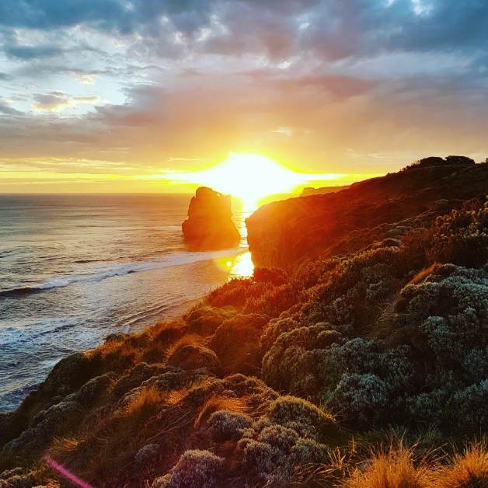
Call to Worship
O God, you summon the day to dawn;
you teach the morning to waken the earth.
Great is your name, great is your love.
For you the valleys will sing for joy,
the trees of the field will clap their hands.
Great is your name, great is your love.
Your love and justice shall last forever,
fresh as the morning, sure as the sunrise.
Great is your name, great is your love.
ACKNOWLEDGEMENT OF COUNTRY
For thousands of years, indigenous people have walked this land, on their own country.
Their relationship with the land is at the centre of their lives.
We acknowledge the Wurundjeri people of the Kulin nation
and their stewardship of this land throughout the ages.
We pay our respects to their elders and leaders, past, present and emerging,
and pray for the future of their communities.
May we all walk gently together and respectfully on this land,
seeking justice and reconciliation.
HYMN TiS 143 Immortal, invisible, God only wise
Immortal, invisible, God only wise,
in light inaccessible hid from our eyes,
most blessed, most glorious, the Ancient of Days,
almighty, victorious, your great name we praise.
Unresting, unhasting, and silent as light,
nor wanting, nor wasting, but ruling in might;
your justice like mountains, high soaring above,
your clouds which are fountains of goodness and love.
You give life to all, Lord, to both great and small,
in all life now living, the true life of all;
we blossom and flourish as leaves on a tree,
then wither, but ever unchanged you will be.
Great Father of glory, pure Father of light,
your angels adore you, all veiling their sight;
of all your rich graces this grace, Lord, impart –
take the veil from our faces, the veil from our heart.
Walter Chalmers Smith 1824-1908 alt.
For Songs of Praise YouTube version see https://www.youtube.com/watch?v=spE-BE23qxA
prayer
From before the world began
and after the end of eternity,
you are God.
From the sea bursting from its womb
to the wind ceasing from its chase,
you are God.
In the vastness of the universe
and the forgotten corners of our hearts,
you are God.
You are our God, and we bless you.
Because the world is beautiful,
and beauty is a fragile thing,
and we are caretakers of creation,
we need you, God.
We need you, God.
Because we can live without you
and are free to go against you
and could worship our wisdom alone,
we need you, God.
We need you, God.
Because you came among us and sat beside us
and heard us speak and saw us ignore you,
and healed our pain and let us wound you,
and loved us to the end
and triumphed over all our hatred,
we need you, God.
We need you, God.
Because you, not we, are God,
we need you, God.
We need you, God.
(Pause)
Listen for what the God who created us says:
‘Do not be afraid, for I have redeemed you;
I have called you by name: you are mine.
You are precious to me.
I love you, I honour you, I am with you.’
(Pause)
So we respond:
Maker of all, we are your children,
the creatures of your kindness,
the bearers of your image.
This day, we will walk by your light,
follow your Son
and live by your Spirit.
This day, we will not offer to you
offerings that cost us nothing.
For this is the day that the Lord has made:
we will rejoice and be glad in it.
Amen.
BIBLE READINGS
Psalm 8
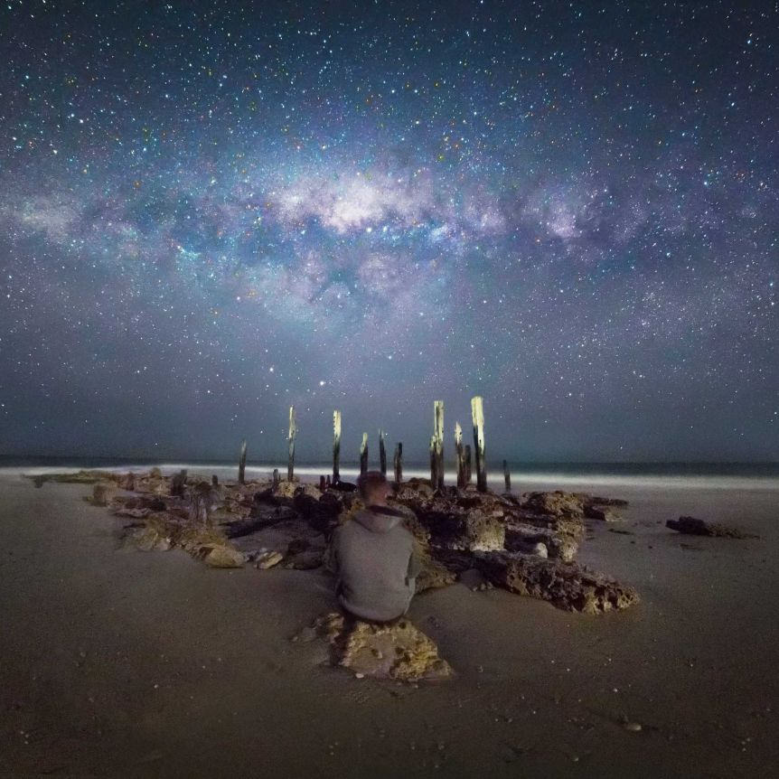
O Lord our God,
how glorious is your name in all the earth;
your majesty is praised above the heavens.
On the lips of children and babies
you have found praise to foil your enemies,
to silence the foe and the rebel.
When I see the heavens, the work of your hands,
the moon and stars which you arranged,
what are human beings
that you should remember them,
mere mortals that you have time for them?
You have made them in your own image,
and crowned them with glory and honour;
you appointed them guardians of all you created;
all things are kept in their care.
All of them, sheep and cattle,
yes even the savage beasts,
birds of the air,
and fish that make their way through the waters.
O Lord, our God,
how glorious is your name
in all the earth.

Genesis 22:1-14
After these things God tested Abraham. He said to him, ‘Abraham!’ And he said, ‘Here I am.’ He said, ‘Take your son, your only son Isaac, whom you love, and go to the land of Moriah, and offer him there as a burnt-offering on one of the mountains that I shall show you.’ So Abraham rose early in the morning, saddled his donkey, and took two of his young men with him, and his son Isaac; he cut the wood for the burnt-offering, and set out and went to the place in the distance that God had shown him. On the third day Abraham looked up and saw the place far away. Then Abraham said to his young men, ‘Stay here with the donkey; the boy and I will go over there; we will worship, and then we will come back to you.’ Abraham took the wood of the burnt-offering and laid it on his son Isaac, and he himself carried the fire and the knife. So the two of them walked on together. Isaac said to his father Abraham, ‘Father!’ And he said, ‘Here I am, my son.’ He said, ‘The fire and the wood are here, but where is the lamb for a burnt-offering?’ Abraham said, ‘God himself will provide the lamb for a burnt-offering, my son.’ So the two of them walked on together.
When they came to the place that God had shown him, Abraham built an altar there and laid the wood in order. He bound his son Isaac, and laid him on the altar, on top of the wood. Then Abraham reached out his hand and took the knife to kill his son. But the angel of the Lord called to him from heaven, and said, ‘Abraham, Abraham!’ And he said, ‘Here I am.’ He said, ‘Do not lay your hand on the boy or do anything to him; for now I know that you fear God, since you have not withheld your son, your only son, from me.’ And Abraham looked up and saw a ram, caught in a thicket by its horns. Abraham went and took the ram and offered it up as a burnt-offering instead of his son. So Abraham called that place ‘The Lord will provide’; as it is said to this day, ‘On the mount of the Lord it shall be provided.’
Matthew 10:40-42
‘Whoever welcomes you welcomes me, and whoever welcomes me welcomes the one who sent me. Whoever welcomes a prophet in the name of a prophet will receive a prophet’s reward; and whoever welcomes a righteous person in the name of a righteous person will receive the reward of the righteous; and whoever gives even a cup of cold water to one of these little ones in the name of a disciple—truly I tell you, none of these will lose their reward.’
REFLECTION
Three very different texts – a Psalm that ponders the place of humanity in the grand vastness of creation, a troubling story from Genesis that is named as ‘a text of terror’ by some commentators, and a short Gospel reading that concludes Jesus’ teaching on mission and the promise of God’s reward.
- What do these texts reveal about the nature of God?
- How do we worship this God, who both threatens death and offers life?
- How do we follow the God who commands yet who remains deeply mysterious?
- How do we trust God who both tests yet who also provides what we need?

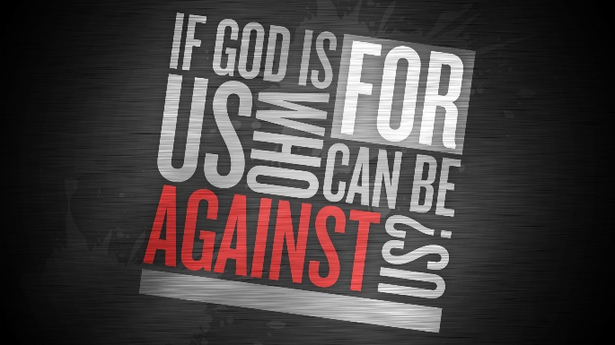
A closing thought from Romans 8:31-32 …
If God is for us, who is against us? He who did not withhold his own Son, but gave him up for all of us, will he not with him also give us everything else?

HYMN TiS 569 Guide me, O thou great Redeemer
Guide me, O thou great Redeemer,
pilgrim through this barren land;
I am weak, but thou art mighty;
hold me with thy powerful hand:
bread of heaven, bread of heaven,
feed me now and evermore,
feed me now and evermore.
Open now the crystal fountain,
whence the living waters flow;
let the fire and cloudy pillar
lead me all my journey through:
strong deliverer, strong deliverer,
be thou still my strength and shield,
be thou still my strength and shield.
When I tread the verge of Jordan,
bid my anxious fears subside;
death of death, and hell's destruction,
land me safe on Canaan's side:
songs of praises, songs of praises,
I will ever give to thee,
I will ever give to thee..
William Williams 1717-91.
YouTube version from Big Sing here https://www.youtube.com/watch?v=Ofp6rdAgRrY
PRAYERS OF THE PEOPLE
Where the hungry go unfed, while the privileged gorge themselves;
where the poor go begging while the rich amass greater fortunes;
where tyrants have bitten the dust but their successors prove no better,
God of justice, show yourself.
Where the prisoner is not prepared for freedom
and the refugee is not accorded dignity;
where those who are disadvantaged are excluded
and those who are disabled are left on the margins;
where gender, race or religion are grounds for suspicion,
or confer unmerited privilege,
God of justice, show yourself.
To those who speak for the voiceless and defend the persecuted,
to those who protest for a fairer world and practise simpler living,
to those who share their faith in Jesus in places where faith is suspected,
God of justice, show yourself.
And to us, that we might serve and love you
with body, soul and mind,
God of justice, show yourself.
God, hear our prayer
and make us willing agents of your gracious purposes,
in Jesus’ name, who taught his followers to pray, saying:
Our Father in heaven …
BENEDICTION
From where we are to where you need us,
Jesus, lead us on.
From the familiarity of what we know
to the wonder of what you will reveal,
Jesus, lead us on.
To transform the fabric of this world
until it resembles the shape of your kingdom,
Jesus, lead us on.
Because good things have been prepared
for those who love God,
Jesus, lead us on.
SENDING SONG TiS 782 Go now in peace
Go now in peace, go now in peace,
may the love of God surround you everywhere,
everywhere you may go.
Words and music © Natalie Sleeth 1930-92. Used with permission.
For YouTube version see https://www.youtube.com/watch?v=oRW1E0FzXek

