worship@home resources for 21 June

This week we celebrate the 43rd anniversary of the inauguration of the Uniting Church in Australia and we give thanks to God.
Call to Worship
We have been created in the image of God
We are created to love God and to love our neighbour
Christ has taught us how to love one another
and we are called to share that love with the world
The Holy Spirit moves in us, giving us gifts to do God’s work
We go where God is leading us
HYMN TiS 106 Now thank we all our God
Now thank we all our God, with heart and hands and voices,
who wondrous things has done, in whom this world rejoices;
who from our mothers’ arms has blessed us on our way
with countless gifts of love, and still is ours today.
O may this bounteous God through all our life be near us,
with ever joyful hearts and blessed peace to cheer us.
Lord, keep us in your grace, and guide us when perplexed,
and free us from all harm in this world and the next.
All praise and thanks to God who reigns in highest heaven,
to Father and to Son and Spirit now be given:
the one eternal God, whom heaven and earth adore,
who ever was, is now, and shall be ever more.
Martin Rinkart 1586-1649. tr. Catherine Winkworth 1827-78 alt.
For a YouTube version see https://www.youtube.com/watch?v=s99dNPKYtHk&t=5s
prayer
God who brings light to the darkness and life to us all,
be with us today as you are with us always.
Bless us as we gather alone or in small groups,
as the body of Christ, your church.
Send your Spirit to inspire our reading,
praying, remembering, wondering and celebrating.
God of light and life,
as a church and as your disciples,
we have not always listened to your whispers,
we have not always turned towards your light,
we have not always trusted you to lead us.
Have mercy on our fear and our frailty,
our hesitance and our neglect of the ways of Christ.
Help us to accept and take up our mission in the world
and to live and speak and act as those who truly belong to you.
We pray in Jesus’ name. Amen.
ASSURANCE OF FORGIVENESS
God has counted even the hairs on your head
so know that you are greatly loved and forgiven
Thanks be to God
BIBLE READINGS
Psalm 122
I was glad when they said to me,
‘Let us go to the house of the Lord!’
Our feet are standing
within your gates, O Jerusalem.
Jerusalem—built as a city
that is bound firmly together.
To it the tribes go up,
the tribes of the Lord,
as was decreed for Israel,
to give thanks to the name of the Lord.
Pray for the peace of Jerusalem:
‘May they prosper who love you.
Peace be within your walls,
and security within your towers.’
For the sake of the house of the Lord our God,
I will seek your good.
Matthew 10:27-39
What I say to you in the dark, tell in the light; and what you hear whispered, proclaim from the housetops. Do not fear those who kill the body but cannot kill the soul; rather fear him who can destroy both soul and body in hell. Are not two sparrows sold for a penny? Yet not one of them will fall to the ground unperceived by your Father. And even the hairs of your head are all counted. So do not be afraid; you are of more value than many sparrows.
‘Everyone therefore who acknowledges me before others, I also will acknowledge before my Father in heaven; but whoever denies me before others, I also will deny before my Father in heaven. Do not think that I have come to bring peace to the earth; I have not come to bring peace, but a sword. For I have come to set a man against his father, and a daughter against her mother, and a daughter-in-law against her mother-in-law; and one’s foes will be members of one’s own household. Whoever loves father or mother more than me is not worthy of me; and whoever loves son or daughter more than me is not worthy of me;
and whoever does not take up the cross and follow me is not worthy of me. Those who find their life will lose it, and those who lose their life for my sake will find it.
REFLECTION
This Sunday we are given the opportunity to reflect on the journey of the Uniting Church since its inauguration in 1977. For some of us this is a time to celebrate the many achievements of the Uniting Church over the last 40+ years. For others it is a chance to reflect on the difficulties and decline of the church during this period. For those born since 1977 or new to the church since Union, there has only been the experience of the Uniting Church and not the lead-up and high expectations associated with forming a ‘new’ church from three existing denominations.
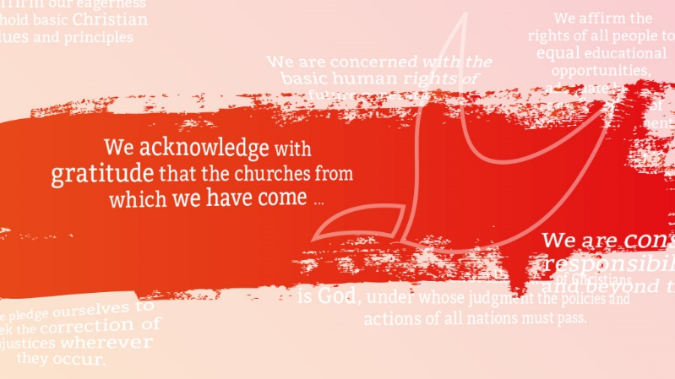
So this week we attempt to walk the fine line between glorifying the past on one hand and regretting the past on the other hand as we try to gain a realistic perspective of where we find ourselves today. To help us in our task, please take a couple of minutes to read the Statement to the Nation that was issued at the time of Union (see below). This statement witnesses to the emerging DNA of the newly formed church and highlights some priorities for ministry. As you read, note any themes or issues that stand out – or that are omitted.
Statement to the Nation: Inaugural Assembly, June 1977
People of the Congregational, Methodist and Presbyterian Churches have united. A new church has been born.
We, who are members of the first Assembly of the Uniting Church in Australia address the people of Australia in this historic moment. The path to unity has been long and at times difficult, but we believe this unity is a sign of the reconciliation we seek for the whole human race.
We acknowledge with gratitude that the churches from which we have come have contributed in various ways to the life and development of this nation. A Christian responsibility to society has always been regarded as fundamental to the mission of the Church. In the Uniting Church our response to the Christian gospel will continue to involve us in social and national affairs.
We are conscious of our responsibilities within and beyond this country. We particularly acknowledge our responsibilities as one branch of the Christian church within the region of South-East Asia and the Pacific. In these contexts we make certain affirmations at the time of our inauguration.
We affirm our eagerness to uphold basic Christian values and principles, such as the importance of every human being, the need for integrity in public life, the proclamation of truth and justice, the rights for each citizen to participate in decision-making in the community, religious liberty and personal dignity, and a concern for the welfare of the whole human race.
We pledge ourselves to seek the correction of injustices wherever they occur. We will work for the eradication of poverty and racism within our society and beyond. We affirm the rights of all people to equal educational opportunities, adequate health care, freedom of speech, employment or dignity in unemployment if work is not available. We will oppose all forms of discrimination which infringe basic rights and freedoms.
We will challenge values which emphasise acquisitiveness and greed in disregard of the needs of others and which encourage a higher standard of living for the privileged in the face of the daily widening gap between the rich and poor.
We are concerned with the basic human rights of future generations and will urge the wise use of energy, the protection of the environment and the replenishment of the earth's resources for their use and enjoyment.
Finally we affirm that the first allegiance of Christians is God, under whose judgment the policies and actions of all nations must pass. We realise that sometimes this allegiance may bring us into conflict with the rulers of our day. But our Uniting Church, as an institution within the nation, must constantly stress the universal values which must find expression in national policies if humanity is to survive.
We pledge ourselves to hope and work for a nation whose goals are not guided by self-interest alone, but by concern for the welfare of all persons everywhere — the family of the One God — the God made known in Jesus of Nazareth the One who gave his life for others.
In the spirit of his self-giving love we seek to go forward.
______________________
In reading this statement it is hard to miss the emphasis on seeking justice and promoting universal human rights, which have been strengths of the Uniting Church since its inception. It is also clear that the very act of union between the three denominations was hoped to be seen as a visible and ongoing act of reconciliation. It is noteworthy, however, in light of later developments, that the Statement makes no reference at all to indigenous Australians and the search for reconciliation between First and Second Peoples.
The statement is clearly outward looking and seeks to engage the minds and imaginations of the Australian people. This willingness to engage in ‘public theology’ is laudable, but has been slowly pushed aside by a society that sees no place for the church in public discourse. In 1977 the Church was mainstream … in 2020 the Church is mostly at the margins.
The involvement with government has also changed markedly over the decades. The Statement speaks of potential conflict with rulers – just as the Gospel reading this week speaks of potential conflict within families – yet this has rarely happened. Instead we have accepted government grants for many of our welfare ministries (e.g. various Uniting ministries, aged care) – and this reduces our ability to critique or speak prophetically.
Being a Statement that addresses the nation, it says little about the internal life of the church – our worship, pastoral care, growing people in their faith, leadership and sharing of the good news with others. These issues have sometimes been neglected in the face of a focus on justice and compassion ministries. The result is that we have not been great at making disciples and this is reflected in the age profile of many of our churches.
As you reflect on your own experience of the Uniting Church, what are you most thankful for? And what do you see as the main challenges facing the Church?
Where might our priorities need to change?
HYMN TiS 468 We are your people
We are your people;
Spirit of grace,
you dare to make us
to all our neighbours,
Christ's living voice, hands and face.
Joined in community,
treasured and fed,
may we discover
gifts in each other,
willing to lead and be led.
Rich in diversity,
help us to live
closer than neighbours,
open to strangers,
able to clash and forgive.
Glad of tradition,
help us to see
in all life's changing,
where you are leading,
where our best efforts should be.
Christ as we serve you
in different ways,
may all we’re doing
show that you’re living,
meeting your love with our praise.
Words Brian Wren © 1975. Rev 1999 Hope Publishing Company. Used by permission.
YouTube version here https://www.youtube.com/watch?v=jJ22KSDgJzk
PRAYERS OF THE PEOPLE
For the life of the Congregationalists
Thanks be to God
For the life of the Methodists
Thanks be to God
For the life of the Presbyterians
Thanks be to God
For the life of the Uniting Church
and her many expressions of the ministry of Christ that we share.
Thanks be to God
Spend some time praying for the Church, for leaders in government and in our community, and for people known to us who need a touch from God’s love today.
Amen.
Finish by praying the Lord’s Prayer
BENEDICTION
Go, knowing that you are precious to God.
Share the blessing you have been given
by the way you live and love in the world.
Make peace.
Speak truth.
Shine the light.
We go in peace to love and serve the Lord. Amen
SENDING SONG TiS 781 Father, bless us as we go
Father, bless us as we go,
Jesus, walk beside us.
Holy Spirit, guide us.
Words and music © Robin Mann.
For YouTube version see https://www.youtube.com/watch?v=POBe6v4fB10

