worship@home resources for Refugee Sunday

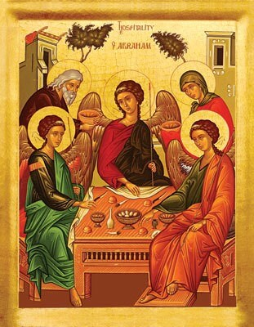
Call to Worship (based on Genesis 18:1-7)
As Abraham welcomed three strangers
so God welcomes us
God greets us with joy
and says, “rest here for awhile”
God brings out water to wash our dusty feet
God prepares a meal to nourish our weary spirits
So let us receive the gracious hospitality of our God
Let us rest in this holy place
where there is shade and water, food and laughter
HYMN TiS 161 Tell out my soul
Tell out, my soul, the greatness of the Lord!
Unnumbered blessings give my spirit voice;
tender to me the promise of his word;
in God my Saviour shall my heart rejoice.
Tell out, my soul, the greatness of his name!
Make known his might, the deeds his arm has done;
his mercy sure, from age to age to same;
his holy name--the Lord, the Mighty One.
Tell out, my soul, the greatness of his might!
Powers and dominions lay their glory by.
Proud hearts and stubborn wills are put to flight,
the hungry fed, the humble lifted high.
Tell out, my soul, the glories of his word!
Firm is his promise, and his mercy sure.
Tell out, my soul, the greatness of the Lord
to children's children and for evermore!
Words Timothy Dudley-Smith © 1962. Used by permission
Songs of Praise version here https://www.youtube.com/watch?v=3E7QWLyDWe8
prayer (from the Uniting Church Assembly)
God of Abraham, Sarah and Hagar,
God of travellers, migrants and refugees.
Thank you for the beauty and uniqueness
of this southern land which we share.
Grant your protection and grace to all who live and shelter here.
Forgive the racism and destruction that have been part of our history,
and our disregard for the pain and oppression
within the Australian community today.
Help us shed our narrow expectations.
Take away our cultural tunnel vision.
Open our hearts to be caring neighbours to each other.
Direct our lives to just and peaceful action.
God of a thousand faces,
help us also to acknowledge you are worshipped in many languages,
in different songs and rhythms of life from our own.
May we respect these insights in each other
and assist each faithful expression of you.
We rejoice in you, God,
in whose image we are brothers and sisters
and by whose example in Jesus Christ
we know the breadth and depth of your universal love.
Amen.

ASSURANCE OF FORGIVENESS
Know that you are loved and valued and forgiven
Thanks be to God for hearing our prayer and renewing us
BIBLE READINGS
Psalm 86:1-11
Hear me, Lord, and answer me,
for I am poor and needy.
Guard my life, for I am faithful to you;
save your servant who trusts in you.
You are my God; have mercy on me, Lord,
for I call to you all day long.
Bring joy to your servant, Lord,
for I put my trust in you.
You, Lord, are forgiving and good,
abounding in love to all who call to you.
Hear my prayer, Lord;
listen to my cry for mercy.
When I am in distress, I call to you,
because you answer me.
Among the gods there is none like you, Lord;
no deeds can compare with yours.
Teach me your way, Lord,
that I may rely on your faithfulness;
give me an undivided heart,
that I may fear your name.

Genesis 18:1-14
The Lord appeared to Abraham by the oaks of Mamre, as he sat at the entrance of his tent in the heat of the day. He looked up and saw three men standing near him. When he saw them, he ran from the tent entrance to meet them, and bowed down to the ground. He said, ‘My lord, if I find favour with you, do not pass by your servant. Let a little water be brought, and wash your feet, and rest yourselves under the tree. Let me bring a little bread, that you may refresh yourselves, and after that you may pass on—since you have come to your servant.’ So they said, ‘Do as you have said.’ And Abraham hastened into the tent to Sarah, and said, ‘Make ready quickly three measures of choice flour, knead it, and make cakes.’ Abraham ran to the herd, and took a calf, tender and good, and gave it to the servant, who hastened to prepare it. Then he took curds and milk and the calf that he had prepared, and set it before them; and he stood by them under the tree while they ate.
They said to him, ‘Where is your wife Sarah?’ And he said, ‘There, in the tent.’ Then one said, ‘I will surely return to you in due season, and your wife Sarah shall have a son.’ And Sarah was listening at the tent entrance behind him. Now Abraham and Sarah were old, advanced in age; it had ceased to be with Sarah after the manner of women. So Sarah laughed to herself, saying, ‘After I have grown old, and my husband is old, shall I have pleasure?’ The Lord said to Abraham, ‘Why did Sarah laugh, and say, “Shall I indeed bear a child, now that I am old?” Is anything too wonderful for the Lord? At the set time I will return to you, in due season, and Sarah shall have a son.’
Matthew 10:1, 5-11
Then Jesus summoned his twelve disciples and gave them authority over unclean spirits, to cast them out, and to cure every disease and every sickness. … These twelve Jesus sent out with the following instructions: ‘Go nowhere among the Gentiles, and enter no town of the Samaritans, but go rather to the lost sheep of the house of Israel. As you go, proclaim the good news, “The kingdom of heaven has come near.” Cure the sick, raise the dead, cleanse the lepers, cast out demons. You received without payment; give without payment. Take no gold, or silver, or copper in your belts, no bag for your journey, or two tunics, or sandals, or a staff; for labourers deserve their food. Whatever town or village you enter, find out who in it is worthy, and stay there until you leave.
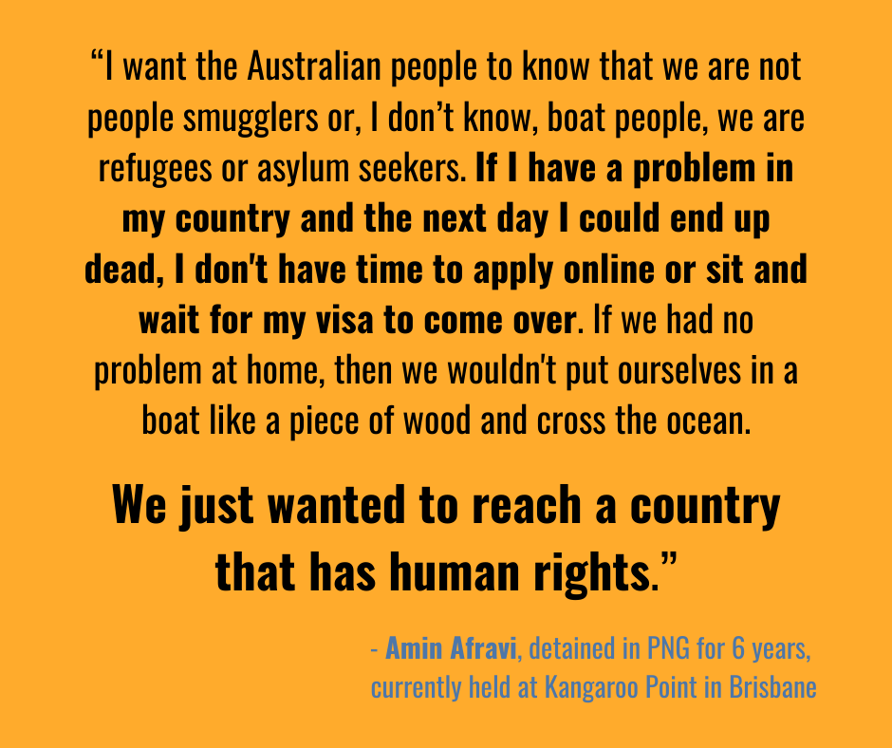
REFLECTION
This Refugee Sunday we remember refugees and asylum seekers. Due to violence, famine and persecution, there are currently an estimated 70 million displaced people in the world. Some of these have made their way to Australia, where our response during the past 20 years has been to incarcerate them in prisonlike conditions or leave them in limbo living in the community but without any government assistance while their claims are ‘processed’. In Australia, this processing may take several years. During the Covid19 pandemic, we endured 7 or 8 weeks of lockdown. Many asylum seekers have endured 7 or 8 years or more of detention. It was not always this way. Following World War 2, we welcomed many refugees to our country … and welcomed many Vietnamese refugees in the late 1970s.
It’s interesting to reflect on which biblical characters were refugees or asylum seekers. The list is long and includes Abraham and Sarah, Jacob and his entire extended family (in Egypt), David, Jeremiah, Isaiah, Esther, Ezra, Nehemiah and most of the people of Israel (in Babylon) … and of course Mary and Joseph and Jesus (escaping from King Herod). The contemporary causes that make people flee their homes to seek safety and shelter in other places have been part of history and have been the lived experience of many of God’s people.
Unsurprisingly, then, there are multiple calls to care for and welcome refugees. A small selection of verses include the following …
- You shall not mistreat or oppress a refugee; you know the heart of a refugee, for you were refugees in the land of Egypt. (Exod 23:9)
- The refugee who resides with you shall be to you as the citizen among you; you shall love the refugee as yourself, for you were refugees in the land of Egypt. (Lev 19:34)
- The Lord your God is God of gods and Lord of lords … who executes justice for the orphan and the widow, and who loves the refugee, providing them food and clothing. (Deut 10:17-18)
In today’s reading from Genesis, Abraham offers a lavish welcome to three strangers. The story is ambiguous whether these visitors are human or perhaps angels in human form or even God. Abraham’s hospitality is extravagant. During the visit, it is Abraham and Sarah who are blessed with the promise of a son. So likewise, when we welcome foreigners and refugees, it is we who are often blessed.
In the Gospel reading this week, Jesus gives instructions to the disciples about their role in extending Jesus’ mission. Like him, they will go to the lost sheep of Israel – the poor and sick and excluded people – and will bring a message of hope and life. Again we are invited to welcome others to enter the kingdom of God and its blessing, and this welcome includes practical help, even as we graciously accept the hospitality of others.
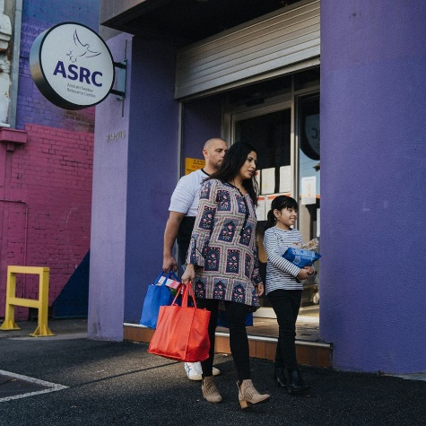
In the face of great need, how might we live out God’s call to welcome refugees and asylum seekers in our midst? First, we must recognise that these are people and not merely statistics who – like us – have parents, partners and children. They did not choose to become a refugee, but were usually forced to flee suddenly due to threats against their lives. They are not ‘queue jumpers’ as usually there was no time or place to write their names on a list. Instead they are vulnerable people who need our welcome and support.
Our welcome may include supporting organisations like the Asylum Seeker Resource Centre (ASRC) who help provide food, medical needs, counselling and legal support. Our welcome may be to visit the Detention Centre in Broadmeadows and provide a little human kindness (although visits are currently suspended due to Covid19). Our welcome may include speaking to local politicians about changing our government’s harsh and cruel policies. And we can pray for change and for compassion. How might you offer welcome to these people?
HYMN All are welcome
Let us build a house where love can dwell
and all can safely live,
a place where saints and children tell
how hearts learn to forgive;
built of hopes and dreams and visions,
rock of faith and vault of grace;
here the love of Christ shall end divisions:
All are welcome, all are welcome,
all are welcome in this place.
Let us build a house where prophets speak,
and words are strong and true,
where all God’s children dare to seek
to dream God’s reign anew.
Here the cross shall stand as witness
and as symbol of God’s grace;
here as one we claim the faith of Jesus:
Refrain
Let us build a house where hands will reach
beyond the wood and stone
to heal and strengthen, serve and teach,
and live the Word they’ve known.
Here the outcast and the stranger
bear the image of God’s face;
let us bring an end to fear and danger:
Refrain
Let us build a house where all are named,
their songs and visions heard
and loved and treasured, taught and claimed
as words within the Word.
Built of tears and cries and laughter,
prayers of faith and songs of grace,
let this house proclaim from floor to rafter:
Refrain
Text: Marty Haugen, b. 1950. Text © 1994 GIA Publications, Inc. Used by permission.
For a YouTube version see https://www.youtube.com/watch?v=wFz_3n224MA

PRAYERS OF THE PEOPLE (a prayer from Common Grace)
Creator God, you are the giver of life.
Saviour Jesus, you have shown us what it is to love.
Guiding Spirit, you awaken us to justice.
Show us how to build a just future,
where all people have equal opportunity to belong
and to flourish in your vitality and love.
We ask for mercy for people in limbo on temporary visas,
for safety for those seeking permanent protection,
for reunion for families who are separated by borders,
and for relief for those losing hope within our detention systems.
We pray for First Nations Peoples
fighting for justice on their own lands,
for survivors of domestic violence
and for creation groaning under climate disruption.
Help us to live out your inclusive love.
Help us to live into your kingdom
where all people have equal opportunity to belong and flourish.
Work through us, towards a just future.
Amen.
Finish by praying the Lord’s Prayer
BENEDICTION
May the love of God surround you,
the compassion of Jesus inspire you
and the wisdom of the Holy Spirit guide you.
We go in peace to love and serve the Lord. Amen
SENDING SONG TiS 779 May the feet of God walk with you
May the feet of God walk with you,
and God’s hand hold you tight.
May the eye of God rest on you,
and God’s ear hear your cry.
May the smile of God be for you,
and God’s breath give you life.
May the Child of God grow in you,
and God’s love bring you home.
Words © A.W. Podlich. Music © R. Mann.
For YouTube version see https://www.youtube.com/watch?v=OJ6RaKX4_I4&t=12s

