worship@home resources for Trinity Sunday

Call to Worship (based on Exodus 34:6-8)
What is God like?
God is forgiving and gracious
What is God like?
God is slow to anger
What is God like?
God is rich in kindness
Creator, Redeemer and Sustainer
God welcomes us with love
HYMN TiS 132 Holy, holy, holy
Holy, holy, holy! Lord God Almighty,
early in the morning to you our praise shall be;
Holy, holy, holy! merciful and mighty
God in three persons, blessed Trinity.
Holy, holy, holy! though the darkness hide you,
though the sinful human eye your glory may not see,
you alone are holy, there is none beside you
perfect in power, in love and purity.
Holy, holy, holy! Lord God Almighty,
all your works shall praise your name in earth and sky and sea;
Holy, holy, holy! merciful and mighty
God in three persons, blessed Trinity.
Reginald Heber 1783-1826 alt.
Beautiful YouTube version here https://www.youtube.com/watch?v=AgHrNNM23p8
prayer
Mysterious God,
power behind all we see,
grace beyond all we know,
love before all we meet,
we cannot comprehend your majesty.
We only know your presence in our lives:
you, who knew us before we were born;
you, who will cradle us after our last breath.
We cannot imagine your glory;
instead we marvel at all the works your hand has made
and we worship you.

Forgiving God,
we believe in your goodness yet we also have doubts about you
Strengthen our faith
Gracious Lord Jesus,
we try to follow your ways yet we often feel guilty when we fall short
Release us from our negative thoughts
Life-giving Spirit,
we hear your call nudging us out of our comfort zones
Change our hearts and show us how to follow you
Trinity of love,
release us from what holds us back.
Help us to grow up into all that you intend us to be.
We pray in Jesus’ name. Amen.

ASSURANCE OF FORGIVENESS
God loves us, deeply and unconditionally
Jesus offers us grace and compassion
The Spirit binds us together with believers everywhere
Hear the good news: through Christ we are loved and renewed
Thanks be to God for inviting us to share the life of the Trinity of love
BIBLE READINGS
Psalm 8
O God, how majestic is your name in all the earth!
Creation throbs with your glory
Your glory is revealed in the vast reaches of the universe;
in the twinkling stars reflected in the wondering eyes
and simple songs of little children.
Compared with God’s awesome power,
our lives may seem insignificant
if we did not know how deeply God cares for us and for all of creation
For God chose to honour humanity
giving us the responsibility of caring for this wonderful creation
O God, how majestic is your name in all the earth!
Ephesians 4:1-6
I therefore, the prisoner in the Lord,
beg you to lead a life worthy of the calling to which you have been called,
with all humility and gentleness, with patience,
bearing with one another in love,
making every effort to maintain the unity of the Spirit in the bond of peace.
There is one body and one Spirit,
just as you were called to the one hope of your calling,
one Lord, one faith, one baptism, one God and Father of all,
who is above all and through all and in all.
Matthew 28:16-20
Now the eleven disciples went to Galilee, to the mountain to which Jesus had directed them. When they saw him, they worshipped him; but some doubted. And Jesus came and said to them, ‘All authority in heaven and on earth has been given to me. Go therefore and make disciples of all nations, baptizing them in the name of the Father and of the Son and of the Holy Spirit, and teaching them to obey everything that I have commanded you. And remember, I am with you always, to the end of the age.’

REFLECTION
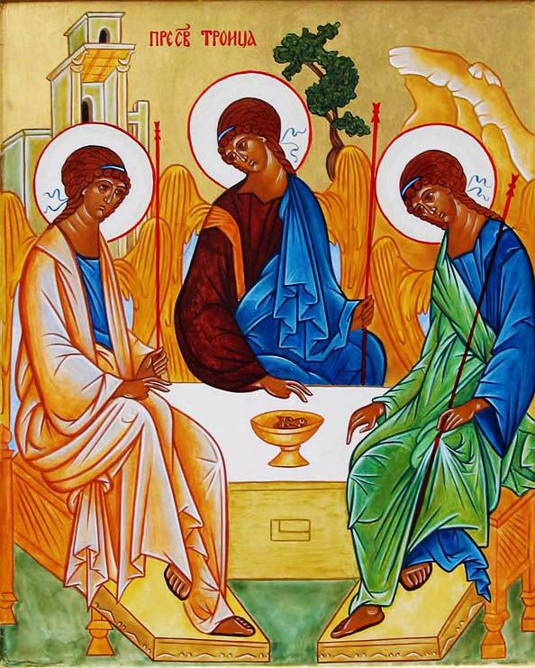
The Trinity is one of those mysteries that is hard to get one’s mind around. We proclaim that there is only one God – and then we name God as Father, Son and Holy Spirit – which implies a threeness – as depicted in the famous Rublev icon of the Trinity opposite. This form of addressing God – which has biblical precedent from passages such as Matthew 28:19 – raises other issues for us as it sounds quite patriarchal to our contemporary culture. And yet here we are on Trinity Sunday, invited to reflect on who God is for us and what it means to be God’s people in the world.
Something that may surprise you is that trinitarian thinking came very early in the life of the church. The apostle Paul was using a trinitarian blessing within 20 years of Jesus’ death – what we know as the Grace from 2 Cor 13:13 – ‘May the grace of our Lord Jesus Christ, the love of God and the communion of the Holy Spirit be with you all’. From a very early date baptism was carried out in the name of the Father, Son and Spirit.
Although the Trinity is a way of thinking about God, it’s actually mostly about Jesus and attempts by the church to describe the relationship between Jesus and God. So in the Great Commission at the end of Matthew’s Gospel, it’s Jesus who claims that all authority in heaven and on earth has been given to him – effectively claiming God’s authority for himself. It’s Jesus who is worshipped on the mountain by the disciples. And it’s Jesus promising to be with the disciples forever – as Emmanuel – God with us – the title given to him in the opening chapter of this Gospel. How will Jesus be with us? Through the presence of the Holy Spirit! So this passage is thoroughly trinitarian – and thoroughly focused on Jesus – as are the later creeds of the Church – and the Basis of Union of the Uniting Church.
There have been many attempts over the years to visualise the Trinity symbolically or using an analogy of some sort (e.g. water exists in three states – gas, liquid and solid). Most of these attempts are somewhat problematic. One common symbol is a triangle or Celtic knot (with three points representing the three persons of the Trinity). The problem here is the implied hierarchy, with the Father at the top, with the Son and the Spirit as lesser.
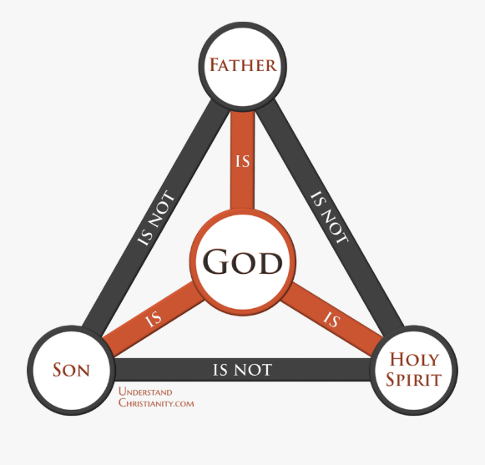
A better image might be a circle – which has no beginning or end – representing the eternal relationship between the three persons. But a circle is a geometric shape and doesn’t capture the personhood of God who invites us into a living relationship. Some suggest that we view this relationship as a dance that we are invited to join – so that we may be in God in a similar way that Jesus is in the Father and the Father is in Jesus (e.g. John 14:11, 17:21).
One of the implications of this is that all three persons of the godhead act together, whether in creation or on the cross or at Pentecost. Another implication is that the Trinity is a community of love that we are invited to participate in … and also a community of justice … and a community set apart from the world (which we call holiness) yet fully involved in the life of the world.
What sort of response might we make to these truths about God? An appropriate response would be great thankfulness for our inclusion in God’s community. Another response might be worship … or a renewed commitment to follow the ways of Jesus. However we choose to respond, let us take some time to sit in God’s presence and ponder God’s grace and love for us. God our Creator, our Redeemer and our Sustainer, help us to know you more clearly, love you more dearly and follow you more nearly each and every day.
HYMN (tune Morning has broken TiS 156)
God of Creation
gentle life-giver;
present at birth, and
all through our days.
Author of sunrise,
song in the night sky,
here in this place, we
offer our praise.
Jesus, Companion,
teacher and healer,
friend of the grieving,
suffering, and poor.
Stand with your people,
whisper among us -
promise of mercy,
goodness for all.
Spirit of Comfort
blow through creation,
stir up new life, breathe
peace through our world.
Healer of hearts, and
hope for tomorrow,
weave all our sorrows
into new dawn.
Here we give thanks for
life in its fullness,
blessings received
your gifts to us all.
Make us a people
filled with compassion,
selflessly giving,
serving your world.
© 2010 Craig Mitchell. Used with permission.
PRAYERS OF THE PEOPLE (adapted from a trinitarian prayer by Janet Nelson)
Blessed are you, O God our Creator, for you have
brought to birth a universe of beauty and splendour.
We pray for the peoples and eco-systems of the earth …
(add your own prayers here …)
Look with compassion on your creation that is groaning and in pain.
Teach us how to live with justice and with care for the whole creation.
Ever–living God, in your mercy. Hear our prayer.
Blessed are you, O God our Redeemer, for your love
and grace for your people is as sure as the sunrise.
We pray for your church, both here and across the world …
(add your own prayers here …)
Heal our divisions and distrust and teach us how to live
as members of one body.
Ever–living God, in your mercy. Hear our prayer.
Blessed are you, O God our Sustainer, for you are
with us always, in times of sadness and in times of joy.
We pray for those we know who are in need today …
(add your own prayers here …)
Be present with those who are suffering and teach us how to live
as a caring and compassionate community.
Ever–living God, in your mercy. Hear our prayer.
Blessed are you, O God,
Creator, Redeemer and Sustainer,
who has loved us with an everlasting love.
Amen.
BENEDICTION
So now we leave this time of worship
and while much of our road ahead is uncertain,
we know some things that are as solid and sure
as the ground beneath our feet,
and the sky above our heads.
We know God is love.
We know Christ’s light endures.
We know the Holy Spirit is here,
closer to us than our next breath,
binding us to each other,
until we meet we again.
We go in peace to love and serve the Lord. Amen
SENDING SONG
God to enfold you,
Christ to uphold you,
Spirit to keep you in heaven’s sight;
so may God grace you,
heal and embrace you,
lead you through darkness into the light.
Words and music John L. Bell and Graham Maule © WGRG. Used with permission.
For YouTube version see https://www.youtube.com/watch?v=zy8qDlxBp5I

