worship@home resources for Pentecost

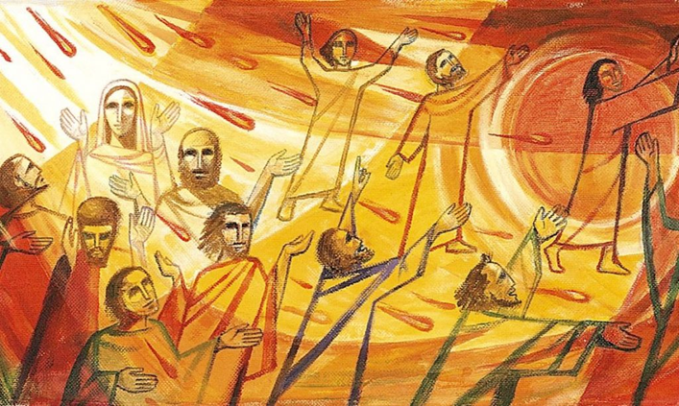
Call to Worship
God speaks to us
through the riches of creation
God speaks to us
through the stories of Jesus
God speaks to us
through the lives of other people
HYMN TiS 398 Come down, O Love divine
Come down, O Love divine,
seek thou this soul of mine,
and visit it with thine own ardour glowing;
O Comforter, draw near,
within my heart appear
and kindle it, your holy flame bestowing.
There let it freely burn,
till earthly passions turn
to dust and ashes, in its heat consuming;
and let your glorious light
shine ever on my sight,
and clothe me round, the while my path illuming.
And so the yearning strong,
with which the soul will long
shall far outpass the power of human telling;
for none can guess its grace
till we become the place
in which the Holy Spirit makes his dwelling.
Bianco de Siens 1434 tr. Richard Littledale 1833-90 alt.
YouTube version here https://www.youtube.com/watch?v=zXO4rqBQOAU
prayer
God of freedom and new beginnings,
we come to worship you this morning,
aware of our weaknesses and frailties
- but also aware of your creative and renewing power.
We remember this morning how you breathed new life
into your people at Pentecost
and how you inspired and empowered them with fresh vision.
Although some of us may be getting old and set in our ways,
breathe your Spirit afresh into our lives.
Disturbing God, you are always doing new things in our midst
Forgive us when we have no expectation or desire for newness of life
Creating God, you promise to give your people dreams and visions
Forgive us when we are unwilling to see beyond what we’ve always known
Strong God, you empower us every day through your Spirit
Forgive us when we hide behind our fear and remain silent
Gracious God, refresh and renew us with your Holy Spirit
so that we be filled with faith, courage and joy.
We pray in Jesus’ name. Amen.

ASSURANCE OF FORGIVENESS
God promises to give us new life through the Spirit
Hear the good news: God loves us and guides our path
Thanks be to God for moving among us

BIBLE READINGS
Genesis 1:1-5, 2:5-7 (The Message)
First this: God created the heavens and earth—all you see, all you don’t see. Earth was a soup of nothingness, a bottomless emptiness, an inky blackness.
God’s Spirit brooded like a bird above the watery abyss.
God spoke: “Light!” And light appeared.
God saw that light was good and separated light from dark.
God named the light ‘day’, he named the dark ‘night’.
It was evening, it was morning— day one.
At the time God made earth and heaven, before any grasses or shrubs had sprouted from the ground—God hadn’t yet sent rain on the earth, nor was there anyone around to work the ground (the whole earth was watered by underground springs)—God formed man out of dirt from the ground and blew into his nostrils the breath of life. The man came alive—a living person!

Acts 2:1-16, 22-24, 32-39
When the day of Pentecost had come, they were all together in one place. And suddenly from heaven there came a sound like the rush of a violent wind, and it filled the entire house where they were sitting. Divided tongues, as of fire, appeared among them, and a tongue rested on each of them. All of them were filled with the Holy Spirit and began to speak in other languages, as the Spirit gave them ability.
Now there were devout Jews from every nation under heaven living in Jerusalem. And at this sound the crowd gathered and was bewildered, because each one heard them speaking in the native language of each. Amazed and astonished, they asked, ‘Are not all these who are speaking Galileans? And how is it that we hear, each of us, in our own native language? Parthians, Medes, Elamites, and residents of Mesopotamia, Judea and Cappadocia, Pontus and Asia, Phrygia and Pamphylia, Egypt and the parts of Libya belonging to Cyrene, and visitors from Rome, both Jews and proselytes, Cretans and Arabs—in our own languages we hear them speaking about God’s deeds of power.’ All were amazed and perplexed, saying to one another, ‘What does this mean?’ But others sneered and said, ‘They are filled with new wine.’
But Peter, standing with the eleven, raised his voice and addressed them: ‘Men of Judea and all who live in Jerusalem, let this be known to you, and listen to what I say. Indeed, these are not drunk, as you suppose, for it is only nine o’clock in the morning. No, this is what was spoken through the prophet Joel …
… ‘You that are Israelites, listen to what I have to say: Jesus of Nazareth, a man attested to you by God with deeds of power, wonders, and signs that God did through him among you, as you yourselves know— this man, handed over to you according to the definite plan and foreknowledge of God, you crucified and killed by the hands of those outside the law. But God raised him up, having freed him from death, because it was impossible for him to be held in its power. …
… This Jesus God raised up, and of that all of us are witnesses. Being therefore exalted at the right hand of God, and having received from the Father the promise of the Holy Spirit, he has poured out this that you both see and hear. … Therefore let the entire house of Israel know with certainty that God has made him both Lord and Messiah, this Jesus whom you crucified.’
Now when they heard this, they were cut to the heart and said to Peter and to the other apostles, ‘Brothers, what should we do?’ Peter said to them, ‘Repent, and be baptized every one of you in the name of Jesus Christ so that your sins may be forgiven; and you will receive the gift of the Holy Spirit. For the promise is for you, for your children, and for all who are far away, everyone whom the Lord our God calls to him.’

REFLECTION
The Pentecost story has several overlapping strands. It’s about God’s promise and presence and power, it’s about praise and prophecy, and it’s also about people and purpose. This week I am focusing on the people aspect and how Pentecost builds community.
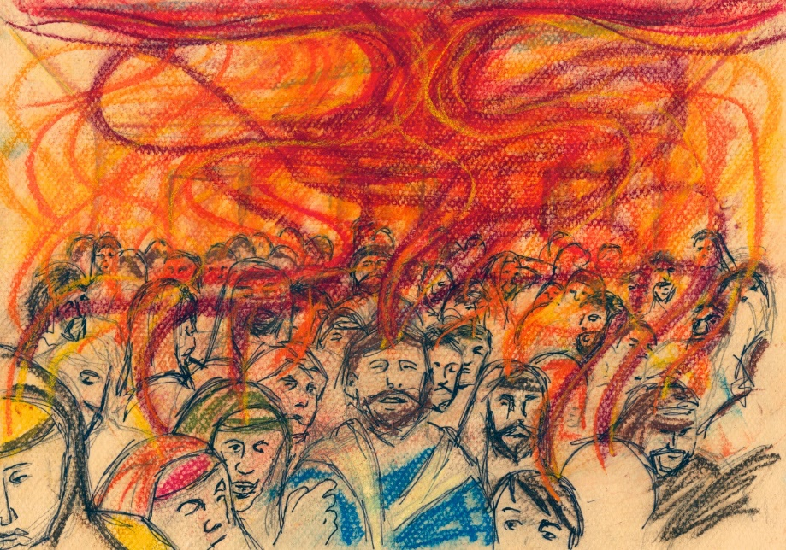
Just as we may be feeling lonely, isolated or anxious about the future, just trying to take things one day at a time, so too for the first disciples of Jesus on the day when their world turned upside down, not for the first time. They’d followed Jesus but it hadn’t worked out the way they’d hoped, so they were just hanging in there and hoping and praying about the future.
At Pentecost, the Spirit gave them new courage, new direction and renewed hope for the future. After Peter’s inspiring message about Jesus, prompted by the Spirit, many people embraced the new faith and a vibrant and growing community was born. Everyone was included and people were generous with their hospitality and time and goods.
Like those first disciples, we too are relearning some of the behaviours that build community. Many families are reconnecting through spending more time together, friends are keeping in touch over the phone, people are slowing down and talking to their neighbours, others are taking the time to listen and some are rediscovering old ways of cooking and growing vegetables. There has been a new kindness movement happening.
But Pentecost also brought creative changes prompted by the Spirit, new possibilities, new ways of being God’s people in the world. And so in these days, we also have found new means of connecting such as by Zoom. How many of us even knew what this involved two months ago?
Pentecost was a catalyst for change, although many challenges remained ahead for the emerging community. So I wonder how our current situation will help us make lasting change towards a new more equitable and compassionate future. How will we better align ourselves with God’s ways after this pandemic is over? How can all of us in this country learn to truly sing together that we are all Australian and that we do share a common dream?
HYMN TiS 418 She sits like a bird
She sits like a bird, brooding on the waters,
hovering on the chaos of the world’s first day;
she sighs and she sings, mothering creation,
waiting to give birth to all the Word will say.
She wings over earth, resting where she wishes,
lighting close at hand or soaring through the skies;
she nests in the womb, welcoming each wonder,
nourishing potential hidden to our eyes.
She dances in fire, startling her spectators,
waking tongues of ecstasy where dumbness reigned;
she weans and inspires all whose hearts are open,
nor can she be captured, silenced or restrained.
For she is the Spirit, one with God in essence,
gifted by the Saviour in eternal love;
she is the key opening the scriptures,
enemy of apathy and heavenly dove.
Words and music © 1988 John L. Ball and Graham Maule. Wild Goose Publishing. Used with permission.
For a very gentle version of this song watch https://www.youtube.com/watch?v=dwsiXzcYFis

PRAYERS OF THE PEOPLE (adapted from a prayer by Rev Joanna Harader)
Flaming God of Pentecost,
you empower your people to speak into the needs of the world.
Empower us to speak words of comfort
to those weeping over the bodies of their loved ones
dying from coronavirus, or illness or accident or old age.
Empower us to speak words of courage
to those living in fear and anxiety
in these days of uncertainty.
Empower us to speak words of care
for the most vulnerable in our world –
whether human beings, animals or ecosystems.
Empower us to speak words of love
for you and for your people,
that your language might be our language.
And when we have no words to speak,
let our hearts burn with your fire,
let our ears hear your words in our own native tongue,
let our skin feel the wind of your Spirit–
blowing where it will.
Amen
Conclude by praying the Lord’s Prayer.
BENEDICTION
God of fire and beauty
Warm us
God of wind and wonder
Disturb us
God of Pentecost
Kindle your love in our lives
SENDING SONG TiS 781 Father, bless us as we go
Father, bless us as we go.
Jesus, walk beside us.
Holy Spirit, guide us.
Words and music © Robin Mann.
For YouTube version with sign language see https://www.youtube.com/watch?v=POBe6v4fB10

