worship@home resources for 24 May

This week we will explore Jesus’ promise of the Holy Spirit and ascension from Acts chapter 1.
Call to Worship
Lord of life,
you have been raised in glory
that we might live in hope
You reign with God
that we might live in peace
You are present everywhere
that we might be fully present in our own lives
We come to worship you and to seek your face

HYMN TiS 477 Jesus calls us here to meet him
Jesus calls us here to meet him
as through word and song and prayer,
we affirm God's promised presence
where his people live and care.
Praise the God who keeps his promise;
praise the Son who calls us friends;
praise the Spirit who, among us,
to our hopes and fears attends.
Jesus calls us to confess him
Word of Life and Lord of All,
sharer of our flesh and frailness
saving all who fail or fall.
Tell his holy human story;
tell his tales that all may hear;
tell the world that Christ in glory
came to earth to meet us here.
Jesus calls us to each other:
found in him are no divides.
Race and class and sex and language
such are barriers he derides.
Join the hand of friend and stranger;
join the hands of age and youth;
join the faithful and the doubter
in their common search for truth.
John L. Bell and Graham Maule. Wild Goose Publications. Used by permission.
YouTube version here https://www.youtube.com/watch?v=ModYoPReYYw

prayer
Living God,
we do not know the face of the future,
any more than the first disciples did.
Like them, we have many questions:
how to live, how to bear witness.
Like them, we thirst for the refreshing waters of your Spirit
to inspire us in our living,
to give us everyday words to share our hope.

Holy God,
we confess that we sometimes have our eyes set in the clouds
instead of on the earth you have given us.
Forgive us for our short sightedness.
Call us back to the down-to-earth message of your love,
to care for the needs of those around us,
especially the forgotten and marginalised.
You have called us to care for widows, orphans and strangers among us;
help us to see all those who are feeling left out and are in need.
We pray in Christ’s name.
Amen.

ASSURANCE OF FORGIVENESS
Know that you are forgiven and loved
by the God who made both earth and you.
We praise you for your grace and kindness.

BIBLE READINGS
Psalm 68:4-6, 32-35
Sing to God, sing in praise of his name,
extol him who rides on the clouds;
rejoice before him—his name is the Lord.
A father to the fatherless, a defender of widows,
is God in his holy dwelling.
God sets the lonely in families,
he leads out the prisoners with singing;
but the rebellious live in a sun-scorched land.
Sing to God, you kingdoms of the earth,
sing praise to the Lord,
to him who rides across the highest heavens,
who thunders with mighty voice.
Proclaim the power of God,
whose majesty is over Israel,
whose power is in the heavens.
You, God, are awesome in your sanctuary;
the God of Israel gives power and strength to his people.
Praise be to God!
Acts 1:1-11
In the first book, Theophilus, I wrote about all that Jesus did and taught from the beginning until the day when he was taken up to heaven, after giving instructions through the Holy Spirit to the apostles whom he had chosen. After his suffering he presented himself alive to them by many convincing proofs, appearing to them over the course of forty days and speaking about the kingdom of God. While staying with them, he ordered them not to leave Jerusalem, but to wait there for the promise of the Father. ‘This’, he said, ‘is what you have heard from me; for John baptized with water, but you will be baptized with the Holy Spirit not many days from now.’
So when they had come together, they asked him, ‘Lord, is this the time when you will restore the kingdom to Israel?’ He replied, ‘It is not for you to know the times or periods that the Father has set by his own authority. But you will receive power when the Holy Spirit has come upon you; and you will be my witnesses in Jerusalem, in all Judea and Samaria, and to the ends of the earth.’ When he had said this, as they were watching, he was lifted up, and a cloud took him out of their sight. While he was going and they were gazing up towards heaven, suddenly two men in white robes stood by them. They said, ‘Men of Galilee, why do you stand looking up towards heaven? This Jesus, who has been taken up from you into heaven, will come in the same way as you saw him go into heaven.’
REFLECTION
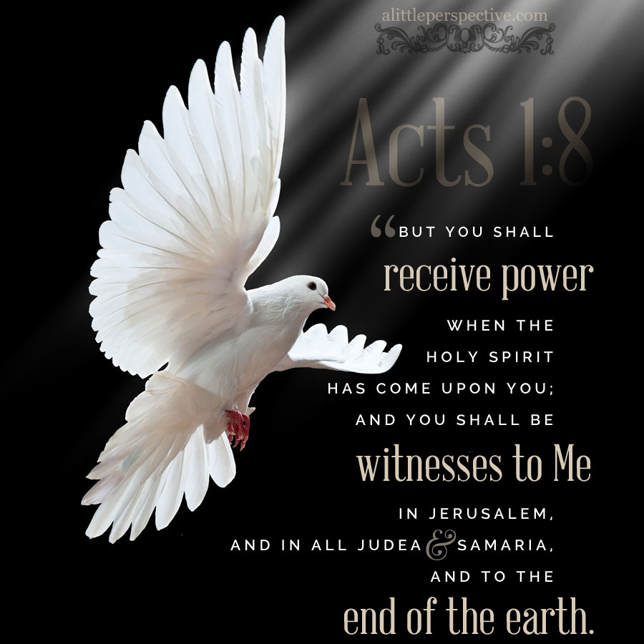
The reading that we are focusing on this week comes from the opening chapter of Acts, the second book in Luke’s two volume story about Jesus. This second book begins with the ascension of Jesus and goes on to tell the story of Jesus’ followers as they proclaim the good news of Jesus in word and in action, starting from Jerusalem and finally reaching Rome.
In the opening passage from Acts, Jesus commissions the disciples for their new role, that of being witnesses. It is as if Jesus is handing on the relay baton to them.
But just what are they to be witnesses of? Based on the many stories recounted in Acts, their witness is focused on the death and resurrection of Jesus, who is to be regarded as both Messiah and Lord, and also on his message of good news about the kingdom of God. After a momentous start in Jerusalem on the day of Pentecost, their witness gradually expands geographically and also racially as more and more Gentiles (i.e. non-Jews) embrace the message.
In order to equip them for their witnessing task, Jesus urges them to wait for the gift of the Holy Spirit, who will provide them power. The Greek word used here is dunamis, from which we derive English words such as dynamo and dynamite, and it may mean might, strength or ability. One demonstration of power comes in the Pentecost story as Peter is given the words and the courage to stand up and proclaim a message about Jesus. On other occasions the apostles demonstrate power for compassion and for healing. And throughout the book of Acts, there is another dimension of power demonstrated, namely power to form community. In each instance, the Holy Spirit supplies what they need at the time.
The question for us as we reflect on this passage is how we are called to be witnesses of Jesus in our context and situation. Obviously our witness will be quite different from the original disciples since we did not physically witness events like the cross and the resurrection of Jesus. So how best to be witnesses is a challenge for every generation of Jesus’ followers.
As we contemplate our call to ‘proclaim by word and example the good news of God in Christ’ – which is part of the baptism liturgy and therefore applicable to every baptised follower of Jesus – we may want to ponder what help we most need from the Holy Spirit. Is it courage to speak? Is it compassion? Is it the perseverance and energy to form community? As we do so, we might also recall Jesus’ promise to be with us always, and to remember that we are Easter people who know and serve a living Lord.

HYMN TiS 409 O breath of life
O breath of life, come sweeping through us,
revive your church with life and power;
O breath of life, come cleanse, renew us,
and fit your church to meet this hour.
O wind of God, come bend us, break us,
till humbly we confess our need;
then in your tenderness remake us,
revive, restore, for this we plead.
O breath of love, come breathe within us,
renewing thought and will and heart;
come, love of Christ, afresh to win us,
revive your church in every part.
Revive us, Lord! Is zeal abating
while harvest fields are vast and ripe?
Revive us, Lord, the world is waiting,
equip your church to spread the light.
Elizabeth Ann Porter Head 1850-1936.
For a YouTube version of this song watch https://www.youtube.com/watch?v=rKz1BwFe6uE

PRAYERS OF THE PEOPLE
The apostle Paul links pastoral concerns with the ascension of Christ in Ephesians 1:15-23.
Verse 17 reads: ‘I pray that the glorious Father … may give you spiritual wisdom and understanding so that you might grow in your knowledge of God.’
Verse 18-20: ‘I pray that you may know … God’s power for us who believe … which God put to work when he raised Christ from the dead and seated him at his right hand in heaven.’
Pray for yourself, for those whose needs are known to you and for our leaders to be granted God’s wisdom and power.
Give to us – and those we have named before you in prayer –
a vision of your kingdom,
a glimpse of your glory,
an openness to your rule,
and your Spirit to guide us.
Hear us as we pray in the name of the risen and ascended one. Amen.
Finish by praying the Lord’s Prayer.
BENEDICTION
As people of faith we have gathered for worship.
As people of faith we now return to life in the world.
Go out to share the story of faith,
the story of life, with those around you.
We will share our faith in word and in deed,
in speech and in action.

Go, knowing that God goes with us,
sharing our laughter and our hope,
our fears and our tears.
We go in peace to serve the living Lord.

SENDING SONG
Scatter us Lord Jesus Christ,
you know where we’re going.
Use our gifts so that we may
share life overflowing.
Heal us, bless us now, our Lord,
in your name we’re going.
Be our comfort and our strength,
share life overflowing.
Holy Spirit, go with us,
in your joy we’re growing.
Be our light, our love, our hope,
be life overflowing.
Words and music © 2012 Beatrice Panne. Used with permission.

