worship@home resources for 10 May

How and where is Jesus present to guide and sustain us in these troubling times?
How do we celebrate Mother’s Day and give thanks for all the significant women in our lives during these days of physical isolation?
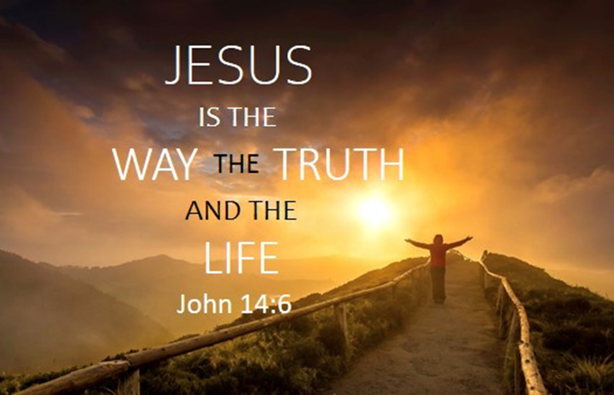
Call to Worship
Companion God,
sharing laughter, sharing pain
You are our way
Ever-living God,
sharing wisdom, sharing hope
You are our truth
Nurturing God,
sharing stories, sharing community
You are our life

prayer
Gracious God,
We thank you for this new day
and for the privilege of being called your people.
Some of us come to this day with light and joyful hearts
while others come with anxious and heavy hearts.
We praise you that you welcome all people
with open arms and a loving embrace
however we are feeling.
Speak your word to us this day,
lighten our burdens and lead us more fully
into the glorious life you have planned for your people.
May we whose hearts are full of thankfulness
quietly offer up our thanks to God.
May we who are feeling fearful or empty
sense the presence of God deep within.
May we who have come seeking forgiveness and peace
bring our requests before God.
Living God, we ask you to renew us and make us whole,
through Christ Jesus our Lord. Amen

ASSURANCE OF FORGIVENESS
God of grace,
you offer us compassion, friendship and new life.
We praise you for hearing our prayer.
HYMN TiS 585 I heard the voice of Jesus say
I heard the voice of Jesus say,
‘Come unto me and rest;
lay down, O weary one, lay down
your head upon my breast.’
I came to Jesus as I was,
weary and worn and sad;
I found him in a resting place,
and he has made me glad.
I heard the voice of Jesus say,
‘Behold, I freely give
the living water; thirsty one,
stoop down and drink and live.’
I came to Jesus, and I drank
of that life-giving stream;
my thirst was quenched, my soul revived,
and now I live in him.
I heard the voice of Jesus say,
‘I am this dark world's light;
look unto me, your morn shall rise,
and all your day be bright.’
I looked to Jesus, and I found
in him my star, my sun;
and in that light of life I'll walk
till traveling days are done.
Horatius Bonar 1808-89 alt.
Beautiful YouTube version here https://www.youtube.com/watch?v=74kyfROS4q8

REFLECTING ON MOTHER’S DAY
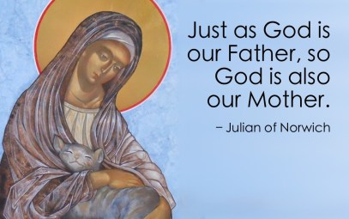
Today is the traditional day on which we pause to remember and give thanks to our mothers who brought us into the world and nurtured us in the best way they could. It’s good to also extend our thanks to the many other significant women in our lives who were our teachers, nurses when we were sick, friends, role models for caring and sources of wisdom about life.
Perhaps it’s also a good opportunity to reflect on the nature of God, whom we often portray with masculine imagery, yet who embraces and loves us like a mother. God of course is neither male nor female. On this day let us expand our thinking about God.
BIBLE READINGS
Psalm 31:1-5, 15-16 (responsively)
In you, O LORD, I seek refuge;
do not let me ever be put to shame;
in your righteousness deliver me.
Incline your ear to me; rescue me speedily.
Be a rock of refuge for me, a strong fortress to save me.
You are indeed my rock and my fortress;
for your name's sake lead me and guide me,
take me out of the net that is hidden for me,
for you are my refuge.
Into your hand I commit my spirit;
you have redeemed me, O LORD, faithful God.
My times are in your hand;
deliver me from the hand of my enemies and persecutors.
Let your face shine upon your servant;
save me in your steadfast love.
John 14:1-18
‘Do not let your hearts be troubled. Believe in God, believe also in me. In my Father’s house there are many dwelling-places. If it were not so, would I have told you that I go to prepare a place for you? And if I go and prepare a place for you, I will come again and will take you to myself, so that where I am, there you may be also. And you know the way to the place where I am going.’ Thomas said to him, ‘Lord, we do not know where you are going. How can we know the way?’ Jesus said to him, ‘I am the way, and the truth, and the life. No one comes to the Father except through me. If you know me, you will know my Father also. From now on you do know him and have seen him.’
Philip said to him, ‘Lord, show us the Father, and we will be satisfied.’ Jesus said to him, ‘Have I been with you all this time, Philip, and you still do not know me? Whoever has seen me has seen the Father. How can you say, “Show us the Father”? Do you not believe that I am in the Father and the Father is in me? The words that I say to you I do not speak on my own; but the Father who dwells in me does his works. Believe me that I am in the Father and the Father is in me; but if you do not, then believe me because of the works themselves. Very truly, I tell you, the one who believes in me will also do the works that I do and, in fact, will do greater works than these, because I am going to the Father. I will do whatever you ask in my name, so that the Father may be glorified in the Son. If in my name you ask me for anything, I will do it.
‘If you love me, you will keep my commandments. And I will ask the Father, and he will give you another Advocate, to be with you for ever. This is the Spirit of truth, whom the world cannot receive, because it neither sees him nor knows him. You know him, because he abides with you, and he will be in you. I will not leave you orphaned; I am coming to you.
REFLECTION
The setting for the long discourse in John’s Gospel that runs from chapter 13 through to chapter 17 is the Last Supper. Jesus sets the tone for the message by washing the disciples’ feet and then highlighting the call to love one another (John 13:34-35). This act and this call sum up the message of Jesus and also reveal the heart of God.
The disciples are troubled, probably by Jesus’ repeated statements that he is going where the disciples cannot follow (13:33, 36), so Jesus reassures them about life when he will no longer be physically present with them. This is also relevant for the situation of John’s later community. Like much else in this Gospel, the disciples don’t understand what Jesus is saying.
Some key messages from the passage we read today are …
- Jesus will not abandon the disciples, but will send another helper – the Holy Spirit or paraclete – to be with them always
- Jesus is the way, the truth and the life … the doorway to relationship with God
- To know Jesus is to know God … as Jesus reveals the heart and character of God
- Even now, Jesus is preparing to return to God and will prepare a place for the disciples in God’s house (note that in John’s Gospel, Jesus was with God from the very beginning and came from God and is now returning to God)
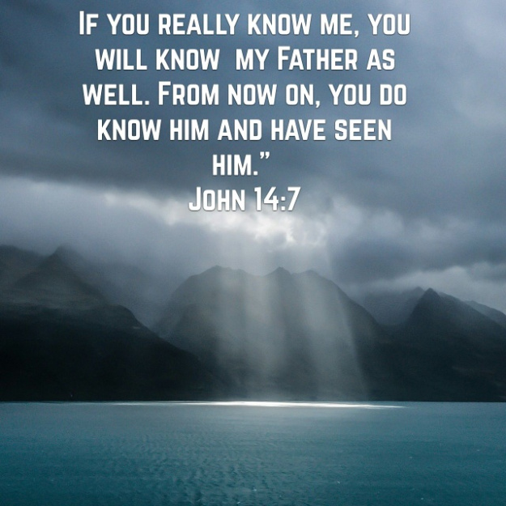
So what is God like? Just like me says Jesus … who embodies the ways and priorities of God … bringing healing and wholeness, lifting religious burdens, breaking down exclusive and exclusionary practices, welcoming and offering hospitality to all including the outcast and those considered unloved or rejected … enjoying an intimate relationship with God through God’s Spirit … so that Jesus can claim he is ‘in’ the Father and the Father is ‘in’ him.
If we want to live in this same close relationship with God that Jesus enjoys, we will keep Jesus’ commandments (John 14:15) and especially the command to love one another. Then we will be doing the works of Jesus. How will we know how to do this? Through the gift of the Spirit of truth, whom God will send in Jesus’ name, who will remind us of everything Jesus said (John 14:26) and who will be ‘in’ us, bringing us into relationship with Jesus and with God.
- What do you find most encouraging in this passage?
- What do you find most challenging?
HYMN TiS 624 Christ be my leader by night as by day
Christ be my leader by night as by day;
safe through the darkness for he is the way.
Gladly I follow, my future his care,
darkness is daylight when Jesus is there.
Christ be my teacher in age as in youth,
drifting or doubting, for he is the truth.
Grant me to trust him; though shifting as sand,
doubt cannot daunt me; in Jesus I stand.
Christ be my Saviour in calm as in strife;
death cannot hold me, for he is the life.
Nor darkness nor doubting nor sin and its stain
can touch my salvation: with Jesus I reign.
Words © 1964 Hope Publishing Company, 380 S Main Pl, Carol Stream, IL 60188. All rights reserved. Used by permission.
For a contemplative version of this song watch https://www.youtube.com/watch?v=Ym8iB29G6IU

PRAYERS OF THE PEOPLE
Bring your praise and requests to God today by following the form of the Lord’s Prayer.
As you pray this prayer, pause after each line and expand on the thought … so for instance, you might pray something like this …
Our Father in heaven … our compassionate and wise God who also embraces us like a mother
Hallowed by your name … may your love and joy and peace be known and honoured
Your kingdom come … may your ways of kindness and inclusion become our new normal …

Alternatively, you might like to rewrite the Lord’s Prayer in your own words.

A Prayer on Mother’s Day (adapted from a prayer by John Harvey)
Living God, father and mother of us all,
hear us as we give thanks for mothers,
and for mothering on this special day.
We pray for all mothers,
including the mothers and grandmothers among us.
We pray for expectant mothers, who are anxious in these days.
We pray for those who wish to bear children, but who cannot.
We pray for single mothers, who are struggling in their role.
We pray especially for mothers who watch
as their children suffer, or starve, or grow sick.
We remember before you mothers whose children have died –
through sickness, road trauma, in fires, or at the hand of troubled human beings.
And we remember with love,
those grieving the deaths of their mothers in recent months.
May your mothering love surround them
and bring them comfort and strength.

BENEDICTION
We are traveling the way of justice
and exploring the way of truth
We are discovering the abundant life
and journeying with our God
SENDING SONG
God gives us a future, daring us to go
into dreams and dangers on a path unknown.
We will face tomorrow in the Spirit’s power,
we will let God change us, for new life starts now.
We must leave behind us sins of yesterday,
for God’s new beginning is a better way.
Fear and doubt and habit must not hold us back:
God gives hope and insight and the strength we lack.
Holy Spirit, teach us how to read the signs,
how to meet the challenge of our troubled times.
Love us into action, stir us into prayer,
till we choose God’s life, and find our future there.
Words © E. J. Smith. Used with permission.

