worship@home resources for 3 May

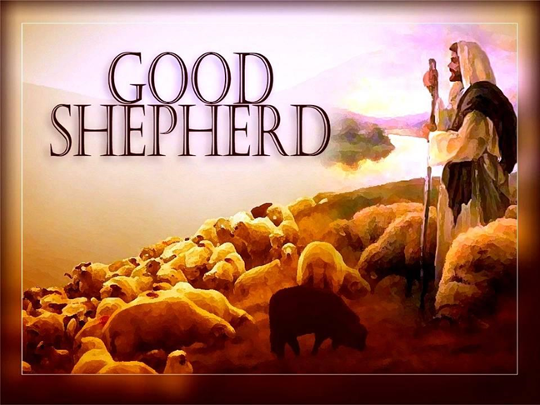
Today is known as Good Shepherd Sunday, when we reflect on Jesus as our good shepherd … a widely used metaphor for pastoral care in the church. Today’s Gospel reading also includes Jesus’ statement that he came to guide us towards the abundant life.
Call to Worship
Shepherding God,
guide us when the way seems dark
Lead us into the light of your ways
Shepherding God,
guide us when we are anxious or fearful
Lead us into your way of peace
Shepherding God,
show us where we need to change
Lead us into your abundant life
prayer
Gracious God,
we praise you that Jesus Christ gives new shape and meaning
to the evocative image of the shepherd.
In him, your compassion and love have been fully revealed.
His risen presence continues to guide and lead us in paths that lead to life abundant.
As we still ourselves to worship you,
open our minds to your truth,
our ears to your voice,
and our hearts to your grace.
_______________________
When we are lured astray by the voices of the many popular shepherds of our age,
who seek to exploit or misguide us:
Lord have mercy.
When we try to dominate those around us with our ideas and wishes, acting as if we were the good shepherd:
Christ have mercy.
When we become spiritually self-important, imagining that we no longer need the help of other members of the flock of Christ:
Lord have mercy.
Great Shepherd of our souls,
forgive us our rebellion,
rescue us from our wandering,
and set our feet on the secure but narrow path that leads to abundant life.
Through Christ Jesus our Lord.
Amen
ASSURANCE OF FORGIVENESS
The Good Shepherd knows his sheep
and lays down his life so that the sheep may live.
In Christ, we find wholeness and restoration.
Thanks be to God.

HYMN The Lord’s my shepherd
The Lord's my shepherd, I'll not want.
He makes me lie in pastures green.
He leads me by the still, still waters,
his goodness restores my soul.
And I will trust in you alone
And I will trust in you alone
For your endless mercy follows me
Your goodness will lead me home
He guides my ways in righteousness,
and he anoints my head with oil,
and my cup, it overflows with joy,
I feast on his pure delights.
Refrain
And though I walk the darkest path,
I will not fear the evil one,
for you are with me, and your rod and staff
are the comfort I need to know.
Refrain
Stuart Townend © 1996 Thankyou Music
YouTube version here https://www.youtube.com/watch?v=pN4tPkX0MG0

BIBLE READINGS
Acts 2:42-47 (The Message)
The community committed themselves to the teaching of the apostles, the life together, the common meal, and the prayers. Everyone around was in awe—all those wonders and signs done through the apostles! And all the believers lived in a wonderful harmony, holding everything in common. They sold whatever they owned and pooled their resources so that each person’s need was met.
They followed a daily discipline of worship in the Temple followed by meals at home, every meal a celebration, exuberant and joyful, as they praised God. People in general liked what they saw. Every day their number grew as God added those who were saved.

John 10:1-10
“Very truly, I tell you, anyone who does not enter the sheepfold by the gate but climbs in by another way is a thief and a bandit. The one who enters by the gate is the shepherd of the sheep. The gatekeeper opens the gate for him, and the sheep hear his voice. He calls his own sheep by name and leads them out. When he has brought out all his own, he goes ahead of them, and the sheep follow him because they know his voice. They will not follow a stranger, but they will run from him because they do not know the voice of strangers.” Jesus used this figure of speech with them, but they did not understand what he was saying to them.
So again Jesus said to them, “Very truly, I tell you, I am the gate for the sheep. All who came before me are thieves and bandits; but the sheep did not listen to them. I am the gate. Whoever enters by me will be saved, and will come in and go out and find pasture. The thief comes only to steal and kill and destroy. I came that they may have life, and have it abundantly.”

REFLECTION
How do we envisage the abundant life that Jesus speaks of? Two companion texts for today – Psalm 23 and Acts 2:42-47 – provide some insights, along with other texts from the Gospel of John (1:4, 5:24, 11:25, 14:6, 17:3).
It is a life lived in communion with God and in communion with God’s people. All we need will be provided (pasture, still waters) … yet the way will not always be easy (walking in the valley of the shadow of death). We are promised blessing (provision, joy peace) … and called upon to be a blessing to others in turn (as demonstrated by members of the early church and their attitude towards any in need). How can we help point others towards this abundant life, which is available here and now?
PRAYER
Lord, we long to hear your shepherd’s voice speaking to us
and to have the courage to follow where you lead.
We desire to live the abundant life you spoke of.
But other voices demand our attention.
Doubts cause us to question your goodness.
And so too often we settle for a comfortable but mediocre life.
Guide us, disturb us, inspire us
and lead us into the full and abundant life
you have planned for all your people.
We pray in Jesus’ name. Amen.
HYMN TiS 670 Jesus put this song into our hearts
Jesus put this song into our hearts,
Jesus put this song into our hearts,
it's a song of joy no one can take away;
Jesus put this song … into our hearts.
Jesus taught us how to live in harmony,
Jesus taught us how to live in harmony;
different faces, different races, he made us one:
Jesus taught us how to live … in harmony.
Jesus taught us how to be a family,
Jesus taught us how to be a family,
loving one another with the love that he gives:
Jesus taught us how to be … a family.
Jesus turned our sorrow into dancing,
Jesus turned our sorrow into dancing,
changed our tears of sadness into rivers of joy:
Jesus turned our sorrow … into a dance.
Words and music Graham Kendrick © 1986 Kingsway Thankyou Music. All rights reserved.
For a lively rendition of this song watch https://www.youtube.com/watch?v=-w_QwKAdd8A

PRAYERS OF THE PEOPLE
Who and what is on your heart today?
Who could you phone today to remind them of God’s love and care?
Finish by praying the Lord’s Prayer.
BENEDICTION
Coming and going
God watches over us
Resting and working
God watches over us
Through good and through evil
God watches over us
All the days of our lives
God safeguards us with love
SONG
God to enfold you,
Christ to uphold you,
Spirit to keep you in heaven’s sight;
so may God grace you,
heal and embrace you,
lead you through darkness into the light.
Words © John L. Ball & Graham Maule. Used with permission.

