worship@home resources for 26 April

Today we will be reflecting on another Easter story, this time from Luke’s Gospel, about two discouraged disciples as they head for home. You’re invited to listen to the story, then spend some time in quiet contemplation, write in your journal, go for a walk or talk to a friend …
Call to Worship
Lord, you walk alongside us
You share our journeys
Lord, you surprise us and bless us
You fill us with wonder
Lord, you call us together into community
You call us to life

HYMN TiS 376 I know that my Redeemer lives (to tune of Duke Street, TiS 594)
I know that my Redeemer lives –
what joy this blest assurance gives!
He lives, he lives, who once was dead;
he lives, my everlasting Head!
He lives triumphant from the grave;
he lives eternally to save;
he lives exalted, throned above;
he lives to rule his church in love.
He lives to bless me with his love;
he lives to plead for me above;
he lives my hungry soul to feed;
he lives to help in time of need.
He lives, my kind, wise, heavenly friend;
he lives and loves me to the end;
he lives, and while he lives, I’ll sing;
he lives, my Prophet, Priest, and King.
He lives, all glory to his name!
He lives, my Saviour, still the same;
what joy this blest assurance gives:
I know that my Redeemer lives!
Samuel Medley 1738-99
YouTube version here https://www.youtube.com/watch?v=2k8rKROCaDk

prayer
Gracious God,
We gather as your scattered people this morning
in response to your love for us
and your promise to be present among your people.
Like the first disciples after Easter
we do not always recognise your presence
and so we are sometimes anxious or fearful or lonely.
Remind us again today that you are not far off,
that you walk with us every day
and meet us right where we are.
Risen Lord Jesus,
we confess that we are often blind and deaf
to your gentle presence in our lives,
and fail to recognise you in the lives of our neighbour.
Open our eyes and ears and hearts
so that we might be aware of your presence with us.
Fill us with the joy and assurance of your presence,
so that, like the travellers on the road to Emmaus,
our hearts too may be warmed
and we may be prepared to share the good news with others.
We pray in Jesus’ name. Amen.

ASSURANCE OF FORGIVENESS
The living Lord promises to be with us always
even through times of fear, loneliness or struggle
Thank you Jesus for your promises that bring life

BIBLE READINGS
Psalm 116:1-9 (responsively)
I love the Lord, because he has heard
my voice and my supplications.
Because he inclined his ear to me,
therefore I will call on him as long as I live.
The snares of death encompassed me;
the pangs of Sheol laid hold on me;
I suffered distress and anguish.
Then I called on the name of the Lord:
“O Lord, I pray, save my life!”
Gracious is the Lord, and righteous;
our God is merciful.
The Lord protects the simple;
when I was brought low, he saved me.
Return, O my soul, to your rest,
for the Lord has dealt bountifully with you.
For you have delivered my soul from death,
my eyes from tears, my feet from stumbling.
I walk before the Lord
in the land of the living.

Luke 24:13-35
Two friends, traditionally known as Cleopas (C) and his wife Mary (M) (see John 19:25 and Luke 24:18), are travelling back to their home in Emmaus on the first day of the week. This imaginative retelling of their story is by Jan Pickard. Where do you find yourself in this story?
C/M We were two friends on our way home …
C walking on the dusty road,
M trudging, not saying much,
C sharing our disappointment and confusion.
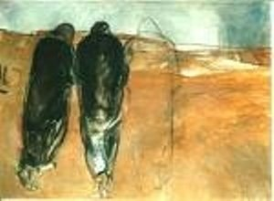
C Then another joined our journey –
M unknown to us –
C looking into our crying eyes,
M listening to our lost hopes
and the wild rumours we’d heard.
C He spoke to us … and we heard the whole sweep of God’s salvation – as told in the Scriptures – as though for the very first time.
M We travelled on, gradually getting closer to home.
C We finally arrived home
M but our stranger wanted to go further – to be on his way.
C As dusk was falling, we asked him to stay.
M We went inside and sat down, tired,
to share a meal together.
C He took the bread, blessed it,
broke it and offered it to us.
M All at once we knew who our companion was!
… but then he was gone.
C/M We remembered our journey –
M the words we heard –
C and his presence with us on the road, at the table,
and in breaking the bread.
M We knew then that this news must be shared.
C We couldn’t just sit there …
M so, right then and there, we set out again
back along that same dusty road.
C/M We were two friends, walking on God’s way.
REFLECTION
The Easter story is about transformation.
And so in today’s story, two disciples travel from disappointment to fresh insight, from discouragement to enthusiasm, from noting the absence of God to celebrating the presence of God. Their transformation comes about as they welcome a stranger into their midst, allow themselves to be vulnerable and as they experience God’s hospitality.
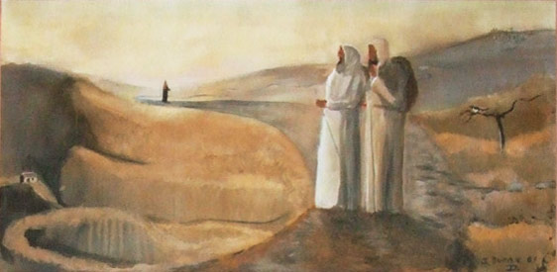

The shape of this story reminds me about the movement of worship.
First we welcome people into our midst, just as the two disciples welcomed the stranger, not knowing who he was. Later in the story they welcome the stranger into their home in an act of hospitality.
- In these challenging days, how do we continue to welcome and offer hospitality to the stranger?
Next, the disciples share honestly with Jesus about how they are struggling. They acknowledge their disappointment, discouragement and confusion. This is a place of confession, a place of vulnerability, a place that we often try to hide from others, from God and even from ourselves. We need to tread carefully here and be gentle with ourselves.
- How is vulnerability a pathway towards authenticity and connection with others?
Then Jesus opens the Scriptures with them. That must have been an amazing experience, which they later describe as having their hearts burn within them. Through God’s Spirit, these ancient texts continue to speak a word to us that is relevant and life-changing today.
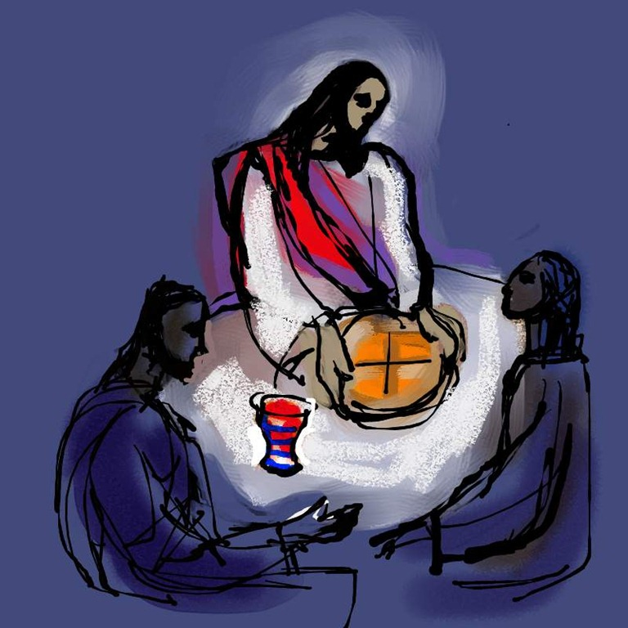
- How has God been speaking to you through the Scriptures these last few weeks?
When they arrive home, hospitality is offered and the guest becomes the host as he breaks the bread, in a scene reminiscent of Communion. Suddenly the disciples recognise Jesus’ presence with them.
- How might you recognise and welcome Jesus to your table at home?
Finally, the disciples’ eyes are opened and they discern it has been Jesus all along. They immediately return to Jerusalem to share the good news with others. This is mission, being sent out into the world with a message of hope and transformation.
- With whom might you share your experience or understanding of the risen Christ?
PRAYER
God, companion with us on our journey,
empower us to be a community of invitation,
of welcome and of hospitality.
May we respond to your presence in our lives
by walking alongside others,
especially those who walk in the shadow of suffering
and those who feel as though they walk alone.
Guide us to witness to your work in our lives
and to the resurrections we have experienced
in ways that deepen community and build faith.
Amen.

HYMN (sing to tune of Columcille, TiS 287)
On the journey to Emmaus with our hearts cold as stone –
the One who would save us had left us alone.
Then a stranger walks with us and, to our surprise,
he opens our stories and he opens our eyes.
And our hearts burned within us as we talked on the way,
how all that was promised was ours on that day.
So we begged him, 'Stay with us and grant us your word.'
We welcomed the stranger and we welcomed the Lord.
And that evening at the table as he blessed and broke bread,
we saw it was Jesus aris'n from the dead;
though he vanished before us we knew he was near –
the life in our dying and the hope in our fear.
On the journey to Emmaus, in our stories and feast,
with Jesus we claim that the greatest is least:
and his words burn within us – let none be ignored –
who welcomes the stranger shall welcome the Lord.
Words © 1995 Marty Haugen. All rights reserved.
Listen to this song here https://www.youtube.com/watch?v=2h-wlsGDnUE

PRAYERS OF THE PEOPLE
Who and what is on your heart today? Bring these people and situations before God.
As we remember Anzac Day, pray for those affected by wars and conflicts, both past and present.
Pray for those finding the current restrictions on life very difficult.
Finish by praying the Lord’s Prayer.
BENEDICTION
When we are disappointed and worn down
Lord, walk with us
When we doubt what we believe
Lord, teach us
When we need a sign of your presence
Lord, break bread with us
As we seek your kingdom
Lord, fill our hearts with fire
SONG TiS 779 May the feet of God walk with you
May the feet of God walk with you
and God’s hand hold you tight.
May the eye of God rest on you
and God’s ear hear your cry.
May the smile of God be for you
and God’s breath give you life.
May the Child of God grown in you
and God’s love bring you home.
Words © A. W. Podlich Music © R. Mann

