worship@home resources for 19 April

Please feel free to use these resources in a way that best suits you. Hymn words, Bible readings and links to YouTube songs are included because some people value these. Images and more open-ended questions are there for others. Add your own prayers & musings …
Call to Worship
Like the disciples, we may doubt Jesus
Christ loves us and forgives us
Like the disciples, we may struggle with questions
Christ loves us and forgives us
Despite all of our shortcomings, Jesus says “Peace be with you”
We welcome your peace

HYMN TiS 242 Lord of the dance
I danced in the morning when the world was begun,
and I danced in the moon and the stars and the sun;
and I came down from heaven and I danced on the earth,
at Bethlehem I had my birth.
Dance then, wherever you may be;
I am the Lord of the dance said he;
and I’ll lead you all wherever you may be,
and I’ll lead you all in the dance said he.
I danced for the scribe and the Pharisee,
but they would not dance and they wouldn't follow me.
I danced for the fishermen, for James and John,
they came with me and the dance went on.
Refrain
I danced on the Sabbath and I cured the lame;
The holy people said it was a shame.
They whipped and they stripped and they hung me high,
and they left me there on a cross to die.
Refrain
I danced on a Friday when the sky turned black;
it's hard to dance with the devil on your back.
They buried my body and they thought I'd gone;
but I am the dance and I still go on.
Refrain
They cut me down and I leap up high,
I am the life that'll never, never die,
I'll live in you as you live in me:
I am the Lord of the dance, said he.
Refrain
YouTube version here https://www.youtube.com/watch?v=214Vdyo6kSs
prayer
Gracious God,
Your character of love and forgiveness is so clear
when Jesus greets the disciples after the resurrection with the words ‘Peace be with you’.
Where we are feeling lonely, anxious or afraid,
please draw close and bring your peace into our lives.
May our hearts be filled with joy this morning as we meet with you in worship.
May we know your peace
and may we be inspired to take your good news into our community.
Living God,
we confess that we do not always live as joyful Easter people.
We live with fears and worries – that we aren’t good enough,
that we aren’t faithful enough, that you don’t see our pain.
Forgive us for not seeing your life at work in us.
Help us to see we are made in your image
and help us to know and to embrace your peace in our lives.
We pray in Jesus’ name. Amen.
ASSURANCE OF FORGIVENESS
The living Lord promises to be with us always
even through times of fear, loneliness or struggle
Hear the good news: Jesus loves us and offers us peace
Thank you Jesus for your promises that bring life
BIBLE READINGS
Psalm 16 (responsively)
Keep me safe, my God,
for in you I take refuge.
Lord, you alone are my portion and my cup;
you make my lot secure.
The boundary lines have fallen for me in pleasant places;
surely I have a delightful inheritance.
I will praise the Lord, who counsels me;
even at night my heart instructs me.
I keep my eyes always on the Lord.
With him at my right hand, I will not be shaken.
Therefore my heart is glad and my tongue rejoices;
my body also will rest secure,
because you will not abandon me to the realm of the dead,
nor will you let your faithful one see decay.
You make known to me the path of life;
you will fill me with joy in your presence,
with eternal pleasures at your right hand.

John 20:19-31
On the evening of that first day of the week, when the disciples were together, with the doors locked for fear of the Jewish leaders, Jesus came and stood among them and said, “Peace be with you!” After he said this, he showed them his hands and side. The disciples were overjoyed when they saw the Lord.
Again Jesus said, “Peace be with you! As the Father has sent me, I am sending you.” And with that he breathed on them and said, “Receive the Holy Spirit. If you forgive anyone’s sins, their sins are forgiven; if you do not forgive them, they are not forgiven.”
Now Thomas (also known as the Twin), one of the Twelve, was not with the disciples when Jesus came. So the other disciples told him, “We have seen the Lord!”
But he said to them, “Unless I see the nail marks in his hands and put my finger where the nails were, and put my hand into his side, I will not believe.”
A week later his disciples were in the house again, and Thomas was with them. Though the doors were locked, Jesus came and stood among them and said, “Peace be with you!” Then he said to Thomas, “Put your finger here; see my hands. Reach out your hand and put it into my side. Do not doubt but believe.”
Thomas said to him, “My Lord and my God!”
Then Jesus told him, “Because you have seen me, you have believed; blessed are those who have not seen and yet have believed.”
Jesus performed many other signs in the presence of his disciples, which are not recorded in this book. But these are written that you may believe that Jesus is the Messiah, the Son of God, and that by believing you may have life in his name.

REFLECTION
In this week’s reading from John’s Gospel, the disciples are not sitting around eating Easter eggs or having a party. They are afraid and meeting behind locked doors because of the Jewish authorities … and I’m sure they had lots of questions.
Then Jesus suddenly is there, standing among them.
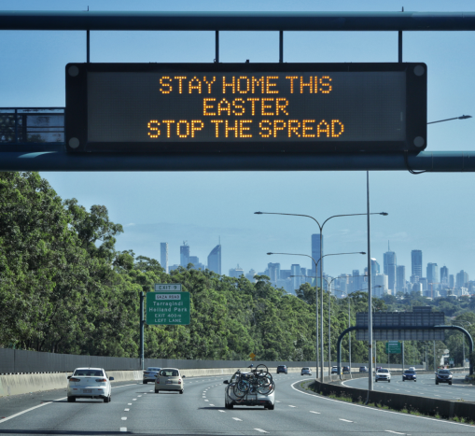
- Are you or your neighbours afraid to go out (because of the risk of Covid19)? Is your front door locked?
- In the midst of your isolation, how might Jesus’ presence come to you?

Something dramatic and unexpected has clearly happened – Jesus was alive again and could be seen, touched, spoken to … it really was Jesus … but he was not the same as before – he could seemingly appear and disappear at will … and yet he speaks words of reassurance, three times saying ‘Peace be with you’. Note that the situation outside the locked doors of the disciples hasn’t changed … the disciples are still in danger.

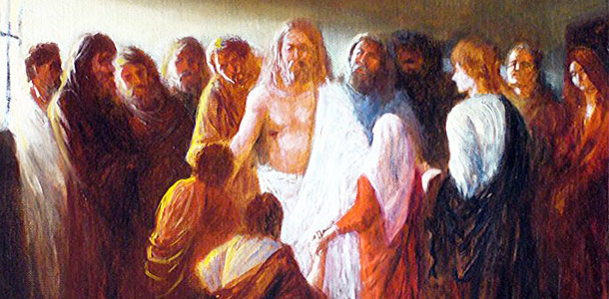

- What message do we need to hear from Jesus to ease our anxiety in our present circumstances?
- What is it about Jesus’ presence and words that gives the disciples – and us – peace and courage to live hopeful and outwardly focused lives?

Then there is Thomas, introduced here as the Twin rather than by history’s less endearing tag of ‘Doubting Thomas’. He was nothing if not pragmatic and concrete … unless I see the scars and touch Jesus, I will struggle to believe.
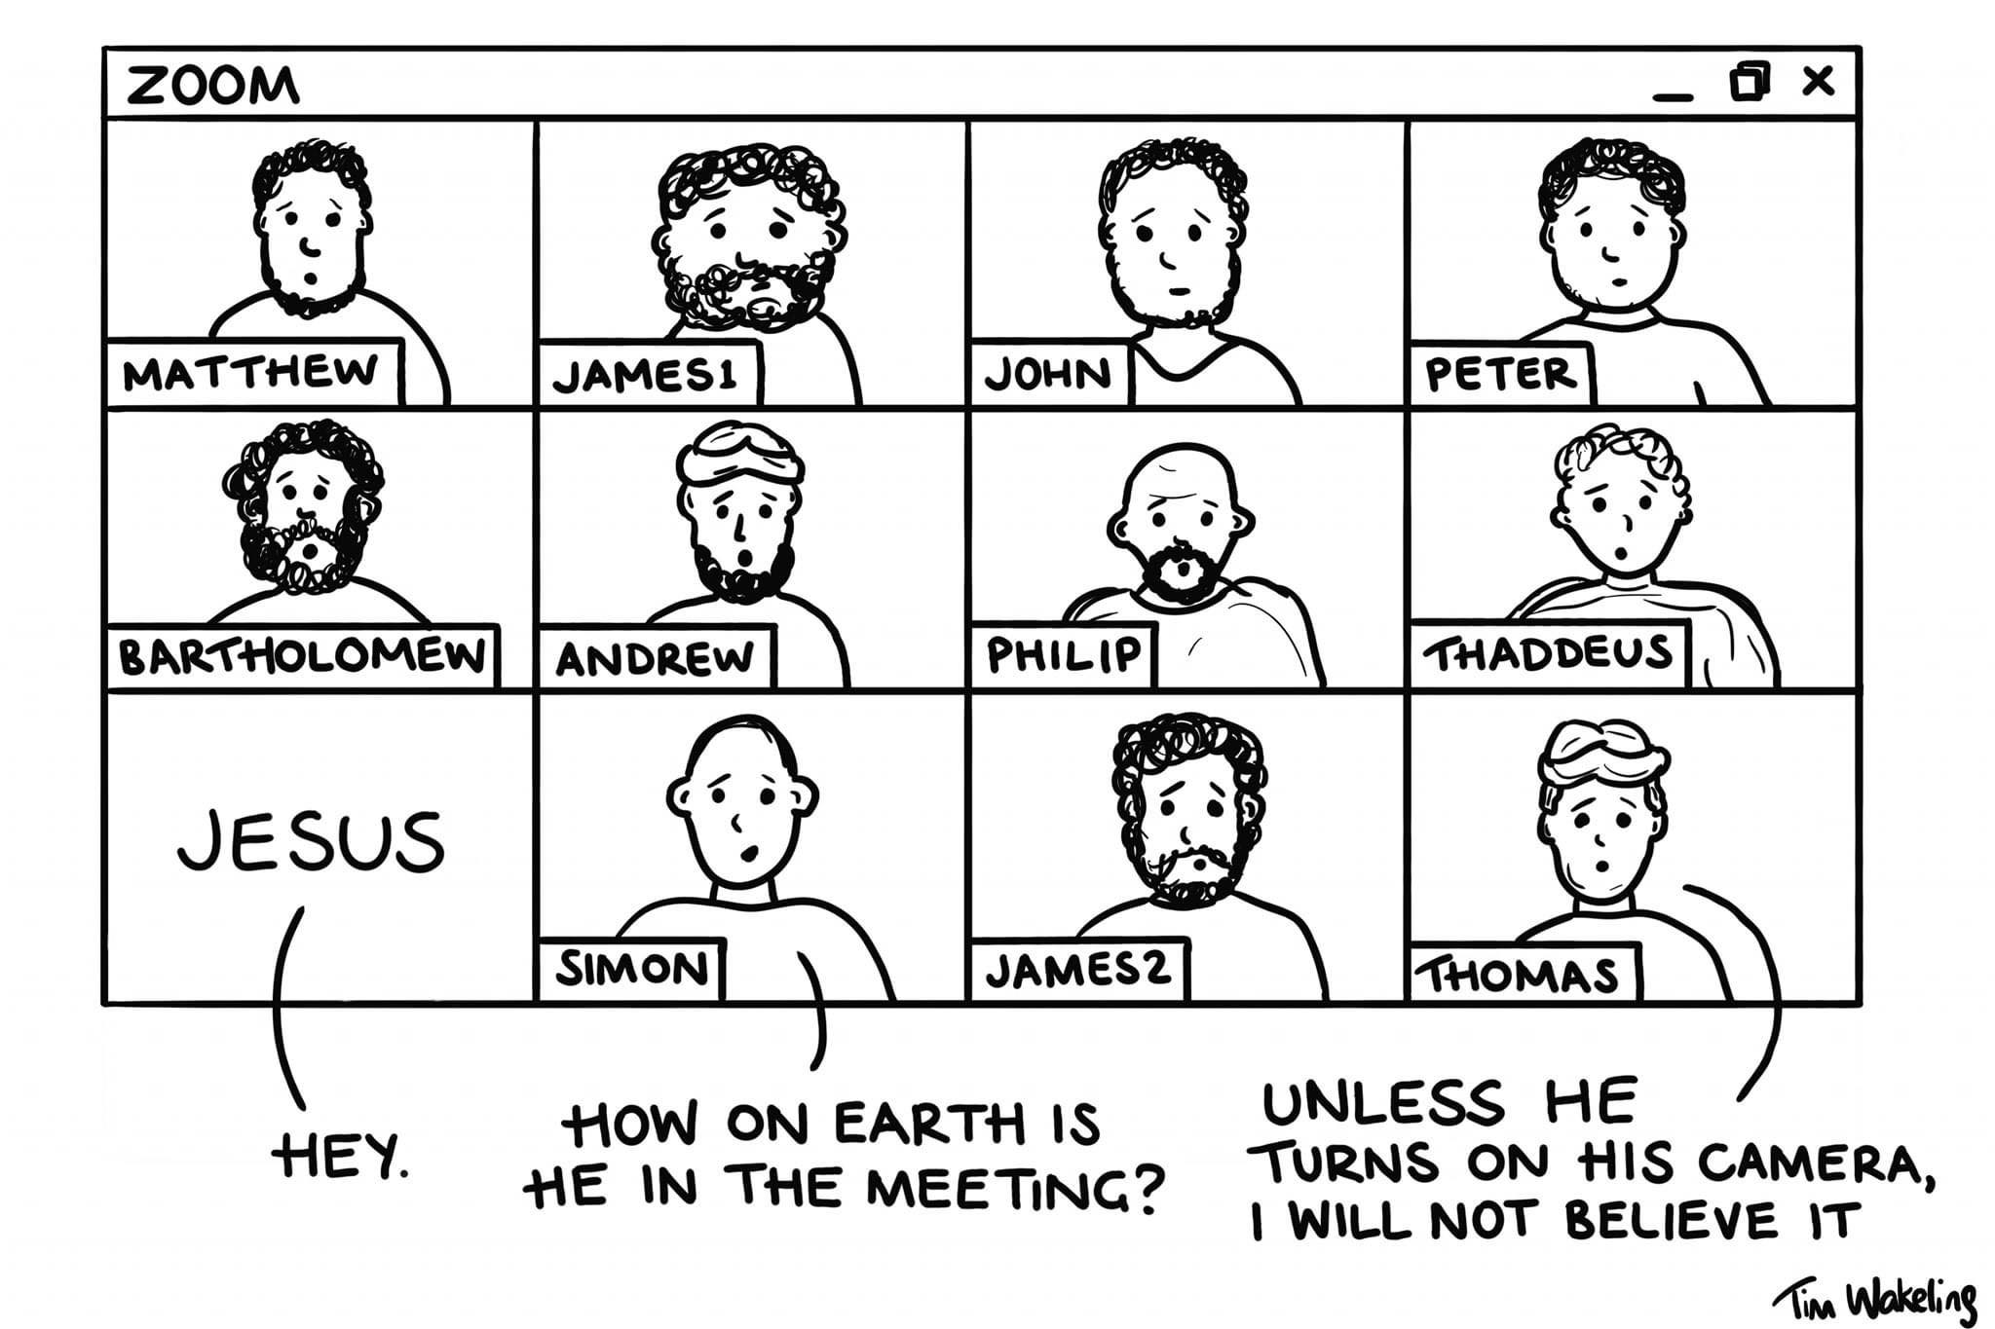
At different times, we all have questions and doubts about our faith. The experience of Thomas – and Jesus’ accepting response – shows that it’s okay to have doubts. As always, Jesus meets us where we are. According to John, the special blessing available to his readers – and to us – is to trust Jesus despite not having seen and touched him like Thomas.
- How can we allow space and permission for our doubts to be expressed in church?
- How do our doubts and questions help us to better understand others as we share the good news of Easter?

PRAYER
Life-giving God,
We thank you for our journey of faith that you ask us to walk,
though we face times of doubts and struggles and questions.
Give us hope when we have doubts.
Give us peace in times of struggle.
Give us faith when we find ourselves bogged down,
and be with us in the darkness and walk with us into your light.
We pray in Jesus’ name. Amen.
HYMN (sing to tune of Hyfrydol, Love divine all loves excelling)
Christ has risen while earth slumbers,
Christ has risen where hope died,
as he said and as he promised,
as we doubted and denied.
Let the moon embrace the blessing;
let the sun sustain the cheer;
let the world confirm the rumour.
Christ is risen, God is here!
Christ has risen for the people
whom he loved and died to save;
Christ has risen for the women
bringing flowers to grace his grave.
Christ has risen for disciples
huddled in an upstairs room.
He whose word inspired creation
can’t be silenced by the tomb.
Christ has risen to companion
former friends who fear the night,
sensing loss and limitation
where their faith had once burned bright.
They bemoan what is no longer,
they expect no hopeful sign
till Christ ends their conversation,
breaking bread and sharing wine.
Christ has risen and forever
lives to challenge and to change
all whose lives are messed or mangled,
all who find religion strange.
Christ is risen, Christ is present
making us what he has been –
evidence of transformation
in which God is known and seen.
Words © 1988 John Bell and Graham Maule. Used with permission. Tune Transformation
YouTube (music only) to original tune https://www.youtube.com/watch?v=7skRCDTjLI0

PRAYERS OF THE PEOPLE
Spend some time reflecting on any issues or thoughts that have arisen during your time of worship – for yourself, your family and friends, and for our world. You might like to write them on a piece of paper – or in your journal – or light a candle as your way of bringing them before God. Or you may like just to sit in silence for a few minutes and then pray the Lord’s Prayer.
BENEDICTION
Go into the world this week,
with the love of God filling you,
the peace of Jesus Christ within your heart,
and the breath of the Holy Spirit inspiring you.
We go in peace to love and serve our living Lord.
SONG TiS 782 Go now in peace
Go now in peace, go now in peace,
may the love of God surround you
everywhere, everywhere you may go.
Words and music © Natalie Sleeth. Used with permission.

