Towards peace and reconciliation
  - 29 May 2022 – Easter 7 – Reconciliation Sunday

BIBLE READINGS (Lynda Reid)

Ps 9:1-10 (responsively)
I will give thanks to you, Lord, with all my heart;
I will tell of all your wonderful deeds.
I will be glad and rejoice in you;
I will sing the praises of your name, O Most High.
My enemies turn back;
they stumble and perish before you.
For you have upheld my right and my cause,
sitting enthroned as the righteous judge. …
The Lord rules the world in righteousness
and judges the peoples with equity.
The Lord is a refuge for the oppressed,
a stronghold in times of trouble.
Those who know your name trust in you,
for you, Lord, have never forsaken those who seek you.

2 Corinthians 5:16-19
From now on we regard no one from a worldly point of view. Though we once regarded Christ in this way, we do so no longer. Therefore, if anyone is in Christ, the new creation has come: the old has gone, the new is here! All this is from God, who reconciled us to himself through Christ and gave us the ministry of reconciliation: that God was reconciling the world to himself in Christ, not counting people’s sins against them. And he has committed to us the message of reconciliation.

Ephesians 2:11-18
Therefore, remember that formerly you who are Gentiles by birth and called ‘uncircumcised’ by those who call themselves ‘the circumcision’ … remember that at that time you were separate from Christ, excluded from citizenship in Israel and foreigners to the covenants of the promise, without hope and without God in the world. But now in Christ Jesus you who once were far away have been brought near by the blood of Christ.
For he himself is our peace, who has made the two groups one and has destroyed the barrier, the dividing wall of hostility, by setting aside in his flesh the law with its commands and regulations. His purpose was to create in himself one new humanity out of the two, thus making peace, and in one body to reconcile both of them to God through the cross, by which he put to death their hostility. He came and preached peace to you who were far away and peace to those who were near. Through him we both have access to the Father by one Spirit.

MESSAGE Towards peace and reconciliation
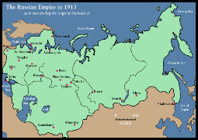
We sometimes have quarrels and disagreements with others over trivial things.
But sometimes the disagreements have much deeper roots, such as Russia’s invasion of Ukraine, where Putin wants to reclaim Ukraine as part of imperial Russia.
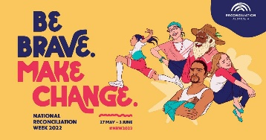
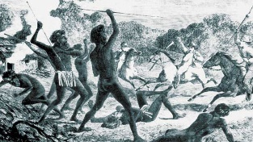
Here in Australia there are deep and long-lasting disagreements between indigenous people, sometimes called the First Peoples, and the settlers and colonisers and their descendants, sometimes called the Second Peoples. These disagreements began with the settlement – or invasion – of the land, depending on your perspective. The distance and distrust between First and Second Peoples remains to this day, even though it is often out of sight and out of mind for most of us.
This week is National Reconciliation Week … which gives us the opportunity to learn about the histories, cultures and achievements of indigenous people, and the chance to explore how each of us can contribute to achieving reconciliation in Australia.
What reconciliation might look like we’ll explore a bit later.
But first up, why is National reconciliation Week held at this time of year?
and why is this year an opportune time to be talking about reconciliation?
Dates matter to many of us.
They mark out the seasons and turning points of the year.
They also mark out special days, like our birthdays or wedding anniversaries, or more sombre events like the death of loved ones.
The starting and finishing dates of National Reconciliation Week are particularly important for indigenous people and should be dates that every Australian knows about. But I wonder if we know their significance?
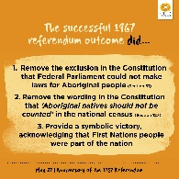
The week always starts on May 27, which marks what important date?
It’s the anniversary of the 1967 Referendum that gave Aboriginal people full citizenship rights by finally being counted in the national census.

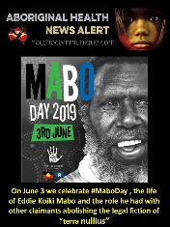
The week finishes on June 3, which marks which other important date?
It’s the anniversary of the High Court Mabo decision in 1992 that effectively overturned the lie that Australia was ‘Terra Nullius’ – ‘empty land’ or ‘land belonging to no one’ when Europeans first settled here in 1788.

The idea of holding a National Reconciliation Week came from the last of the 339 recommendations from the Royal Commission into aboriginal deaths in custody in the early 1990s, namely that a formal process of reconciliation between aboriginal people and the wider community be initiated. This was taken up by various faith communities and has been part of our national calendar since 1996.
The theme of National Reconciliation Week this year is ‘Be brave. Make change’ – and this year it feels as though we might just be at a tipping point in Australia.
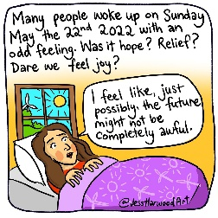
Many people have noted the change that has already come over Australia since the election last weekend. There has been a palpable sense of relief for many that the politics of fear and division, of aggression and indifference is ending. We’re not sure how the new government will handle all the challenges that lie ahead, but there is a renewed sense of hope in many places that we will finally see serious action on climate change, on government integrity and treatment of women and refugees.
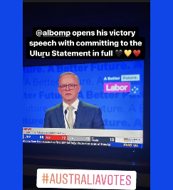
In the reconciliation space, the previous Coalition government had completely rejected the Uluru statement from the heart … and confirmed during the election campaign that it had no plans for a referendum to enshrine an indigenous voice to parliament in the Constitution.
By contrast, in his victory speech last Saturday night, the very first commitment made by new Prime Minister Albanese was to implementing the Uluru Statement in full. This will no doubt be challenging, but there’s been a big change in attitude.

It’s time to be brave and make change.
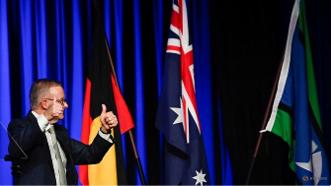
Small details sometimes make a big statement. When Prime Minister Morrison gave a formal speech he liked to have a backdrop of an Australian flag behind him, the bigger the better. He also made a significant point of acknowledging army veterans and those who have fought for Australia. There was always a focus on nationalistic white Australia.
I couldn’t help noticing at the Labor party campaign launch, though, and again during Albanese’s victory speech that the Australian flag was flanked by the Aboriginal flag and the Torres Strait and Islander peoples flag. It may seem like an unimportant detail to many people, but to me it actually says a lot about priorities and inclusion.
But what does reconciliation look like? And is it what First Nations people are actually seeking, or is it what Second Peoples like ourselves want?

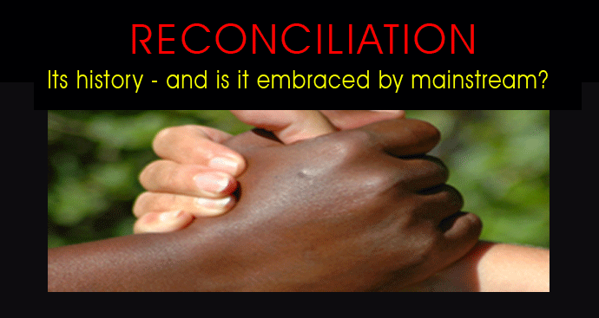
You may have noticed that when I make an acknowledgement of country at the start of each service, I don’t say that we commit ourselves to seeking reconciliation. I usually say that we commit ourselves to walking with the First Peoples of this country in their search for justice. Both are important concepts but it seems to me that justice implies working for both restored relationship (reconciliation) and taking action to address past wrongs (justice).
Perhaps our Bible readings will give us some help in seeing how the concepts of reconciliation, justice, truth and peace go together?…
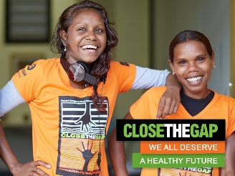
In the Psalm 9, God is recognised as the righteous judge and also a refuge and stronghold for the oppressed. The inference is that God will ultimately judge our stance on how we have lived towards others – especially the oppressed, the poor and the needy. In the context of Australia, it is our ancestors from Europe who oppressed the indigenous people, who continue to live in poverty and great need.
This is reflected in the gap between health outcomes, life expectancy, rates of imprisonment, and so forth. God’s justice and righteousness demand that this gap be addressed before there can be peace between our peoples.
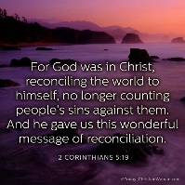
In the reading from 2 Corinthians, the apostle Paul talks about the death of Jesus in terms of reconciliation. Rather than continuing division and enmity between God and people, the death of Christ has restored our relationship with God. This was not something that we as humanity initiated and achieved, but rather the initiative and power to bring about reconciliation lay with God and the key agent was Jesus Christ.
If reconciliation is to happen in this country, it will have to start with the people who hold the power – with us as Second Peoples. We will need to recognise that Australia was colonised without any form of treaty with its first peoples, who had lived in the land for thousands of years. There was conflict and warfare between First and Second peoples for well over 100 years. This is the truth of our history that we must acknowledge if there is to be any movement towards reconciliation. We also need to own the injustices committed – the stolen land, stolen languages, stolen children, people killed, women raped. This acknowledgement quite possibly needs to be written into our Constitution, as has been done in the Uniting Church Constitution. Only with this acknowledgement can we contemplate walking together.
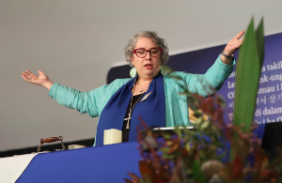
At the recent Uniting Church Assembly meeting where members come together from right across Australia, the first agenda item was to renew the Covenant between the Uniting Church and the Uniting Aboriginal and Islander Christian Congress.
President Sharon Hollis led this prayer …

Before you, God, and before our Congress siblings, we [the Second Peoples of this land] confess anew that we have been and continue to be complicit in the oppression of First Peoples. We took and continue to take land from its rightful custodians. We chose and continue to choose violence, subjugation, prejudice and patronising charity. We have turned a blind eye to the continued desecration of sacred places across our lands. Australia’s justice system continues to discriminate against First Peoples, and the ever-increasing numbers of indigenous deaths in custody show us that justice is yet to roll down like waters. …
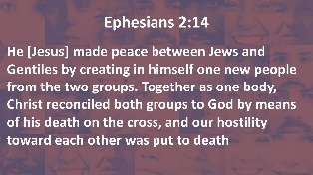
We pray that our commitment to this Covenant will be renewed and enlivened. Kindle in us a flame for justice and equity in these lands known as Australia, and remind us to work in solidarity, shoulder to shoulder, with our First Nations siblings. May we defiantly choose love and justice over racism and fear, every day, in every decision, in every action.
In the Ephesians reading, there is a similar reconciliation theme but now using the imagery of peace. We were estranged from God and estranged from one another. Christ came to make peace – both peace with God and peace with each other. This peace allows us to live in right relationship with God and with each other, to work together, eat together and share resources with each other. Once again, this peace is a gift of God’s grace. It is not something that we earned.
If there is to be true peace between indigenous people and those who came later – our ancestors and ourselves – then the wishes of indigenous people need to be heard. Then perhaps if we listen deeply to each other and act with justice, we might just arrive at peace – and reconciliation.
In the Uluru statement from the heart there are three asks from indigenous people …
- First, an indigenous voice to Parliament enshrined in the Constitution - so that the next government can’t just cancel it. This will need to be voted on in a referendum, but will give indigenous people a say in the policies that affect their lives and their future- rather than have the government decide what’s best for them.
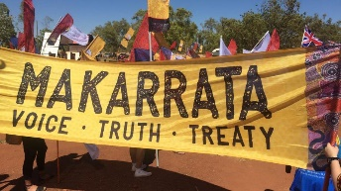
- The second ask is a makarrata or truth-telling commission that will bring to light the true history of European settlement and how aboriginal people were driven from their lands and often killed, or forced to live on small stations like Coranderrk at Healesville.
- The third ask is to establish a treaty – or even a series of treaties between indigenous and Torres Strait Islander people and the Second peoples of this country. The Waitangi treaty in New Zealand or several treaties in Canada show how this could be done. It will be difficult and costly – but if we truly want to be reconciled and to walk together in peace – it will be necessary.
The Victorian government has already established a process to reach a treaty in this state that will recognise and celebrate the unique status, rights, cultures and histories of the traditional owners of the lands and waters that make up Victoria.
I suspect that we will be hearing a lot more about these issues in the next 12-18 months.
While all this may seem too hard or just not very relevant to our lives here in Croydon, if we have received reconciliation and peace from God, and God in turn calls us to be messengers of reconciliation and peace to others, then there is a long festering wound in this country that needs healing – and these are three steps in the healing process. In the words of Reconciliation Week this year, it’s time to be brave and to make change.
Shortly you’ll be invited to participate in an activity for peace and reconciliation, in which each of us can choose to educate ourselves and make a difference, but first, a prayer written by Jennie Gordon … let us pray.
Jesus, be with us.
Be with us as we walk together - First and Second Peoples -
through the dark places of pain and shame, grief and hunger
in the wilderness of colonisation -
joined by you, our common ancestor in the Spirit
Be with us as we sit together - First and Second Peoples -
in the yarning and the listening places,
connecting narratives, holding heart words, in deep respect
joined by you, our common ancestor in the Spirit
Be with us as we stand together - First and Second Peoples -
facing the forces of power, shouting justice from the streets
because we cannot stay silent in the kinship of unyielding love
joined by you, our common ancestor in the Spirit
Jesus you are the strength within and our constant companion
do not leave us now, to puzzle our way out on our own. Amen.
ACTING FOR PEACE
But now it’s time to act for peace, justice and reconciliation. This activity was suggested by Common Grace.
You’ve been given a gum leaf and a pen or texta.
I invite you to choose one of the topics on the screen that relates to Reconciliation Week and to commit yourself to research that topic and discover what you could do to help bring about peace and reconciliation with justice.

Invasion, dispossession and stolen land
Closing the gap
Aboriginal rates of imprisonment and death in custody
1992 Mabo decision and its implications
A voice to Parliament enshrined in the Constitution
Makarrata commission
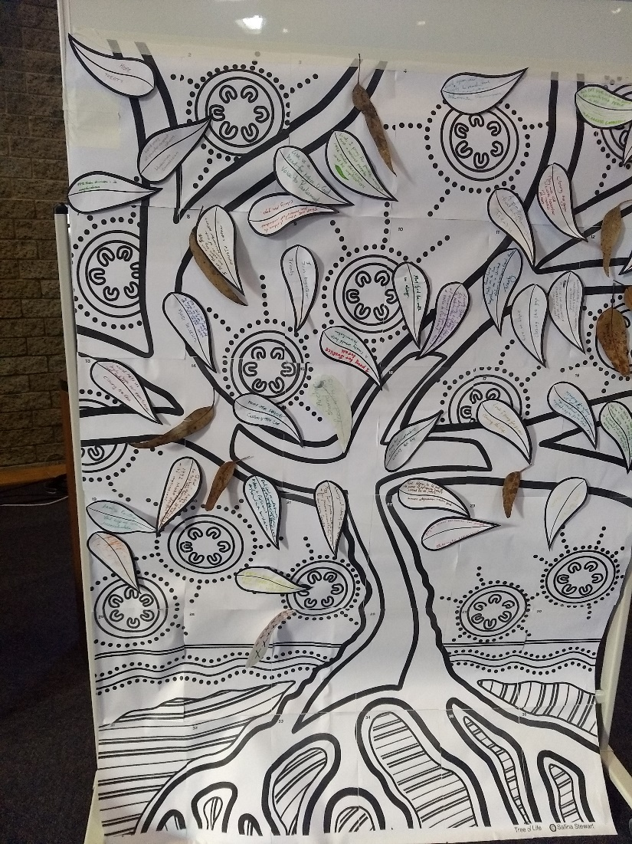
Treaty
When you’ve written on your gumleaf, I invite you to come and attach your leaf to our tree of life, the tree referred to in the book of Revelation, whose leaves are for the healing of the nations.

