Temptation – finding an easier path
  - 6 March 2022 – Lent 1

BIBLE READINGS

Deuteronomy 8:1-3
This entire commandment that I command you today you must diligently observe, so that you may live and increase, and go in and occupy the land that the Lord promised on oath to your ancestors. Remember the long way that the Lord your God has led you these forty years in the wilderness, in order to humble you, testing you to know what was in your heart, whether or not you would keep his commandments. He humbled you by letting you hunger, then by feeding you with manna, with which neither you nor your ancestors were acquainted, in order to make you understand that one does not live by bread alone, but by every word that comes from the mouth of the Lord.

Psalm 91:1-2, 9-16 (responsively)
You who live in the shelter of the Most High,
who abide in the shadow of the Almighty,
will say to the Lord, ‘My refuge and my fortress;
my God, in whom I trust.’
Because you have made the Lord your refuge,
the Most High your dwelling-place,
no evil shall befall you,
no scourge come near your tent.
For he will command his angels concerning you
to guard you in all your ways.
On their hands they will bear you up,
so that you will not dash your foot against a stone …
Those who love me, I will deliver;
I will protect those who know my name.
When they call to me,
I will answer them;
I will be with them in trouble,
I will rescue them and honour them.
With long life I will satisfy them,
and show them my salvation.

Luke 4:1-13
Jesus, full of the Holy Spirit, returned from the Jordan and was led by the Spirit in the wilderness, where for forty days he was tempted by the devil. He ate nothing at all during those days, and when they were over, he was famished. The devil said to him, “If you are the Son of God, command this stone to become a loaf of bread.”
Jesus answered him, “It is written, ‘One does not live by bread alone.’”
Then the devil led him up a mountain and showed him in an instant all the kingdoms of the world. And the devil said to him, “I will give you all their splendour and authority; for it has been given to me, and I give can give it to anyone I please. So if you will worship me, it will all be yours.”
Jesus answered him, “It is written, ‘Worship the Lord your God, and serve only him.’”
Then the devil took him to Jerusalem and placed him on the pinnacle of the temple, saying to him, “If you are the Son of God, throw yourself down from here, for it is written, ‘He will command his angels concerning you,
to protect you,’ and ‘On their hands they will bear you up,
so that you will not dash your foot against a stone.’”
Jesus answered him, “It is said, ‘Do not put the Lord your God to the test.’” When the devil had finished every test, he departed from him until an opportune time.

MESSAGE Temptation – finding an easier path
Welcome to the season of Lent, the 40 day period leading up to Easter.
Lent is perhaps best known for the tradition of fasting for 40 days, based on the 40 days Jesus fasted for in the wilderness while being tempted by the devil. Hence the Bible reading on this first Sunday in Lent is traditionally the one about Jesus’ temptation in the wilderness. Common Lent practices of fasting, prayer, self-denial and simple living were firmly established by the fourth century. So this season has long and deep roots in most Christian traditions.
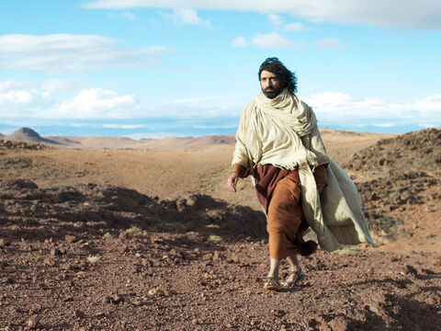
Before we come back to how we might choose to walk through Lent, let’s first unpack today’s passage …
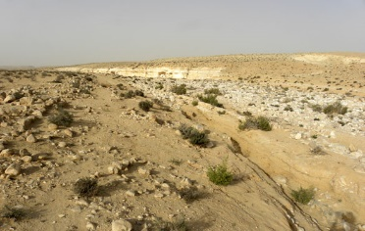
We read that following his baptism in the Jordan River, Jesus was full of the Holy Spirit and was led by the Spirit into the wilderness. The word used for ‘led’ is fairly strong and could be translated driven or coerced. It sounds as though Jesus didn’t have much say in this – rather God’s Spirit forced him into the wilderness.
In Jesus’ day, the wilderness was regarded as an empty, desolate and abandoned place, a place where danger and death lurked, a place to be avoided.

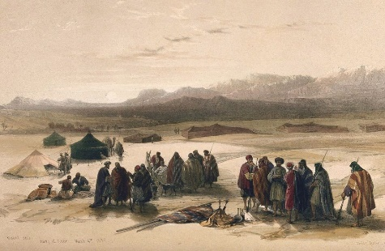
This contrasts with our contemporary view of wilderness as a wild and pristine environment, untouched by humans, a place to go for recreation or enjoyment. Hence one of the attractions of visiting Tasmania is the large areas of wilderness, like this image of the Tarkine wilderness in the north-west of the state.

Although in biblical times the wilderness was generally regarded as a desolate place, there are several stories in the OT where God meets people in the wilderness in life changing ways. So we might think of Elijah meeting God in the wilderness, or God providing for Hagar and Ishmael in the wilderness.
The best known example, though, that is relevant to today’s reading, is the 40 years that Israel spent wandering in the wilderness following their escape from Egypt during which time God sustained them with manna.
In today’s gospel reading, Jesus encounters the devil in the wilderness rather than God. The devil comes to Jesus after he has fasted for many days and is not only hungry and thirsty but probably also half exhausted.

The temptations that the devil brings to Jesus follow a consistent pattern …
if you are the Son of God, then do this … which sets up a test between how Jesus will respond compared with how God’s other children, the Israelites, responded during their time of testing in the wilderness. Will Jesus remain faithful to God’s ways and God’s word or will he rebel like the Israelites?
The temptations are more subtle than they appear and are quite enticing …
Will you use your Spirit given power, Jesus, to satisfy your needs by turning stones into bread? That way you could feed yourself – as well as other hungry people …
Will you seek power and authority over others and seek to rule other kingdoms and nations, such as we have seen Putin do in Ukraine these last two weeks? As God’s Son you would surely rule responsibly? This could all be yours if you just bow down and worship me …
Or will you seek to force God’s hand to save you, within sight of many onlookers so you’ll become a famous celebrity? Then people with less faith will know that God can save them too …

In each case, Jesus refuses the bait.
He will not be tempted to follow the devil’s suggested pathways, as enticing as they may sound.
Instead, Jesus will turn to God, relying on God’s provision for his daily needs and worshipping only God. He will not treat God like a magic slot machine, demanding that God save him.
Although these temptations are presented as occurring before the start of his ministry, we can be fairly sure that they represent typical temptations that Jesus faced during his ministry and right up to the events of Easter.
At heart, these temptations or tests each offer an easier pathway for Jesus …
Don’t rely on God, but provide for yourself and others
Don’t follow God’s way of serving others, but rule over them instead
Don’t risk the way of suffering, but command God to rescue you
We probably don’t face the exact same temptations as Jesus - because we are not called to be the Messiah ... but the temptations we face do often centre on finding an alternative and easier path to walk.
So whether as individuals or as a community of faith …
we might be tempted to always fit in with our culture and look after our own needs first.
we might be tempted to seek personal comfort rather than the harder option of serving others, especially when it’s inconvenient.
we might be tempted to seek security and meaning in life through things – whether buildings or computers or hobbies - rather than through our ongoing relationship with God.
In each case, life may become easier for us, but probably less faithful and less fruitful for God’s kingdom.

It seems to me that one significant difference between the temptations faced by Jesus and the temptations we face is that Jesus was thrust into them whether he liked it or not. He was driven by God’s Spirit into the wilderness where he was tempted. Yet every time we pray the Lord’s prayer, we say the line ‘Lead us not into temptation’ - or in modern translations ‘Save us from the time of trial’ – which has slightly different connotations. This prayer request was obviously a big deal for it to be included in the Lord’s prayer.
So if temptations are to be regarded as a normal part of living, why do we need to keep asking God to not lead us into temptation, when it seems that God deliberately led Jesus into temptation?
Perhaps it’s because temptation and testing are actually a big deal, that taking the easier road may lead us into significant danger, and may take us away from God. As Jesus exhorts us in the Sermon on the Mount:
Enter through the narrow gate; for wide is the gate and easy is the road that leads to destruction and many enter through it. But narrow is the gate that leads to life and only a few find it. (Matt 7:13-14)
In Paul’s first letter to Timothy, he warns Timothy about certain believers who have shipwrecked their faith. And in the book of Revelation, we read about a particular church that nauseates Jesus because of their lukewarm faith. So we have been warned about the possibility of individuals or whole communities being led astray by temptation. Hence the line in the Lord’s prayer ‘Do not lead us into temptation’.
This prayer is asking God to protect us from areas in our life or from situations that may threaten our faith and threaten our walk with God. These sorts of temptations may be subtle and are probably unique to each of us, but the point is we need to be protected from them or they may derail our walk of discipleship.
Which brings us back to how we might choose to walk through this season of Lent. For my part, I will be bringing a series of messages that focus each week on a different aspect of discipleship, a different aspect of how we journey together with Jesus in our walk of faith. So today we have explored temptation. Next week we’ll explore distractions.
I will also be availing myself of prayers and reflections available online for each day or each week during Lent. And also reading this booklet of reflections written by various members of the North Ringwood Uniting Church, a tradition North Ringwood has followed for twenty years. If you would like a copy please either speak to me after the service or email me …
You may prefer to do something entirely different during Lent such as choosing to visit a lonely friend each week and spend time listening to their struggles, or to take up an environmental challenge such as fasting from using plastic bags, or commit yourself to pray for 15 or 20 minutes every day as you go for a walk or work in the garden.
However you choose to spend this season, I invite you to see it as a gift, and an opportunity to grow closer to Jesus. Lent may seem like a hard and fairly sombre season that leads us relentlessly towards the cross of Jesus. That is certainly part of Lent as we’re asked over and over whether we are prepared to follow Jesus on the path he has chosen.
But there is also companionship and laughter and new insights to be gained as well. So while this season is not as joyful as Advent, the goal is similar – to prepare us to receive God’s good and gracious gift and to grow in our faith and our love for one another and for our neighbour … which for me makes it highly valuable season.

